
Champaign County Community Health Plan 2021-2023

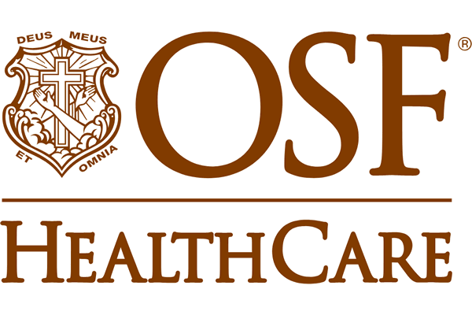

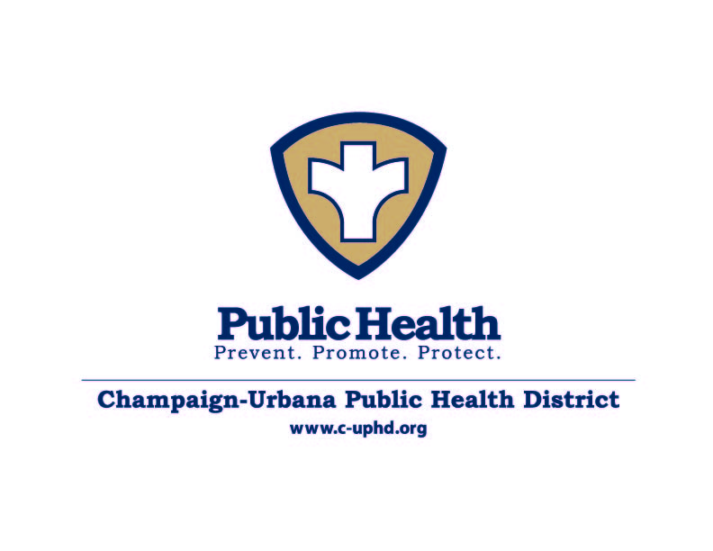
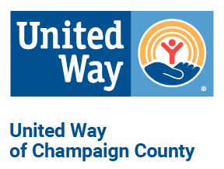
Executive Summary
The Champaign-Urbana Public Health District (CUPHD) is the local public health authority for the Cities of Champaign and Urbana and Champaign County. CUPHD, in conjunction with Carle Foundation Hospital, Presence Covenant Medical Center, and United Way of Champaign County, used the Mobilizing for Action through Planning and Partnership (MAPP) model, a community-based model that necessitates community engagement at all levels to conduct the Champaign Community Health Assessment (CHA) and Community Health Improvement Plan (CHIP). We assessed the current health status of the community, identified needs, and created a comprehensive plan to improve our community’s health by acquiring input from community partners, planners, elected officials, and residents.

The MAPP process is composed of four assessments. The use of survey monkey was imperative to completing each assessment; approximately 25 community leaders submitted information for the assessment and to review the community health data, set a vision, and identify priorities and goals for the 2021-2023 Community Health Improvement Plan.

Vision: Champaign County will be the Healthiest and Safest, environmentally sustainable community to live, work, and visit in the State of Illinois.

The Four MAPP Assessments:

1. The Community Health Status Assessment evaluated the basic demographics and health-related statistics of residents in Champaign County. We used aggregated data accessed from Countyhealthrankings.org and city and county agencies including the Champaign and Urbana Police Departments.
- Champaign County had an estimated 209,689 residents in 2019, an increase of 8,608 residents from 2010. The population is 72% White, 14% Black/African American, 11% Asian, and 6% Hispanic.
- Approximately 18% of Champaign County children live in poverty.
- 31% of Champaign Residents reported being obese, an increase from 25% in 2017.
- Violent crime in Champaign County is much higher than the state and national averages.
- 7% of Champaign County adults are uninsured compared to 10% overall Illinois uninsured rate.
- The teen birth rate (per 1,000 female population, ages 15-19) is 13, compared to 21 teen births per 1,000 in the state of Illinois.

2. To perform the Community Themes and Strengths Assessment, we surveyed 634 community residents representing different community groups to get an in-depth picture of the strengths and weaknesses of the community.
- Residents identified mental health, child abuse, gun violence, and infectious disease as the top health concerns in the community.
- The top three adequate community resources were access to healthcare, employment/ability to find jobs, and funding for schools. The top three resources rated as the most inadequate were mental health services, affordable childcare, and drug treatment services.
- For both health care and dental care, less than 15% of participants were dissatisfied with the quality of health care and dental care. However, over 25% of participants responded that they were not satisfied with the access to affordable health care and dental care. Respondents reported being satisfied with access to high-quality healthcare, although they were dissatisfied with the cost of healthcare.
- Over 12% of participants responded there were times when they ran out of food before they had the means to buy more.

3. The Local Public Health System Assessment (LPHSA) included 25 community leaders from different agencies, including local government, community planners, public health professionals, clinicians, police and fire, local nonprofits, emergency preparedness, and the University of Illinois. This measured how the local public health system is addressing the 10 essential public health services.

- Strengths: enforcing laws, mobilizing partnerships, developing policies/plans, research/innovations, reviewing and improving laws, emergency planning, risk communication, academic linkages, fostering innovations, community partnerships.
- Needing Improvement: linking community members to health services, evaluating the local public health system, assuring a competent and diverse workforce, evaluation of population health, leadership development, and health education/promotion.

4. The Forces of Change Assessment identified the changing ACA legislation as a force impacting many sectors; as well as immigration laws, increased used of social media and smartphones, mental health issues, divisive political climate, lack of state budget, and climate change as major forces of change.

Health Priorities

Based on the four MAPP assessments, community leaders convened to identify priorities. After identifying top health concerns, participants voted to select the top three priorities to address in 2021-2023 implementation cycle. Special consideration was given to ensure that all priority health actions align to include environmental determinants of Public Health. Based on the CDC’s model, SMART objectives were used to identify goals and objectives within each priority that were feasible, actionable, and could be implemented in the upcoming years. Workgroups are formed and met separately to formulate goals and action plans to address each of the priorities.

- Behavioral Health: increase capacity, create behavioral health triage center, promote education and training on mental and behavioral health to reduce stigma, provide youth-targeted prevention programs.
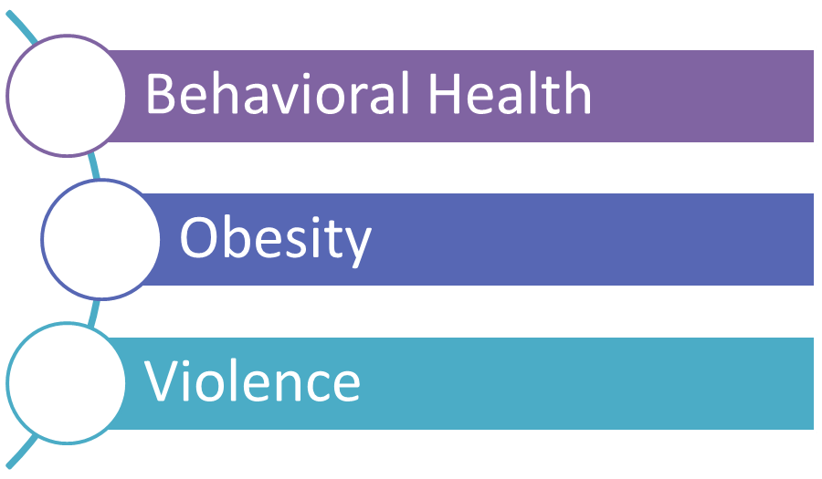
- Reducing Obesity and Promoting Healthy Lifestyles: improve access to healthy food options, expand physical activity prescription program, and increase access to physical activity.
- Violence: promote police-community relations, increase community engagement, and reduce community violence through partnering with local initiatives

The Champaign Regional Executive Committee would like to thank all of the agencies and individuals who participated in this process, as well as the agencies and organizations that make up the Champaign County Local Public Health System. We appreciate their knowledge, collaboration, dedication, and commitment to making our community a great place to live, work, and visit.
Acknowledgements
The Champaign Regional Executive Committee would like to acknowledge and thank the many individuals and organizations that contributed their valuable time and expertise to this report:

Elizabeth Silver | Carle Foundation Hospital
Julianna Sellett | Carle Foundation Hospital
John Walsh | Carle Foundation Hospital
Adani Sanchez | Champaign County Health Care Consumers
Mark Driscoll | Champaign County Mental Health Board
Jameel Jones | Champaign Park District
Awais Vaid | Champaign Urbana Public Health District
Candi Crause | Champaign Urbana Public Health District
Debra Fruitt | Champaign Urbana Public Health District
Julie Pryde | Champaign Urbana Public Health District
Valerie Koress | Champaign Urbana Public Health District
Dottie Vura-Weis | Champaign County Board of Health
Cynthia Hoyle | CU Mass Transit District
Karen Sims | CU Trauma & Resiliency
Emily Yoder | Eastern Illinois FoodBank
Jacquelyn Evers | Land Connection
Kim Bryan | Rattle the Stars Suicide Prevention
Amy Huang | United Way of Champaign County
Beverley Baker | United Way of Champaign County
Chaundra Bishop | United Way of Champaign County
Stephanie Acevado | University of Illinois Extension
Emily Rae Stone | University of Illinois, Interdisciplinary Health Science
Bill Brown | Urbana Councilman
Ashley Dennis | Urbana Park District
Elsie Hedgspeth | Urbana Park District
Linda Gibbens | Urbana School District
Katina Wilcher | Unit 4 School District
Geographic data mapping done by Bill Brown from the University of Illinois
Data analysis done by Larry Weinzimmer from Bradley University

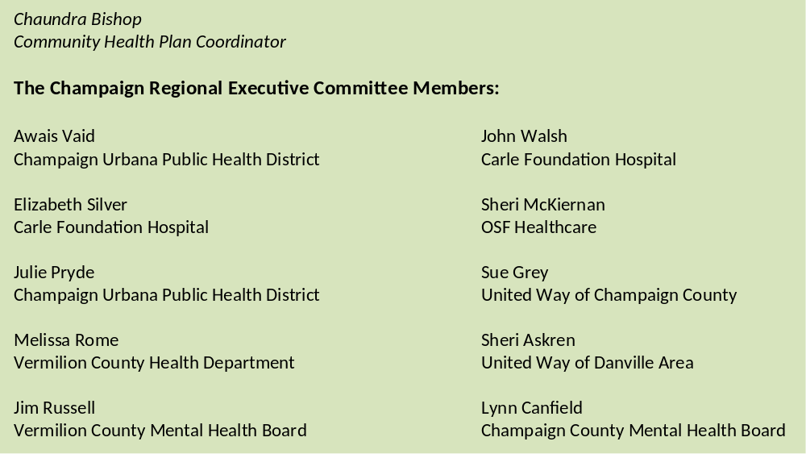
Awais Vaid
Champaign-Urbana Public Health District

Elizabeth Silver
Carle Foundation Hospital

Julie Pryde
Champaign-Urbana Public Health District

Melissa Rome
Vermilion County Health Department

Jim Russell
Vermilion County Mental Health Board

John Walsh
Carle Foundation Hospital

Sheri McKiernan
OSF HealthCare

Sue Grey
United Way of Champaign County

Sherri Askren
United Way of Danville Area

Lynn Canfield
Champaign County Mental Health Board

Introduction and Framework

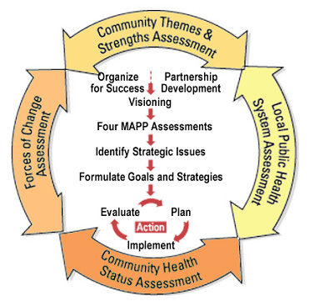
The Champaign County Community Health Plan provides a current portrait of the health assets and needs of the residents of Champaign County. Illinois state law requires every local health department to participate in this process, called the Illinois Project for Local Assessment of Needs (IPLAN). This process must be conducted at a minimum every five years. The detailed assessment and plan provide the foundation for evidence-based health planning and decision-making.

The essential elements of IPLAN are:
1. An organizational capacity assessment;
2. A community health needs assessment; and
3. A community health plan, focusing on a minimum of three priority health problems.

The Champaign County Community Health Plan was created using a model called Mobilizing for Action through Planning and Partnerships (MAPP). This collaborative approach to community health planning was developed by the National Association of County and City Health Officials (NACCHO) in cooperation with the Public Health Practice Program Office and the federal Centers for Disease Control and Prevention (CDC). MAPP helps communities form effective partnerships that can better identify their unique circumstances and needs and use their resources wisely.

MAPP is a community-driven process. It is more intense than other approaches in that it requires a high level of participation from community organizations and residents. This model employs a variety of methods to uncover community health trends, identify gaps in care, evaluate assets, and – most importantly – develop and implement a plan that successfully addresses community health needs.
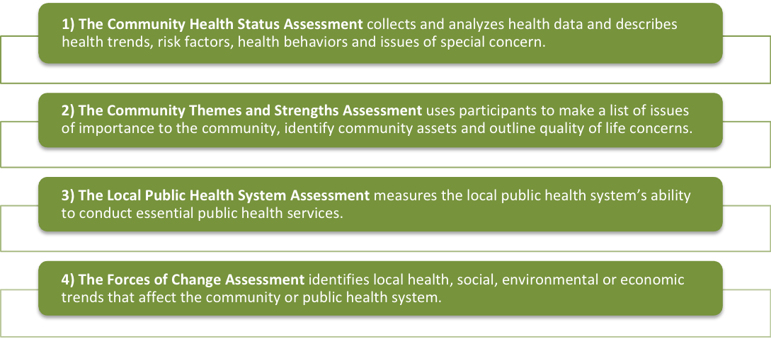
The four components of MAPP include:
Since 2013, the Public Health District and Hospitals have moved from independently conducting the Community Health Assessment and Improvement Plan to a truly collaborative model. Both Carle Hospital and OSF Healthcare, the local chapter of United Way along with the Health District formed an Executive Committee to conduct the Champaign Community CHIP and CHA to fulfill the requirements for certification.
A diverse group of health providers, civic leaders, and community representatives participate in this process. The goal is for all partners in the local public health system to work together to implement the recommendations outlined in this plan.

Background
Champaign County is located in East Central Illinois and is 998.39 square miles with a population density of 208.8 people per square mile. The two major cities, Champaign and Urbana, are home to the University of Illinois, as well as Parkland College and numerous businesses and companies. In 2019 the US Census Bureau estimated the population of Champaign County to be 209,689 residents, a .15% increase since 2015.
Champaign County also include the following villages: Bondville, Broadlands, Fisher, Foosland, Gifford, Homer, Ivesdale, Longview, Ludlow, Mahomet, Ogden, Pesotum, Philo, Rantoul, Royal, Sadorus, Savory, Sidney, St. Joseph, Thomasboro, and Tolono. Townships include: Ayers, Brown, Champaign, Colfax, Compromise, Condit, Crittenden, Cunningham, East Bend, Harwood, Hensley, Kerr, Ludlow, Mahomet, Newcomb, Ogden, Pesotum, Philo, Rantoul, Raymond, Sadorus, Scott, Sidney, Somer, South Homer, St. Joseph, Stanton, Tolono, and Urbana. Champaign County includes the following zip codes: 61820-2, 61801-3, 61866, 61874, 61873, 61880, 61864, 61877-8, 61847, 61863, 61871, 61815, 61824-6.
Community Assets
Participating Organizations and Community Resources

Carle Foundation Hospital | Habitat for Humanity
Court Appointed Special Advocates for Children | Health Alliance
Champaign County Sheriff’s Office | Healthy Champaign County
Champaign County Board | Illinois Dental Society
Champaign County Board of Health | Land of Lincoln
Champaign County Head Start | Midwest Center for Investigative Reporting
Champaign County Healthcare Consumers | National Alliance on Mental Illness
Champaign County Mental Health Board | Parkland College
Champaign County Regional Planning Commission | Prairie Center
Champaign Park District | OSF Healthcare System
Champaign Police Department | Promise Healthcare
Champaign Urbana Public Health District | Prosperity Gardens Inc.
Christie Clinic | Rosecrance
City of Champaign | United Way of Champaign County
City of Urbana | University of Illinois
Community Gardens at Leirman | University of Illinois Extension Office
CRIS Healthy Aging | University of Illinois McKinley Health Center
CU Mass Transit District | University of Illinois Police
Cunningham Children’s Home | Urbana Adult Education
Development Services Center | Urbana Park District
Faith in Action | Urbana School District
Family Resiliency Center | Urbana Neighborhood Connections Center
Family Services Center | Wells Fargo
Greater Community AIDS Project

MAPP ASSESSMENTS
I. Community Health Status Assessment (CHSA)
The CHSA explores how healthy our residents are, and what the health status is of our community. This shows the community's health status and ensures that our priorities include specific health status issues (e.g., high lung cancer rates or low immunization rates). The operational definition of health utilized in this assessment is taken directly from the World Health Organization: Health is a state of complete physical, mental, and social wellbeing and not merely the absence of disease or infirmity. The indicators analyzed represent this philosophy.

Methodology
The Institute of Medicine identifies a need for two kinds of indicators and indicator sets for use in a community health improvement plan. The first is a community health profile with indicators proposed by the Institute of Medicine to provide an overview of a community’s characteristics and its health status and resources. The second is the development of indicator sets for performance monitoring.

Interpretation of this data through comparison over time or with data from other communities can help identify health issues that need to be focused on within Champaign County. We used aggregated data accessed from Countyhealthrankings.org, Center for Disease Control, US Census Bureau, Illinois Department of Public Health, Illinois State Police Crime Reports, Illinois Department of Healthcare and Family Services, and local city and county agencies.
Distribution of the Population by Age, Race, and Ethnicity
Like many areas in the United States, Champaign County is becoming more diverse each year. Being the home of the University of Illinois at Urbana-Champaign, the county was the home to more than 10,000 international students during the 2018-2019 school year, hailing from more than 110 countries. This has increased dramatically from only 4,800 in 2005 and has added much diversity to both the campus and Champaign County. This also affects the age distribution of Champaign County, with the 18-24 age range well above the state and national average.
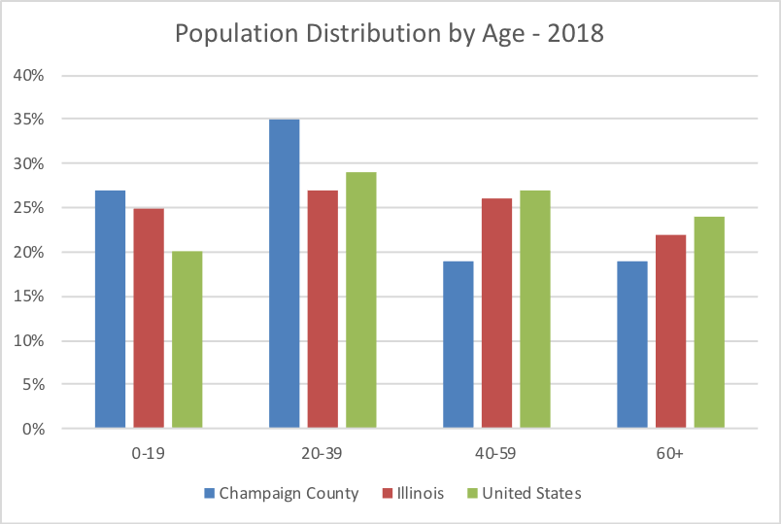

https://censusreporter.org
https://statista.com

Demographics
The total estimated population of Champaign County is 209,689 in 2019 (https://census.gov). Champaign County has 27% of its residents who are below the age of 20 and 13% are over the age of 65. Less than 10% of the residents are Hispanic, while over 70% are White.

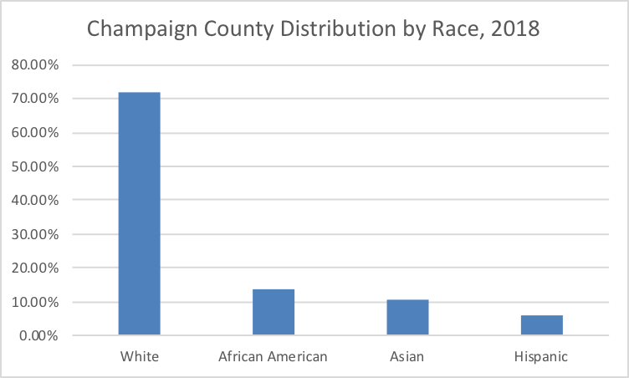

https://census.gov
Racial Diversity, 2018
A dot-density plot of the population based on the 2018 US National Census estimates broken down by race depicts the population density and the racial diversity of their neighborhood. The center of the Champaign-Urbana region is dominated by the University, with a majority of non-residential school buildings and surrounded by a higher percentage of Asian individuals than found in the rest of the region. There is a higher concentration of African Americans represented in the northern part of Champaign as indicated in red. The densest areas are near the center of Champaign-Urbana just within or at the eastern and western edges of the University of Illinois campus.

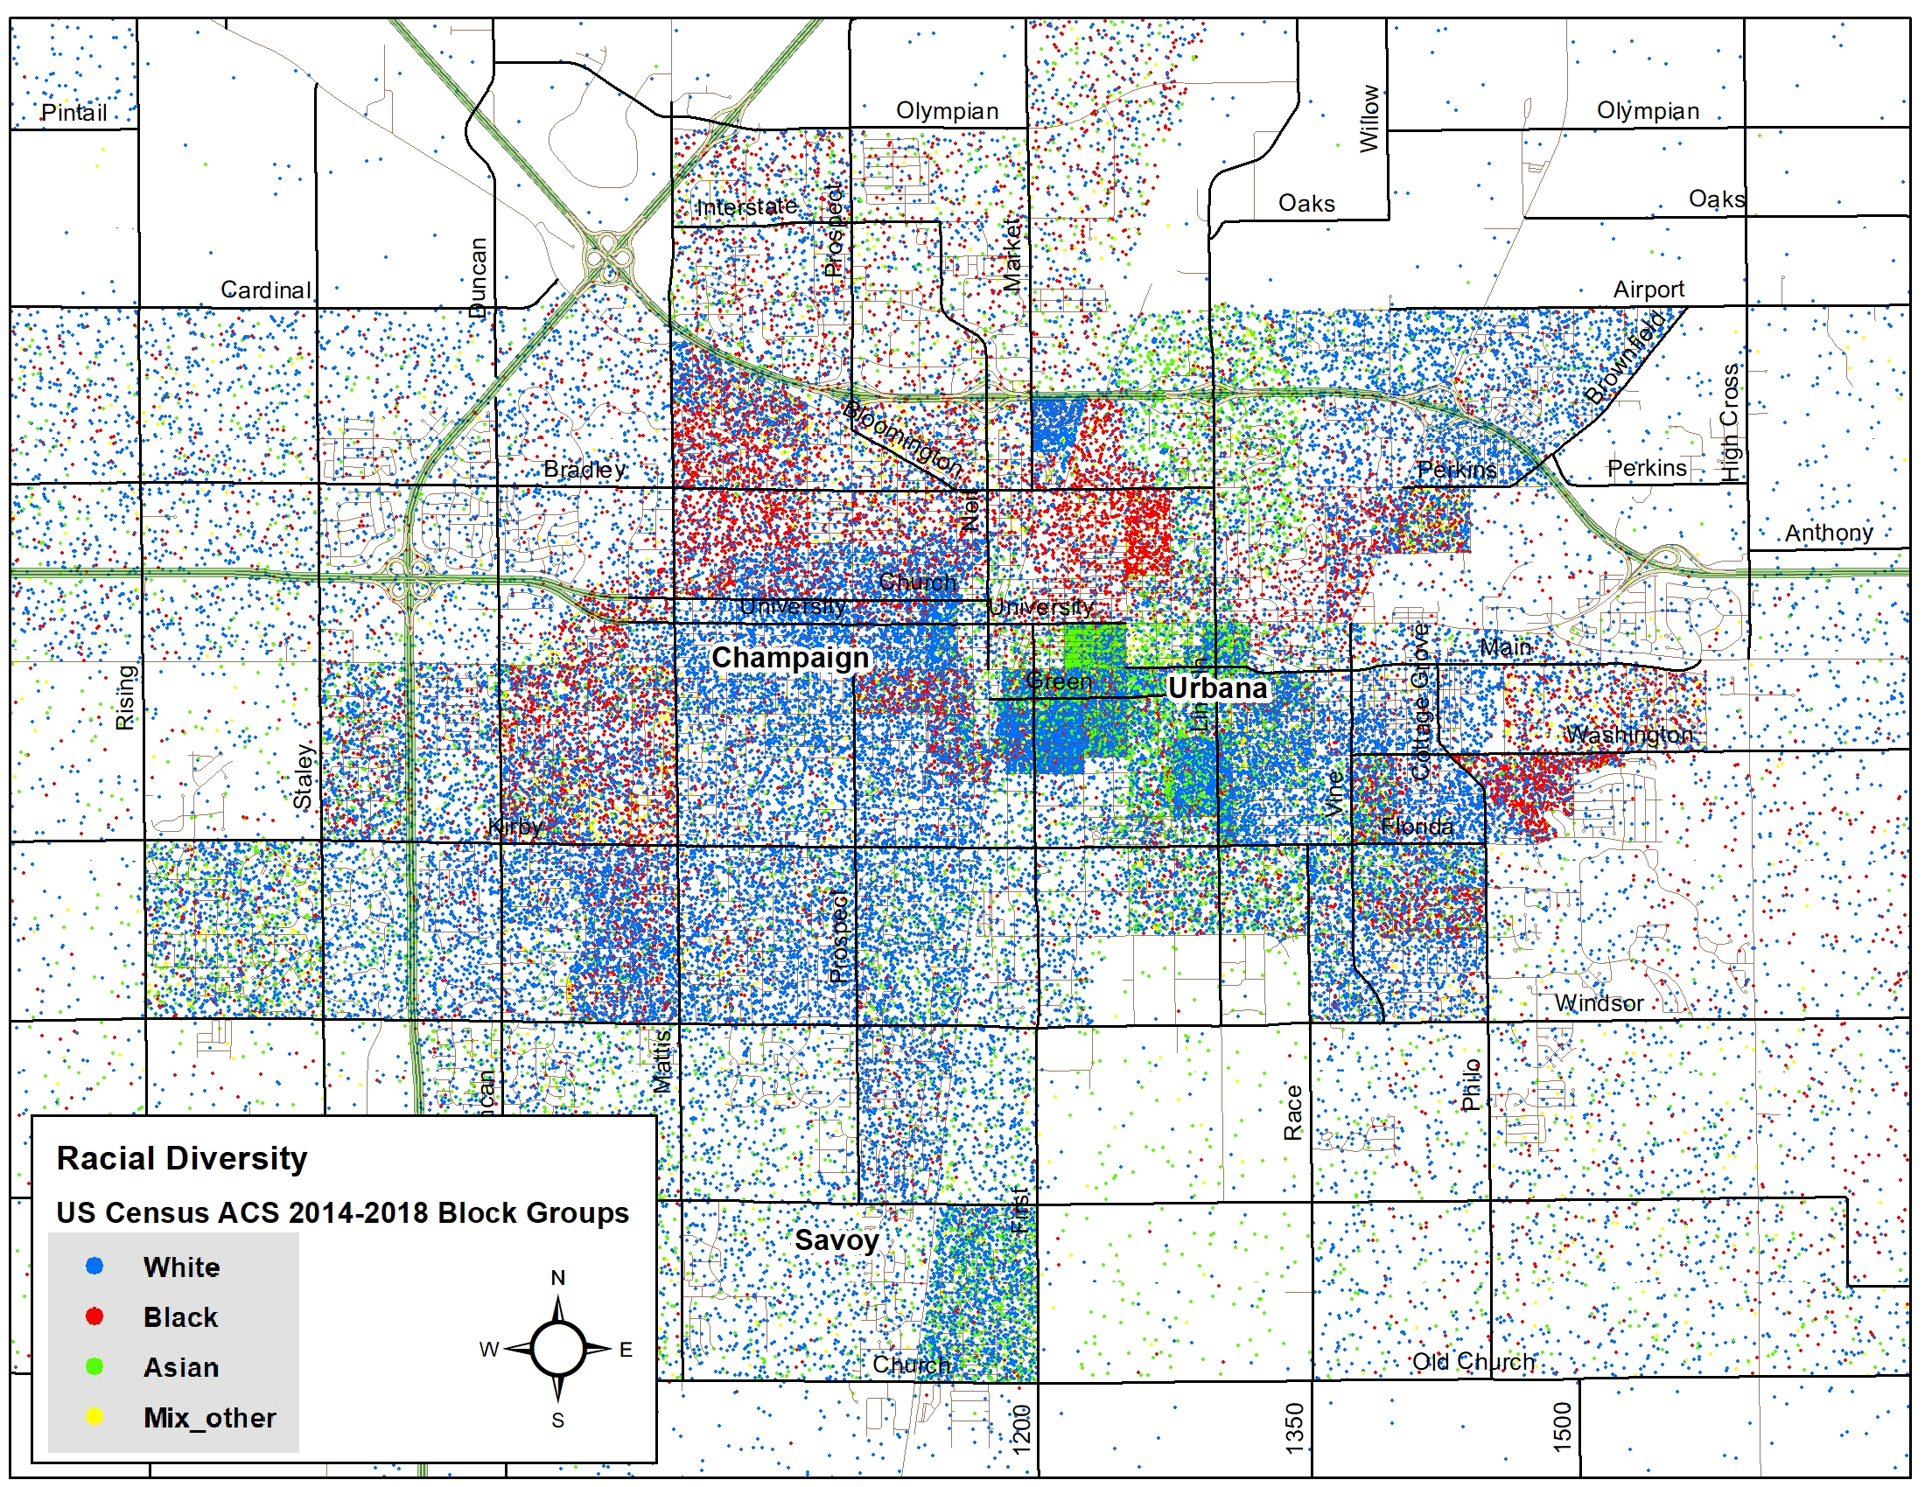

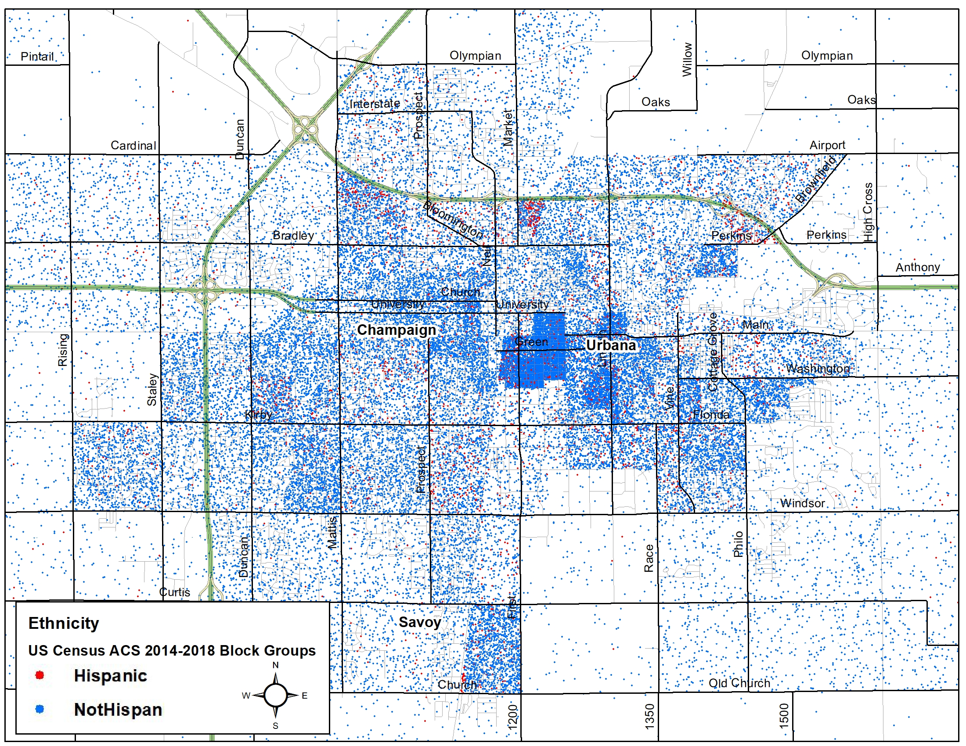

Socioeconomics and Priority Populations
The table below shows the social and economic factors for Champaign County according to the 2017 County Health Rankings. Exactly 80.0% of Champaign County residents report some college, compared to 69.0% of Illinois residents. Violent crimes in Champaign County are substantially higher than the Illinois rate.

Social and Economic Factors - 2018 | Champaign County |  | Illinois
High School Graduation | 86.0% |  | 85.0%
Some College | 80.0% |  | 69.0%
Unemployment | 4.4% |  | 4.3%
Children in Poverty | 18.0% |  | 16.0%
Income Inequality | 6.4% |  | 5.0%
Children in Single-Parent Households | 34.0% |  | 32.0%
Social Associations | 12 |  | 10
Violent Crime | 487 |  | 403
Injury Deaths | 56 |  | 62
https://countyhealthrankings.org
The below table shows the number of persons enrolled in Medicaid in Champaign County

“Number of persons enrolled as of the last day of the State Fiscal Year. State Fiscal Year runs from July 1 through June 30. Enrollment data is available 90 days after the end of the State Fiscal Year.

Children as defined as persons less than the age of 19. Adults are defined as persons older than 19 and younger than 65. Seniors are defined as persons age 65 and older.

Comprehensive Benefit enrollees are clients who are eligible for all services provided under the State's Medical Assistance Program.” (https://www.illinois.gov/hfs/info/factsfigures)

Comprehensive Benefit Enrollees | FY2015​ | ​FY2016 | FY2017​ | ​FY2018 | FY2019​
Children | ​​19,342 | 19,083​​ | 19,402​ | 19,873 | 19,692
Adults with Disabilities | ​2,893 | 2,929​ | ​2,931 | 3,402 | 3,320
ACA | 6,621 | 6,858​​ | ​7,230 | 7,786 | 7,559
Other Adults | ​8,083 | 7,869 | ​7,950 | 7,435 | 6,922
Seniors | 1,439​​ | 1,535 | ​1,614 | 1,759 | 1,716

Total Enrollees
Total Enrollees | ​FY2015 | FY2016​ | FY2017​ | ​FY2018 | FY2019​​
​ | ​ | ​ | ​ | ​ | ​
Total | 38,650​ | 38,542 | 39,430​​ | 40,686 | 39,743
Source: Illinois Department of Healthcare and Family Services

The graph below shows unemployment rates for Champaign County and the State of Illinois overall from January 2010 to January 2020. Over the past 10 years, Champaign County has consistently had a slightly lower unemployment rate than the state average, with the exception of a spike in early 2018.

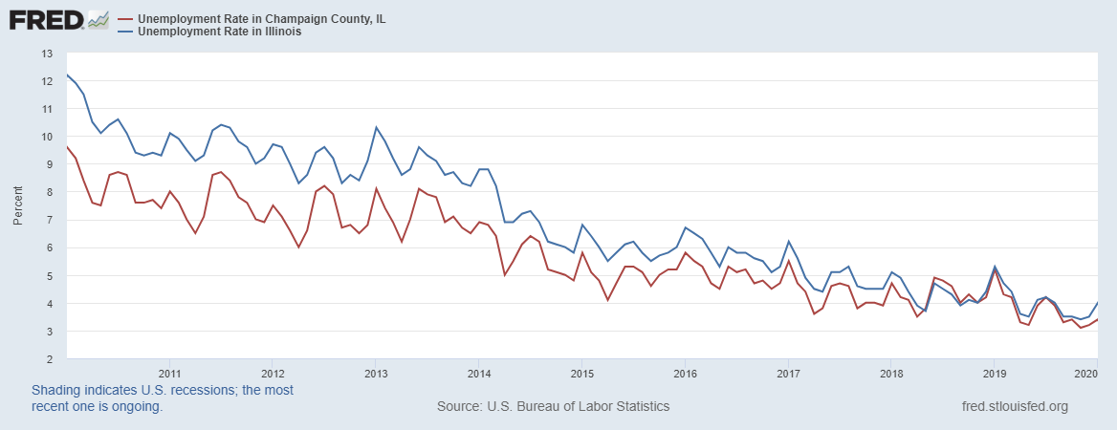

The rates of insurance and health resources in 2018 are shown in the table below. Champaign County has a lower rate of uninsured adults than Illinois. Champaign County has a higher number of preventable hospital stays.

Health Resources and Indicators - 2019 |  | Champaign County |  | Illinois
Uninsured |  | 6% |  | 8%
Uninsured Adults |  | 7% |  | 10%
Uninsured Children |  | 3% |  | 3%
Primary Care Physicians |  | 1,050:1 |  | 1,250:1
Dentists |  | 1,560:1 |  | 1,280:1
Mental Health Providers |  | 400:1 |  | 440:1
Other Primary Care Providers |  | 729:1 |  | 1,214:1
Preventable Hospital Stays |  | 5,169 |  | 5,092
Mammography Screening |  | 44% |  | 43%
Flu Vaccinations |  | 48% |  | 46%
https://countyhealthrankings.org

According to County Health Rankings, the percentage of Champaign County residents that are uninsured has dropped from 7% in 2018 to 6% in 2019, a vast improvement from 18% in 2010.

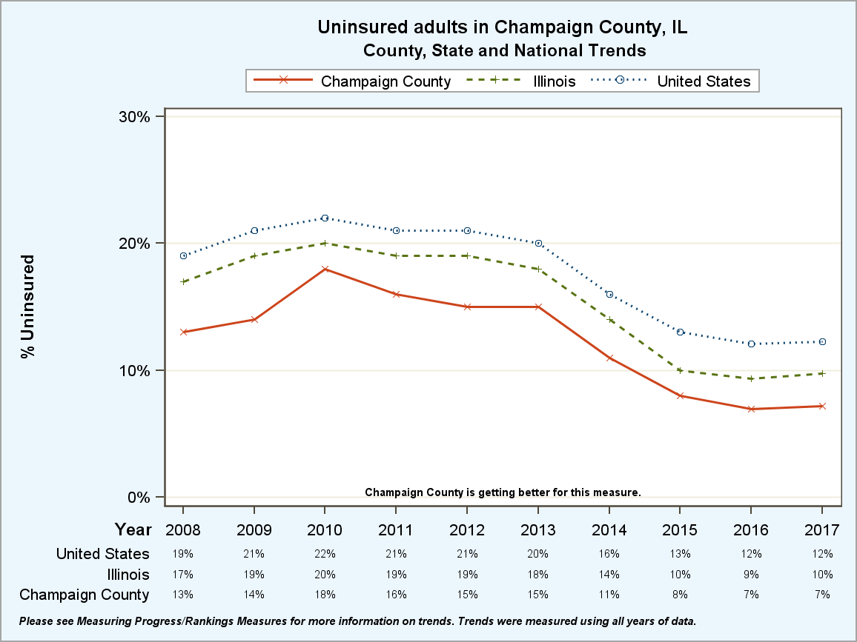https://countyhealthrankings.org

The graph below shows the percent of children living in poverty in Champaign County, the State of Illinois, and the U.S. from 2002 to 2019. Champaign County has a higher poverty rate than Illinois in the past 10 years except for 2015 and 2016. In 2018, the percent of people living in poverty in Champaign County was 18% and has remained at that level for 2019.
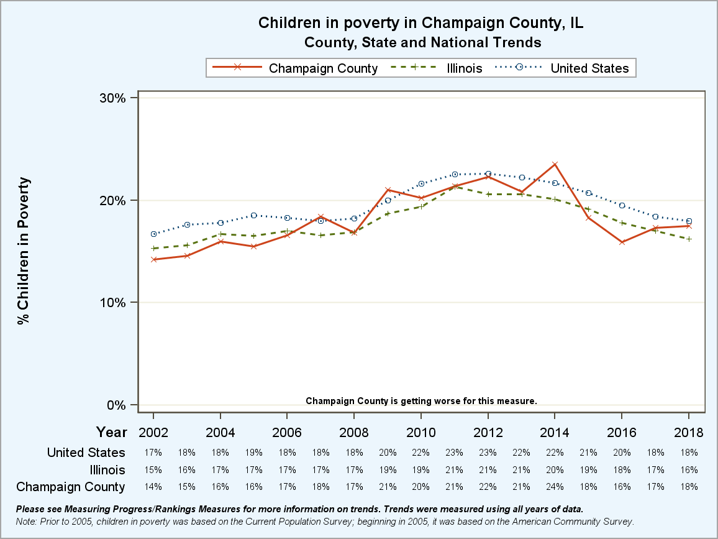
https://countyhealthrankings.org

The map below shows the percentage of families living below the poverty level in Champaign-Urbana, along with the percentage of families with children under the age of 18 living in poverty.

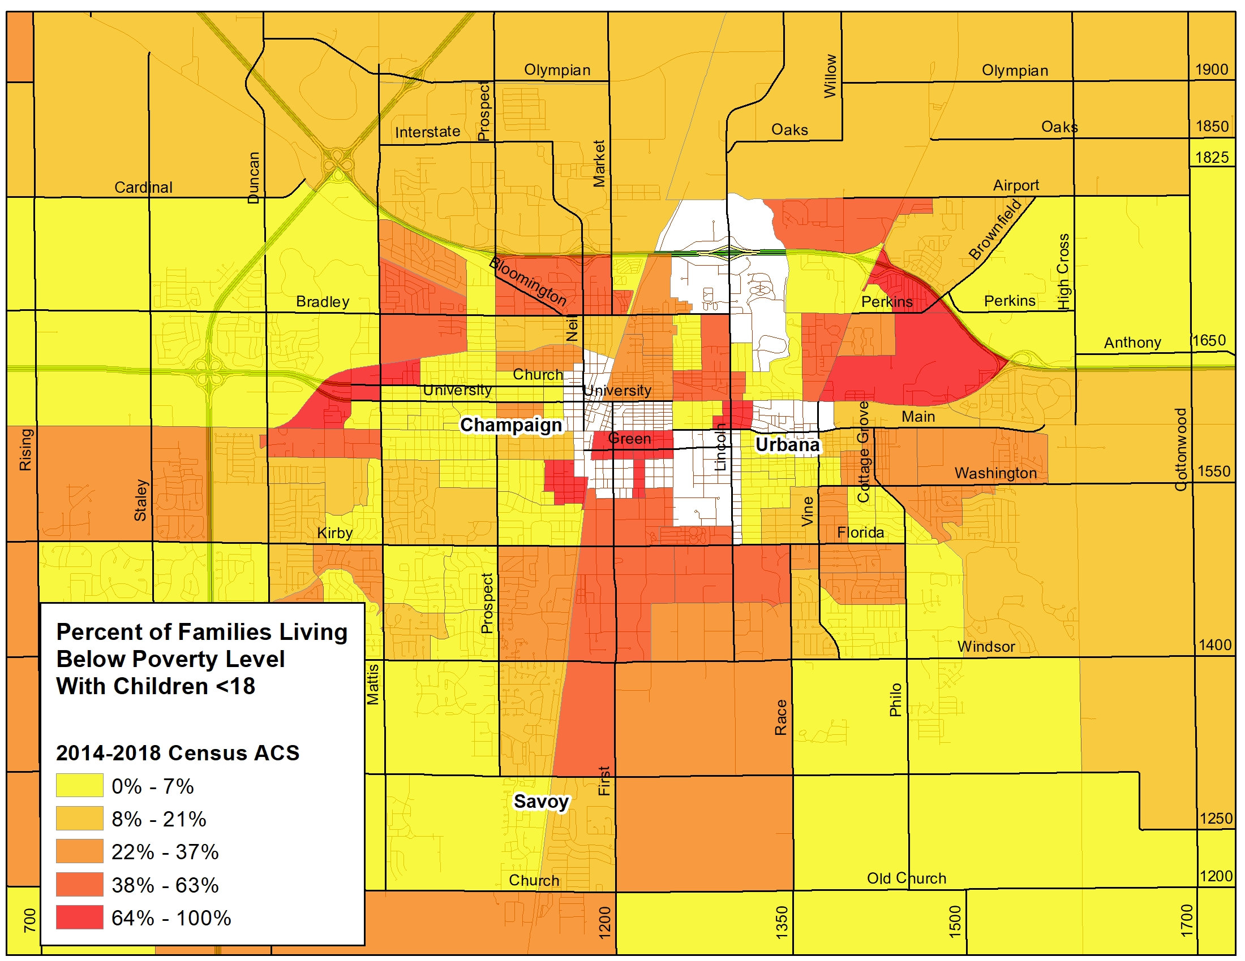

According to County Health Ranking, the 2019 ratio of dentists in Champaign County is 1 dentist to every 1,560 people living in the county. This is fewer dentists available than the state ratio of 1 dentist to every 1,280 citizens. However, the graph shows that the ratio of citizens to dentists is decreasing every year.

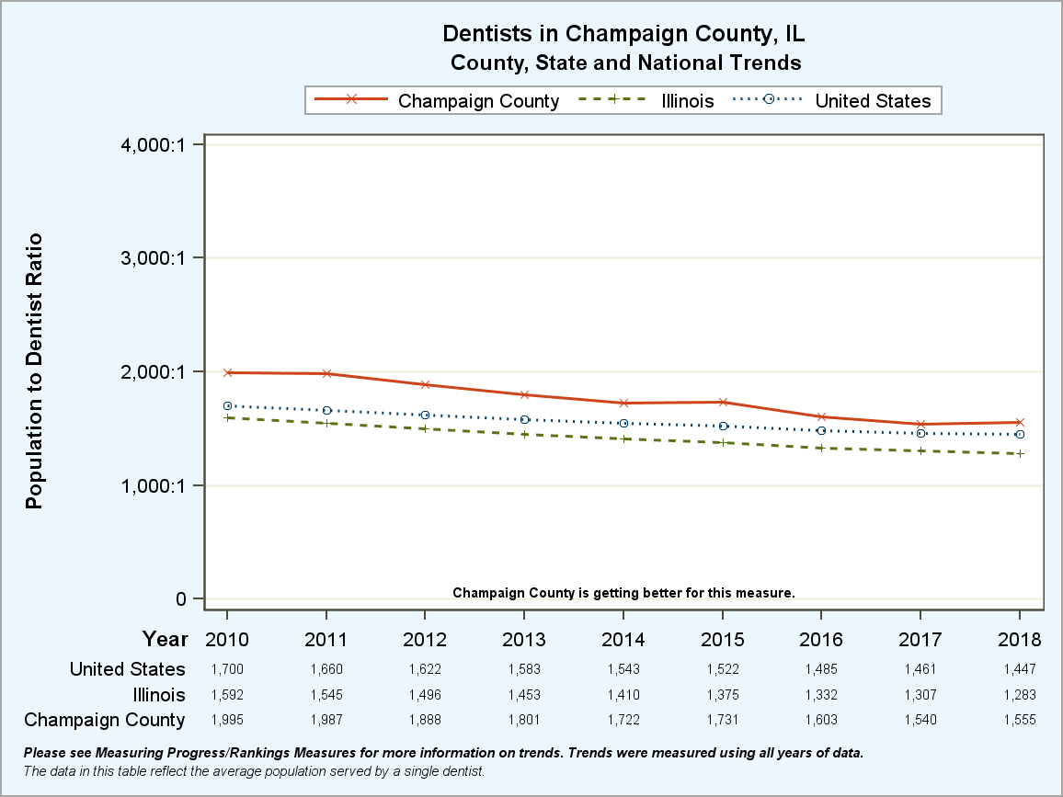
https://countyhealthrankings.org

According to County Health Rankings, the ratio of mental health providers per 100,000 has improved significantly over the past decade, moving from 2055:1 in 2010 to 440:1 in 2019; however, there was a slight decrease in the number of providers from 470:1 in 2018. The table below shows the ratio and number of mental health providers for Champaign County, the State of Illinois, and the U.S. in 2016.

Report Area | Estimated Population | Number of Mental Health Providers | Mental Health Care Provider Rate (Per 100,000 Population)
Champaign County | 209,689 | 445 | 212.2
Illinois | 12,671,821 | 23,090 | 182.2
United States | 330,069,263 | 643,219 | 194.9
Source: University of Wisconsin Population Health Institute and County Health Rankings 2019

Quality of Life

Champaign County residents report relatively good health and quality of life that closely resemble state averages.

Quality of Life - 2019 | Champaign County | Illinois
Poor or fair health | 16% | 17%
Poor physical health days | 3.9 | 3.8
Poor mental health days | 4.0 | 3.8
https://countyhealthrankings.org

Chronic Disease and Health Behaviors

Access to exercise opportunities continues to sit at 84%, 7% lower than Illinois. Sexually transmitted infections, food insecurity, and adult smoking are all higher in Champaign County than the State of Illinois overall.

Health Behaviors - 2018 | Champaign County | Illinois
Adult smoking | 16% | 15%
Adult obesity | 31% | 30%
Food environment index | 7.5 | 8.6
Physical inactivity | 22% | 22%
Access to exercise opportunities | 84% | 91%
Excessive drinking | 21% | 21%
Alcohol-impaired driving deaths | 26% | 32%
Sexually transmitted infections per 100,000 | 813.8 | 589.9
Food insecurity | 15% | 11%
Limited access to healthy foods | 4% | 4%
Motor vehicle crash deaths | 9 | 9
Drug overdose deaths | 14 | 21
https://countyhealthrankings.org

Access to exercise opportunities measures the percentage of individuals in a county who live reasonably close to a location for physical activity. Locations for physical activity are defined as parks (local, state, and national) or recreational facilities, which include gyms, community centers, YMCAs, dance studios, and pools. According to the County Health Rankings, 84% of Champaign County residents have adequate access to opportunities for physical activity. Illinois’ percentage is 89% and US Top Performers’ percentage is 91%. Having adequate access to opportunities for physical activity is defined as individuals who:

  - Reside in a census block within a half a mile of a park, or
  - In urban census tracks: reside within one mile of a recreational facility, or
  - In rural census tracts: reside within three miles of a recreational facility

The map below shows the percent of households with at least one member with a disability in Champaign-Urbana.

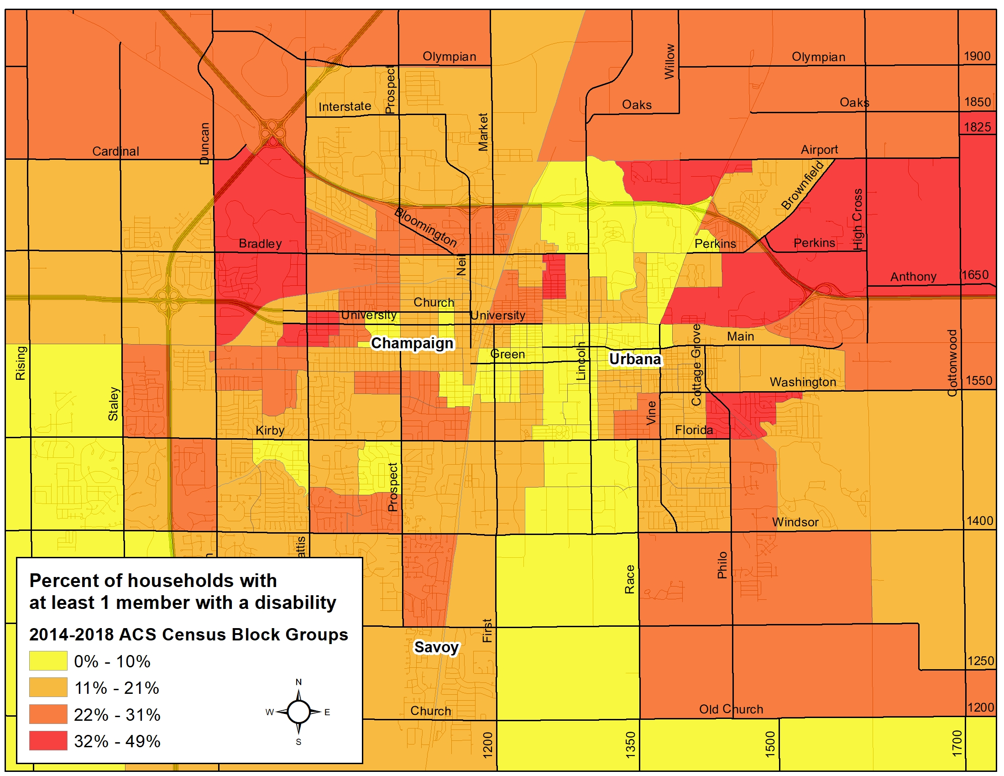

Infectious Disease

The table below shows communicable diseases in Champaign County and Illinois from 2013 to 2016.

 | 2013 | 2014 | 2015 | 2016
Hepatitis B
Illinois | 1,838 | 2,062 | 1,891 | 1,798
Champaign County | 27 | 34 | 36 | 39
Hepatitis C
Illinois | 6,819 | 8,933 | 8,696 | 9,066
Champaign County | 54 | 70 | 75 | 82
Influenza with Hospitalization
Illinois | 680 | 1,558 | 482 | 885
Champaign County | 4 | 15 | 4 | 3
Lyme
Illinois | 337 | 233 | 287 | 237
Champaign County | 5 | 7 | 4 | 6
Mumps
Illinois | 26 | 142 | 430 | 333
Champaign County | 3 | 18 | 203 | 112
Shigellosis
Illinois | 312 | 840 | 886 | 592
Champaign County | 2 | 3 | 71 | 6
Chicken Pox
Illinois | 731 | 596 | 443 | 469
Champaign County | 10 | 7 | 14 | 21
https://iquery.illinois.gov

Sexually Transmitted Infections

The table below shows sexually transmitted infections cases and rates for Champaign County and Illinois from 2013 to 2016.

 | 2013 | 2014 | 2015 | 2016
Chlamydia Champaign | 1,406 | 1,247 | 1,223 | 1,423
Chlamydia Illinois | 63,797 | 66,593 | 69,610 | 72,201
Gonorrhea Champaign | 395 | 380 | 315 | 364
Gonorrhea Illinois | 16,464 | 15,971 | 17,130 | 21,199
Primary and Secondary Syphilis Champaign | 6 | 6 | 9 | 16
Primary and Secondary Syphilis Illinois | 1,607 | 1,682 | 1,974 | 2,398
https://iquery.illinois.gov

Death, Injury, and Violence

The following maps look at the Life Expectancy from 2014-2019 for Champaign County.

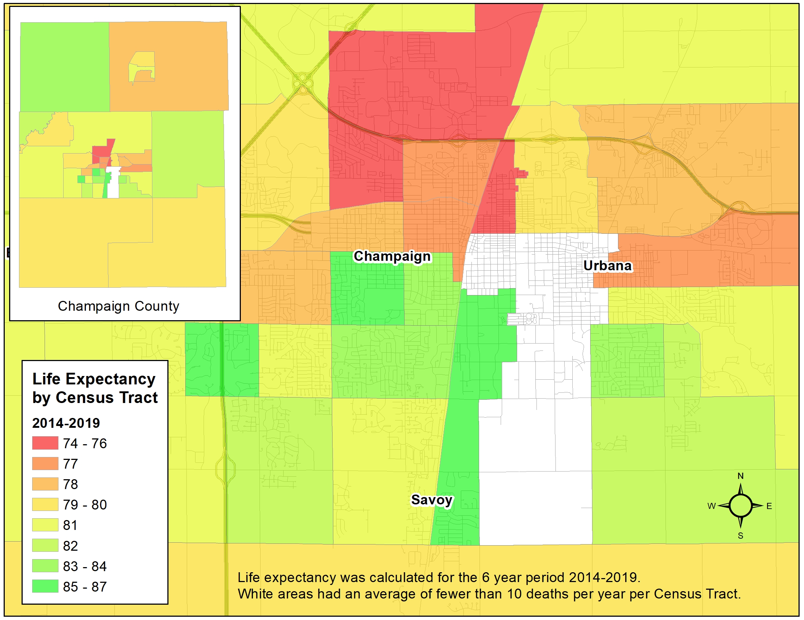

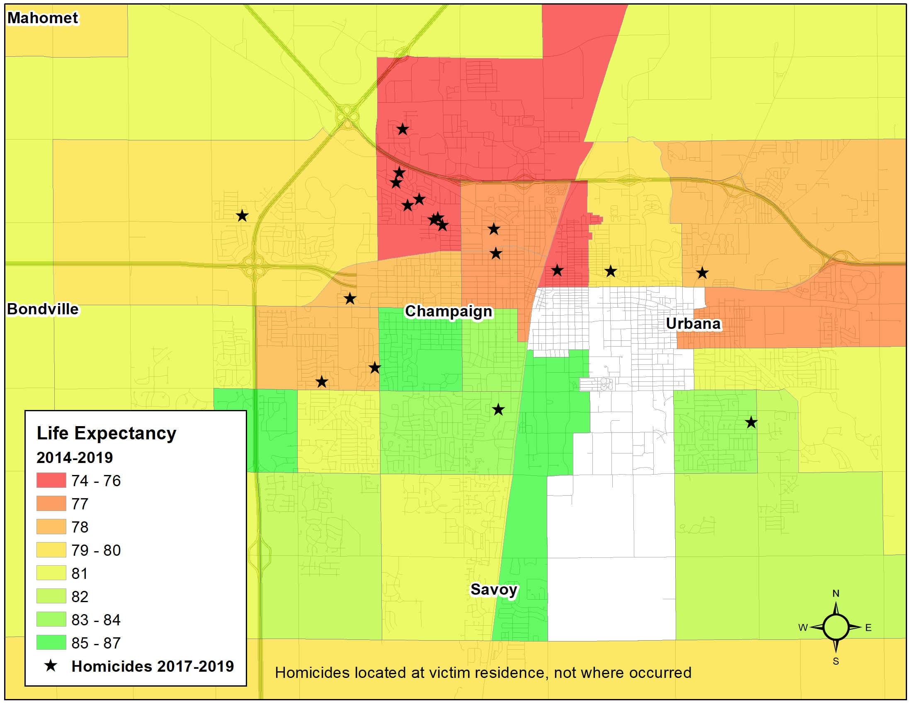
Champaign County crime rate has decreased over the last couple years but remains higher compared to the State of Illinois and surrounding counties. There are many factors that can contribute to crime in the community: poverty, substance abuse, lack of suitable employment, mental health, and other factors.

County or State | 2016 Rate | 2017 Rate | 2018 Rate
Champaign County | 3,322.0 | 2,982.8 | 2,586.0
State of Illinois | 2,418.9 | 2,337.4 | 2,555.5
Total crime rate per 100,000.
Source: Illinois State Police Crime Report 2017-2018

According to 2019 County Health Rankings the violent crime rate (the number of reported violent crime offenses per 100,000 population) is 487 which is substantially higher than the state of Illinois rate of 403. The table below shows the total crime index offenses for Champaign County from 2012-2015.

Champaign County | 2016 | 2017 | 2018 | % change from 2016 – 2018
Total Crime Index Offense | 6,981 | 6,279 | 5,421 | 22.3% Decrease
Criminal Homicide | 11 | 6 | 10 | 9.1% Decrease
Forcible Rape | 128 | 145 | 164 | 28.1% Increase
Robbery | 211 | 190 | 158 | 25.1% Increase
Aggravated Assault/Battery | 681 | 608 | 621 | 8.8% Decrease
Burglary | 1,444 | 952 | 743 | 48.5% Decrease
Theft | 4,260 | 4,154 | 3,545 | 16.8% Decrease
Motor Vehicle Theft | 220 | 190 | 158 | 28.2% Decrease
Arson | 26 | 34 | 22 | 15.4% Decrease
Source: Illinois State Police Crime Reports, 2016-2018

Death Rates in Champaign County

In 2018, the leading causes of death nationwide in decreasing number of deaths are heart disease, cancer, accidents, chronic lower respiratory diseases, stroke, and Alzheimer’s disease. The leading causes of death in Champaign County are similar, although there are a few differences. Below are listed the leading causes of death from 2015 to 2018 in Champaign County.

Crude Death Rate per 100,000 people in Champaign County

Causes | 2015 | 2016 | 2017 | 2018
Heart Disease | 105.3 | 133.7 | 133.5 | 125.8
Cancer | 129.8 | 132.2 | 147.3 | 121.9
Accidental (Unintentional) | 13.4 | 39.0 | 40.4 | 46.7
Stroke | 37.3 | 31.4 | 25.2 | 27.1
Chronic Lower Respiratory Disease | 8.1 | 37.1 | 32.3 | 43.3
Alzheimer disease | 34 | 26.2 | 35.2 | 37.6
Diabetes | 37.8 | 6.7 | 11.9 | 15.2
Kidney Disease | 9.6 | 10.0 | 10.9 | 20.0
Influenza and Pneumonia | 34.9 | 10.5 | 16.1 | 13.8
Septicemia | 12.9 | 14.3 | 8.5 | 4.3
All causes | 601.4 | 623.7 | 650.1 | 650.2

Source: Illinois Department of Public Health Vital Statistics

- In 2018, 125.8 per 100,000 people in Champaign County died due to heart disease. In comparison, Illinois’ heart disease mortality rate was 214.5 per 100,000 people, or about 88.7 per 100,000 more than the Champaign County rate.
- The leading cause of death in Champaign County from 2016 to 2018 was heart disease. In 2015, Cancer was the leading cause of death in Champaign County with a rate of 129.8 per 100,000 populations.
- According to Census data, the Champaign County suicide rate in 2018 was 12.9 per 100,000 which is higher than the state of Illinois rate of 10.3 but lower than the national rate of 13.4.
- Alcohol-impaired driving deaths in Champaign County have more than doubled to 32% since 2015 and is higher than both the state and national percentages.

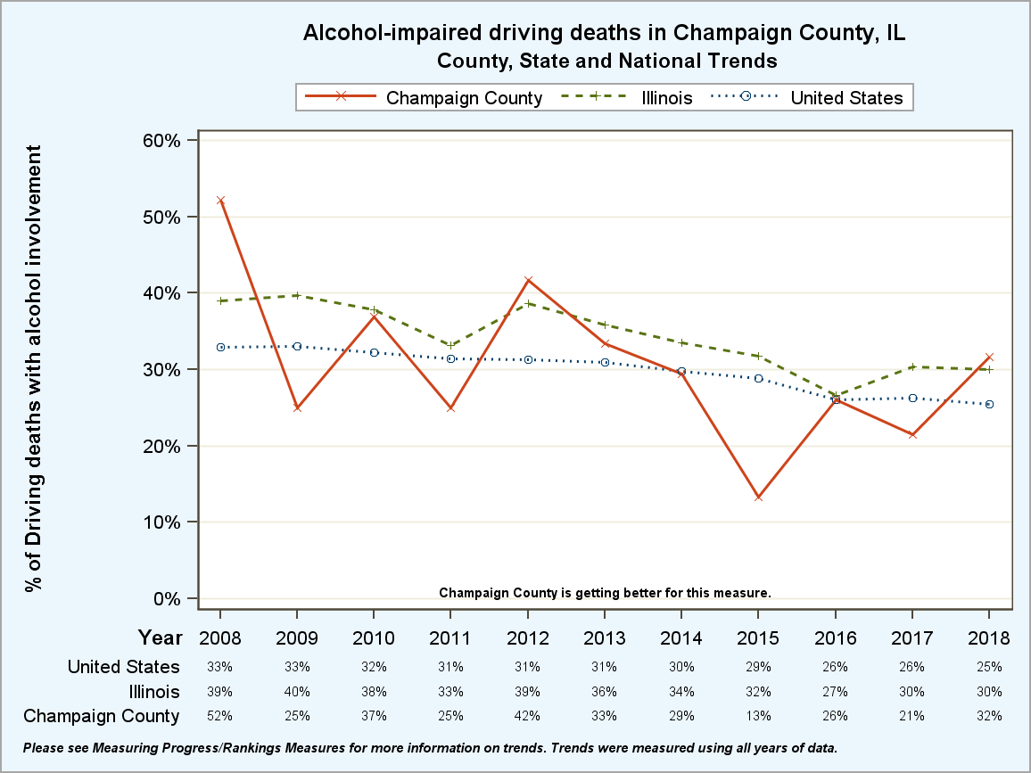
2019 County Health Rankings

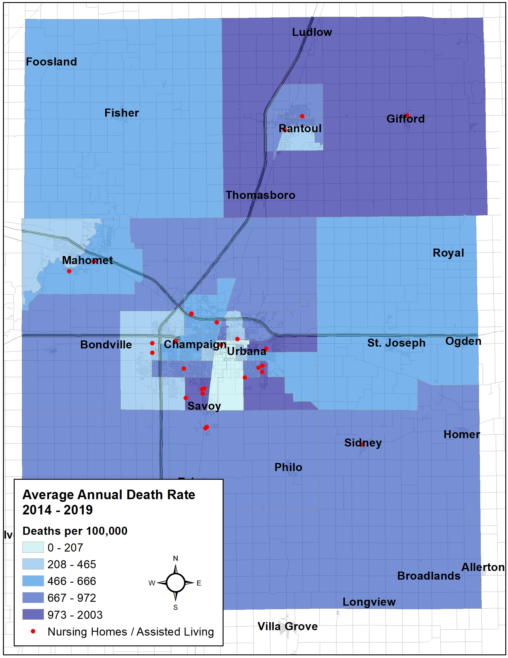
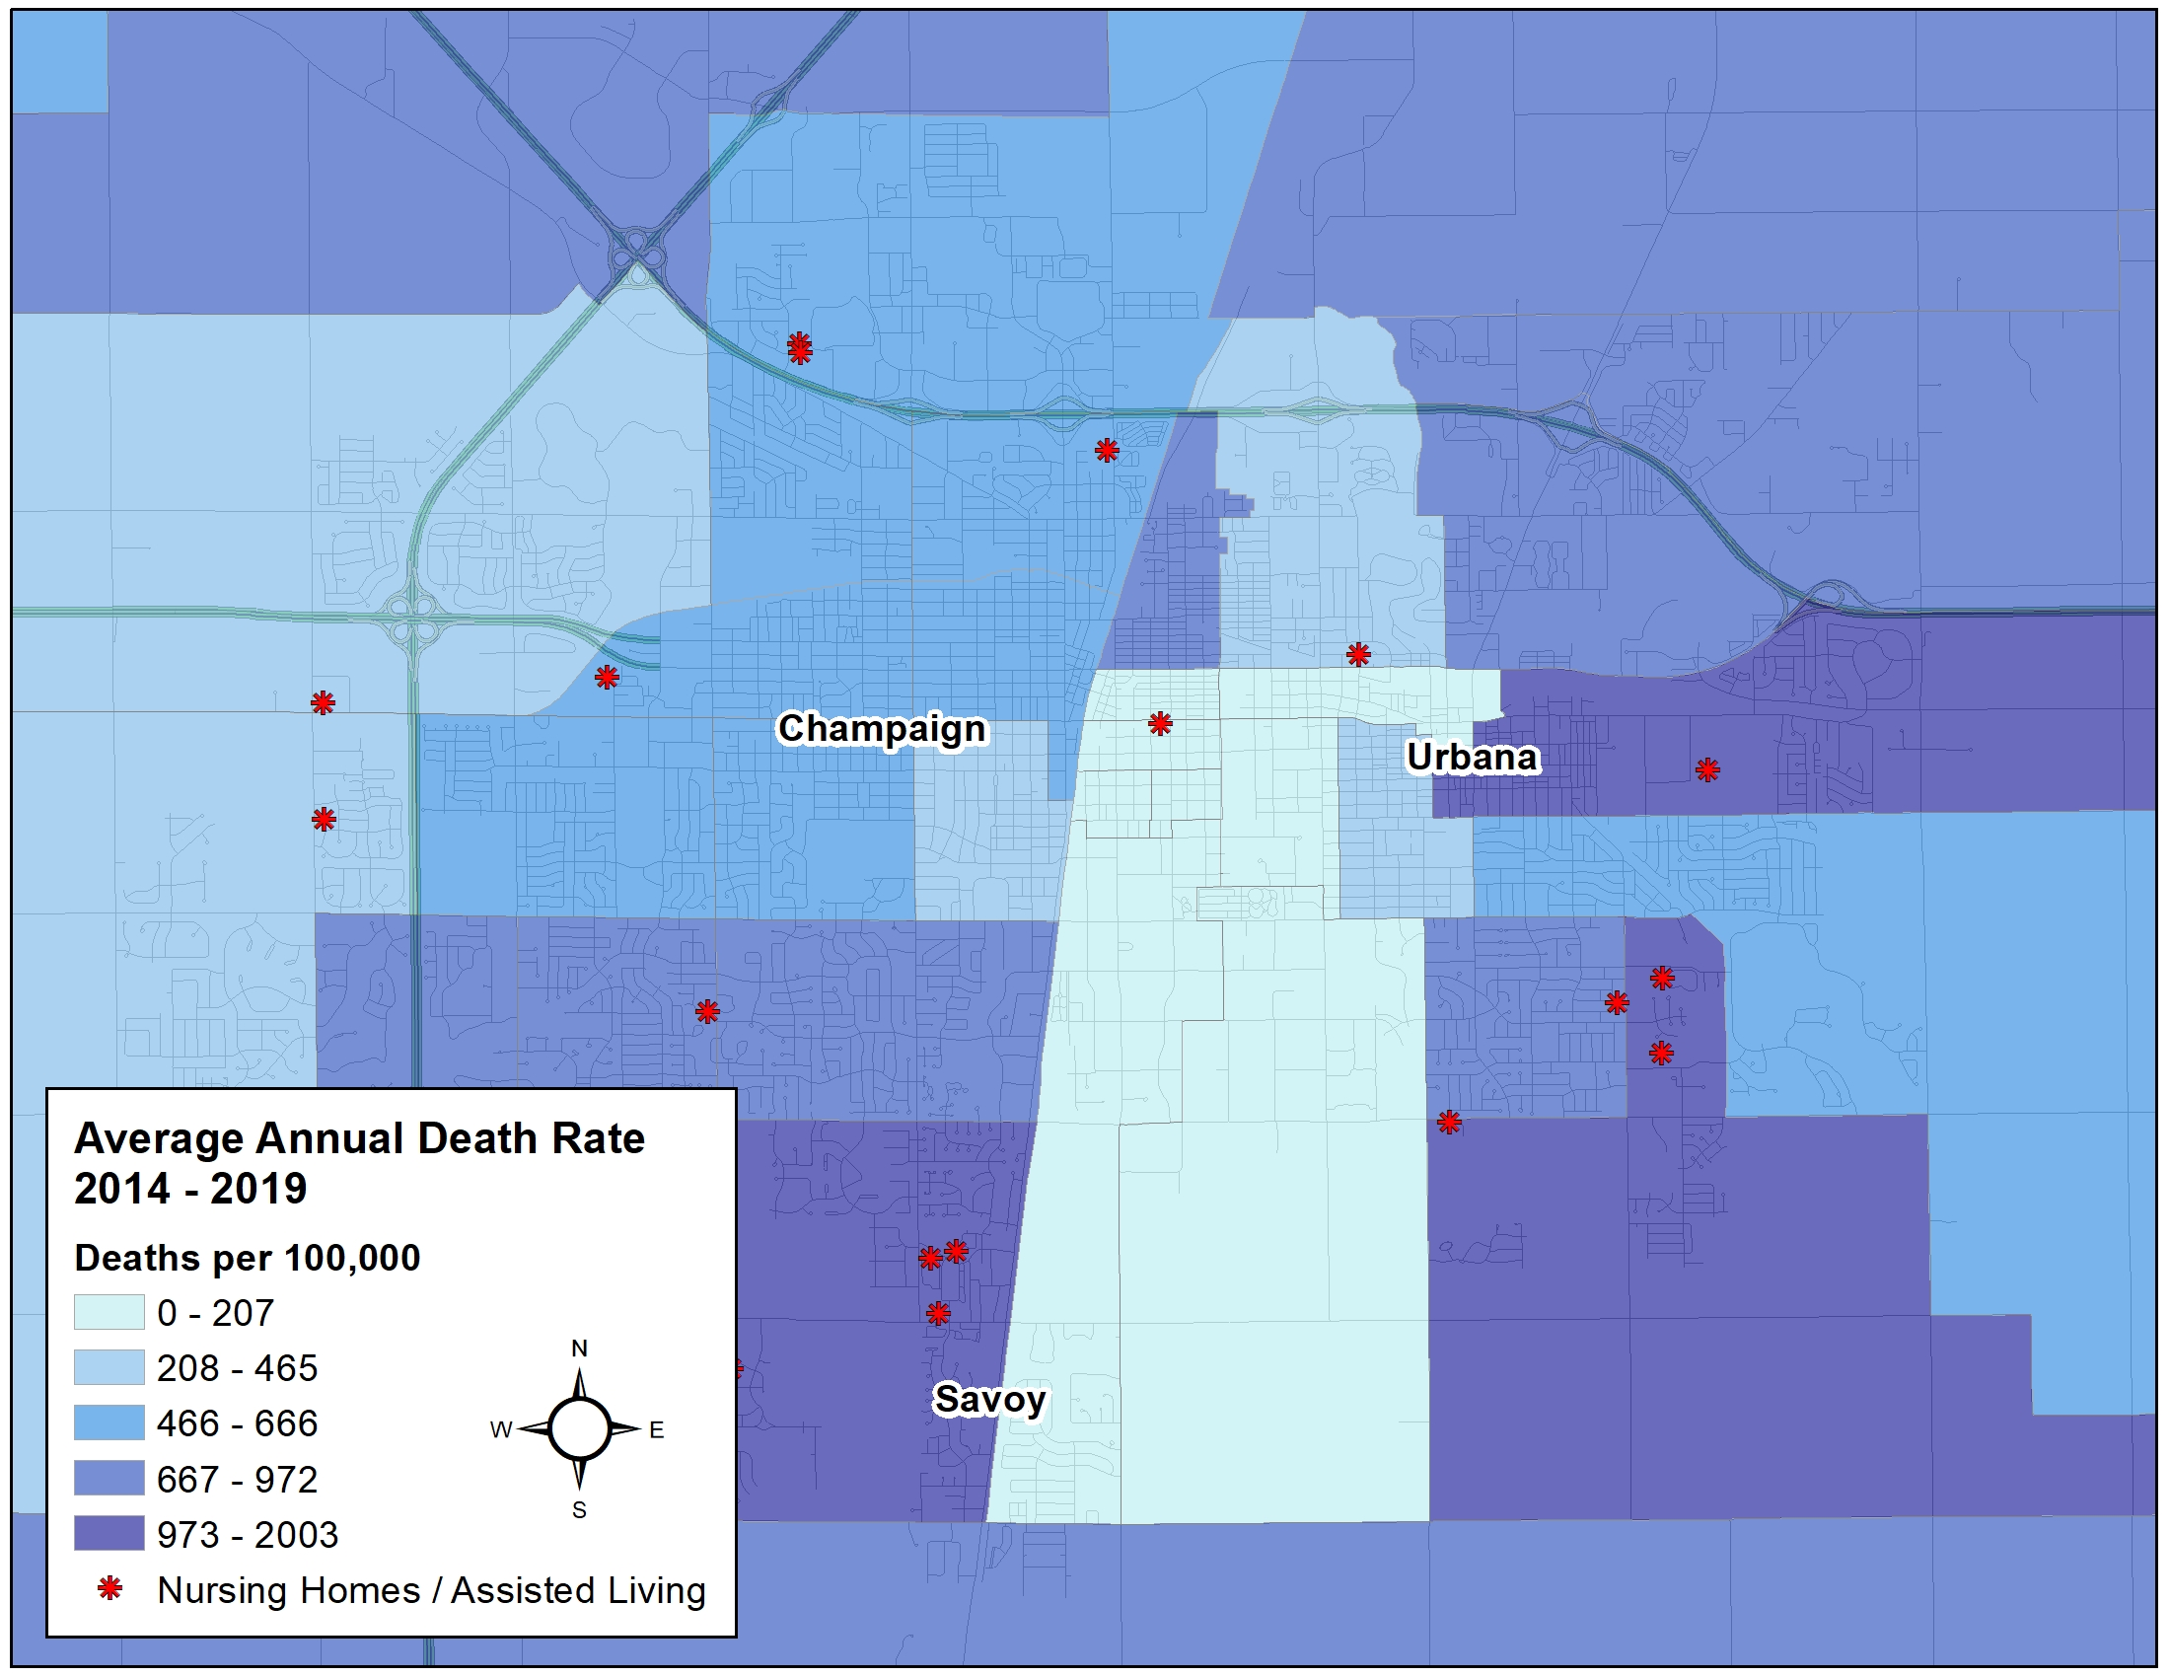

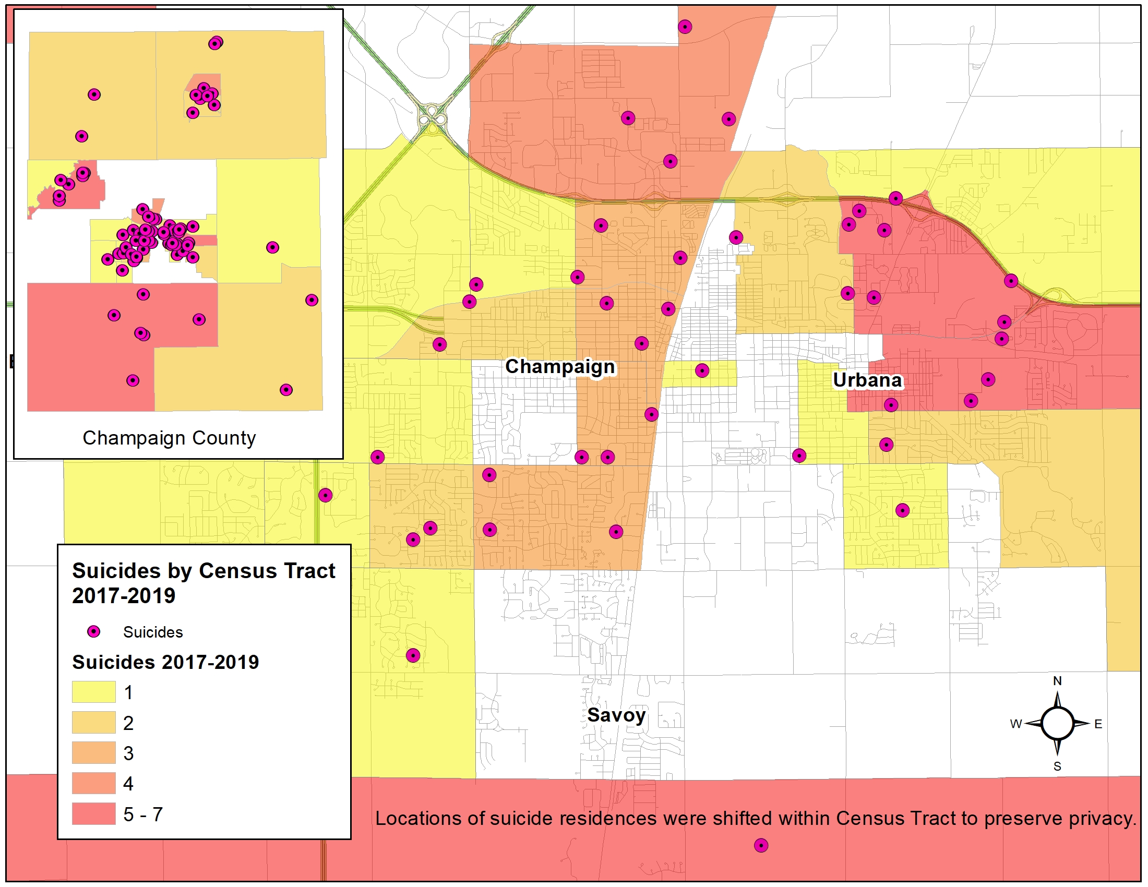

Drug-related Deaths in Champaign County, 2011-2015

According to the death certificate data compiled by Vital Records, Champaign-Urbana Public Health District, there were 262 drug-related deaths for the five-year period 2015-2019. Of these deaths, 198 were residents of Champaign County and those are the ones included in this analysis.

2015 | 2016 | 2017 | 2018 | 2019
52 | 26 | 33 | 36 | 51

One hundred forty-one of the deaths (71%) were in white individuals, and 54 (27%) in Black individuals. Over 71% were male, and 29% were female. Ages of those who had drug-related deaths were from 11 days old to 73 years old.

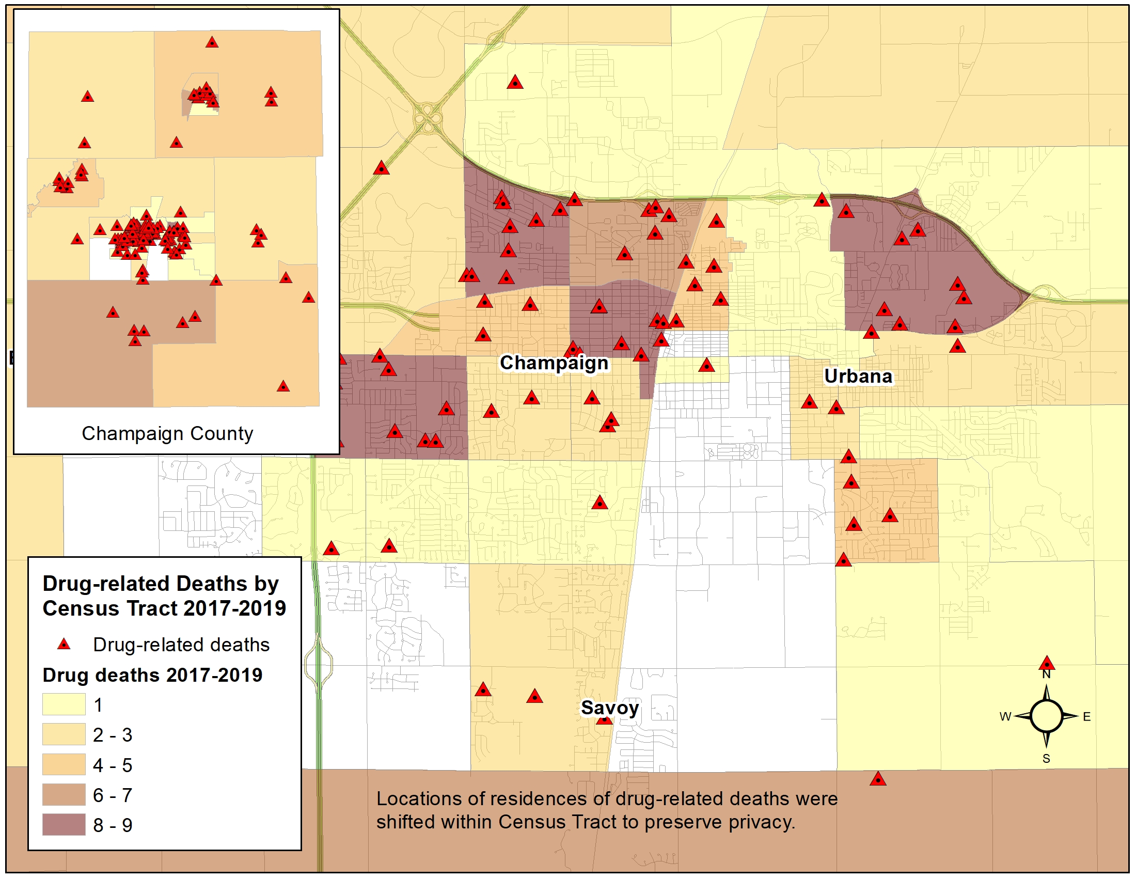

Gun Related Deaths in Champaign County
The table below shows the gun-related deaths in Champaign County from 2015 to 2019.

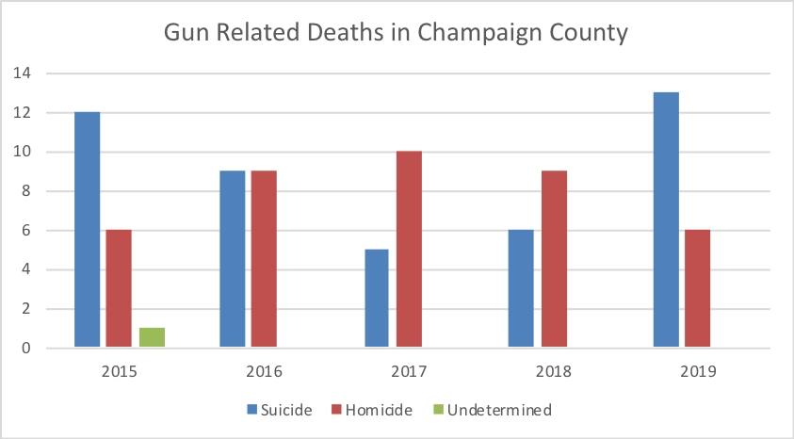
Champaign-Urbana Public Health District Death Certificates

Maternal and Child Health

The teen birth rate (per 1,000 female population, ages 15-19) is 13 newborns. Child and Infant mortality are higher for Champaign County than for the State of Illinois.

Maternal Child Health Indicators - 2018 | Champaign County | Illinois
Teen birth Rate (per 1,000 female population ages 15-19) | 13 | 21
Low birth weight | 8% | 8%
Infant mortality (within 1 year, per 1,000 live births) | 7 | 6
Child mortality (among children under age 18 per 100,000) | 70 | 50
https://countyhealthrankings.org

Environmental Health

Champaign County has more air pollution and severe house problems compared to the State of in Illinois. However, residents of Champaign county are more likely to carpool.

Physical Environment - 2014 | Champaign County | Illinois
Air pollution - particulate matter | 11.8 | 11.5
Severe housing problems | 20% | 17%
Driving alone to work | 70% | 73%
Long commute - driving alone | 13% | 41%
https://countyhealthrankings.org

II. Community Themes and Strengths Assessment

The Community Themes and Strengths Assessment (CTSA) evaluates what is important to our community, how quality of life is perceived, and what assets we have that can be used to improve community health. This assessment highlights what issues in the community are particularly important or concerning.
Methodology
We conducted the Champaign County Community Health Survey by gathering feedback from residents with surveys. Due to the Coronavirus pandemic, the survey was conducted exclusively online through Survey Monkey; residents were surveyed from March 2020 to July 2020, with 634 total surveys completed. While the data-collection efforts attempted to stratify by zip code, race, ethnicity, income, and age, due to the COVID-19 pandemic, face-to-face interactions and paper surveys typically collected in underserved areas was not possible. Consequently, demographic representation reflective of U.S. Census data was not achieved. While bivariate correlations were able to find some statistically significant relationships between demographics and variables of interest, findings, in general, should be interpreted with caution.
Demographics of Survey Respondents
Participants were asked to give their age. To categorize this question, they were grouped by age. Slightly less than 30% of participants were between the ages of 30 and 39. Only .22% of respondents were below the age of 20.
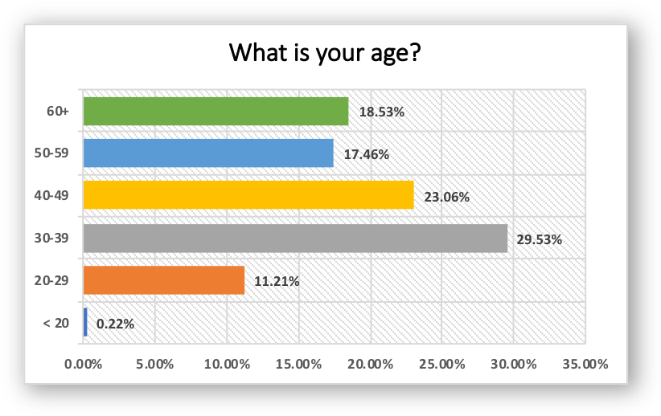
Participants were asked to give their race. Slightly less than 90% are white and 5.38% are black/ African American.
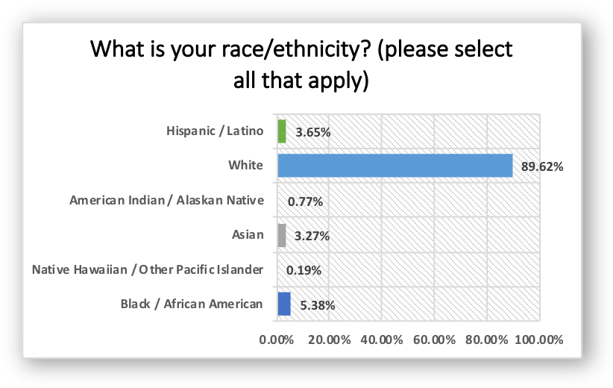
Of the total participants, 83.46% responded they were female and 13.27% responded they were male.
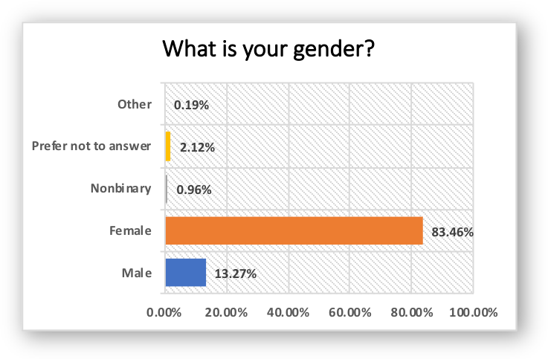

The most common number of people living in a household in Champaign County is two, with 37.72% of participants selecting this option. The least likely is 5 or more.
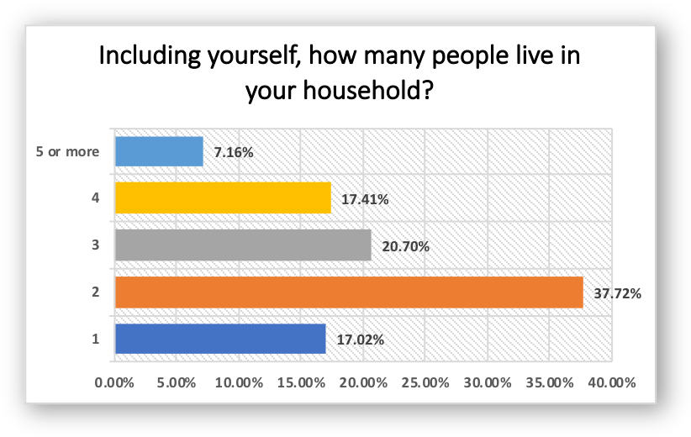
The survey had most participants from the zip code 61822 and 61821.
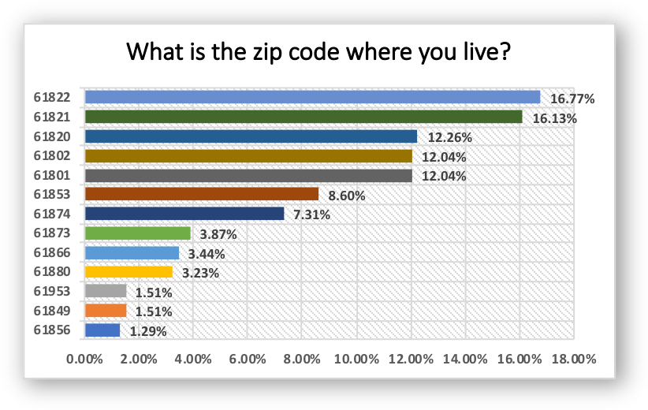

Participants were asked to identify their household income. Of the participants, 56.35% make $65,000 or more, while 12.69% make less than $40,000.
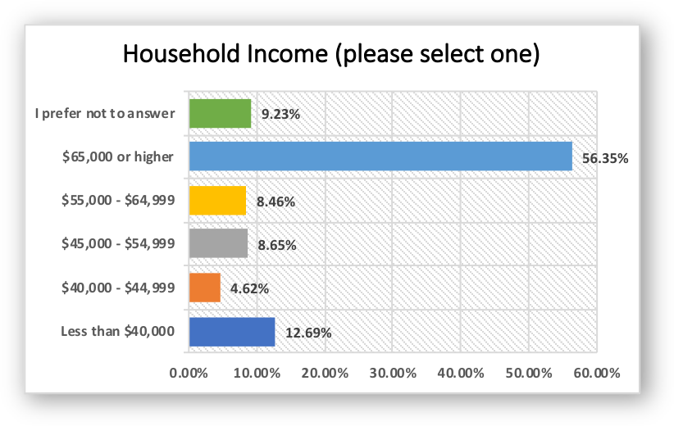
Participants selected their highest level of education. Slightly less than 40% earned a graduate degree or higher, while less than one percent of participants did not earn their high school diploma.
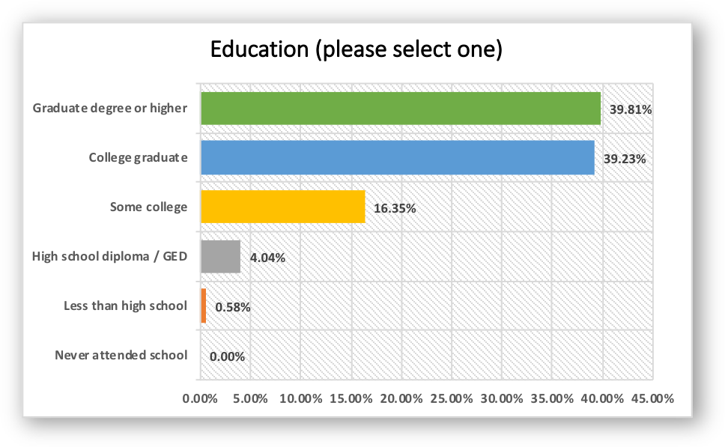

Neighborhood Safety Concerns
Participants were asked to select their safety concerns in Champaign County. The biggest concern selected is the traffic speeds while the lowest selected concern is gang activity.
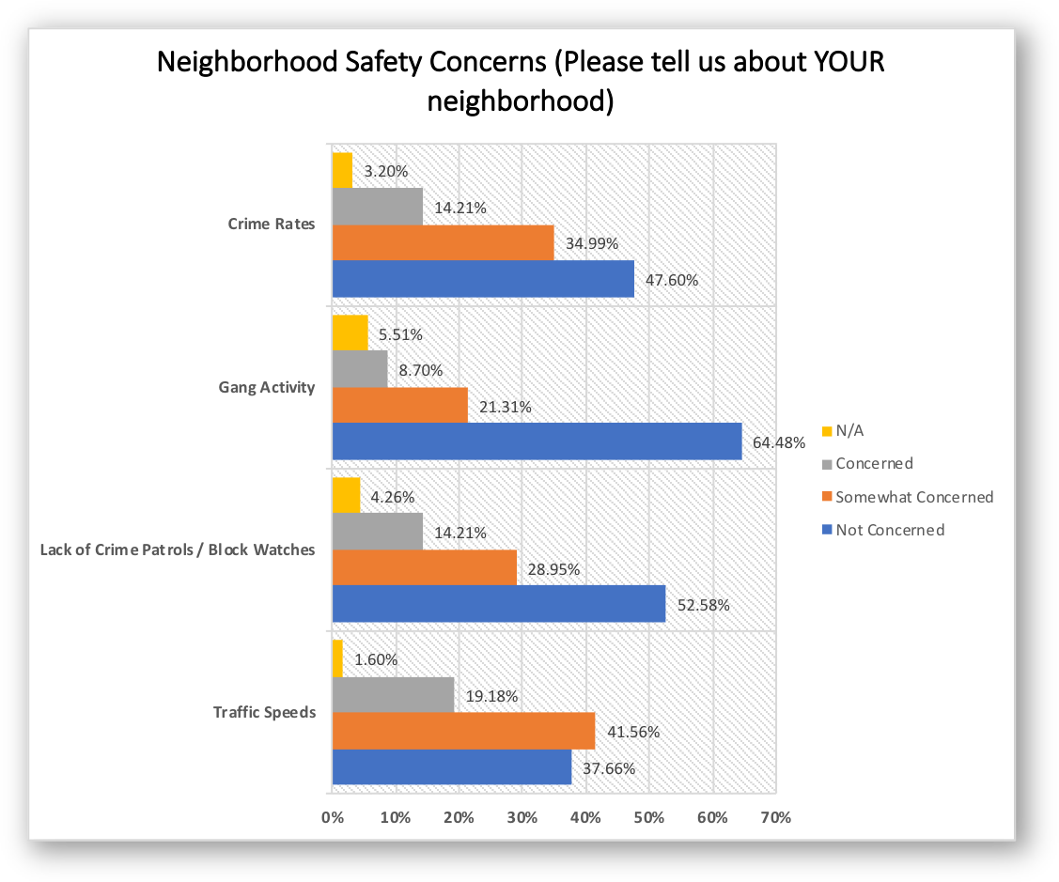

Next, participants were asked to rate their concerns regarding traffic and roads. Access to sidewalks and to public transportation were selected as the highest quality options, while bike paths and low vision accessibility were selected the most for improvement.
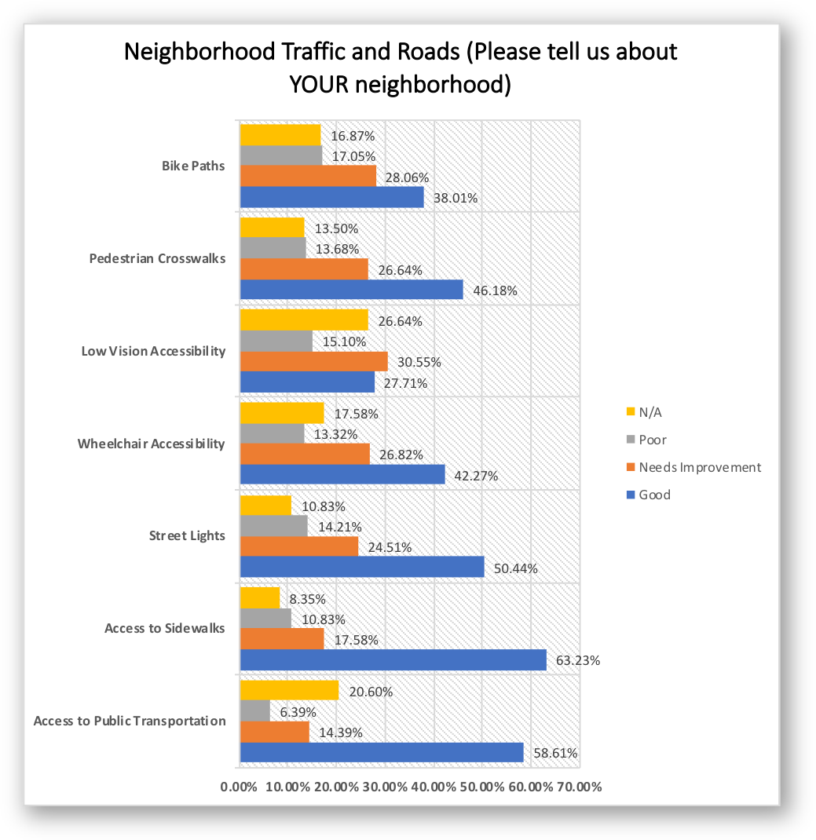

Community Satisfaction
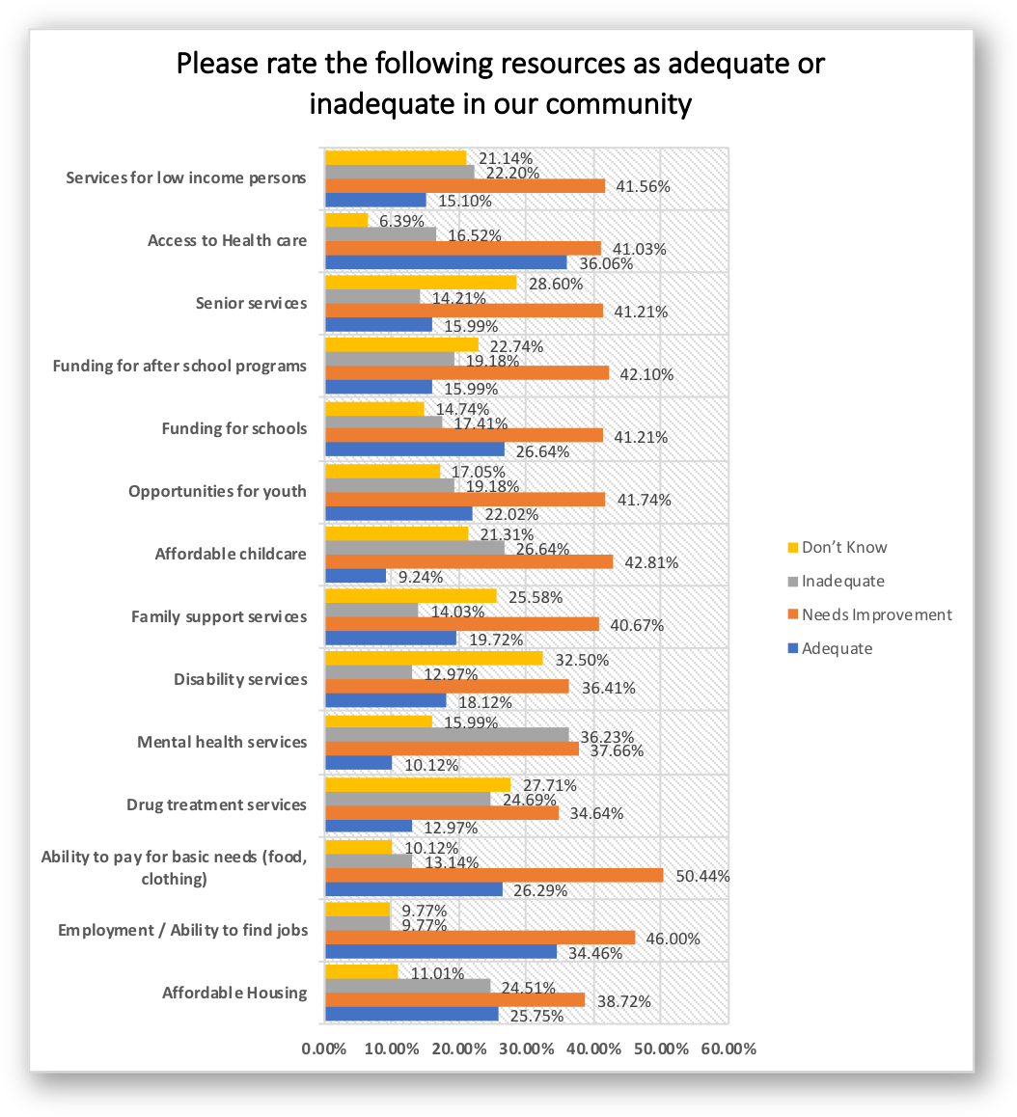
Participants rated various community resources as very adequate, adequate, inadequate, or very inadequate in their community. The top three adequate resources were access to healthcare, employment/ability to find jobs, and funding for schools. The top three resources rated as the most inadequate were mental health services, affordable childcare, and drug treatment services.
Health Behaviors
Participants were asked about their everyday behaviors. Over 30% of the participants responded that they exercise (for at least 30 minutes a day) less than once per week. Other data regarding health behaviors can be found in the graph below.
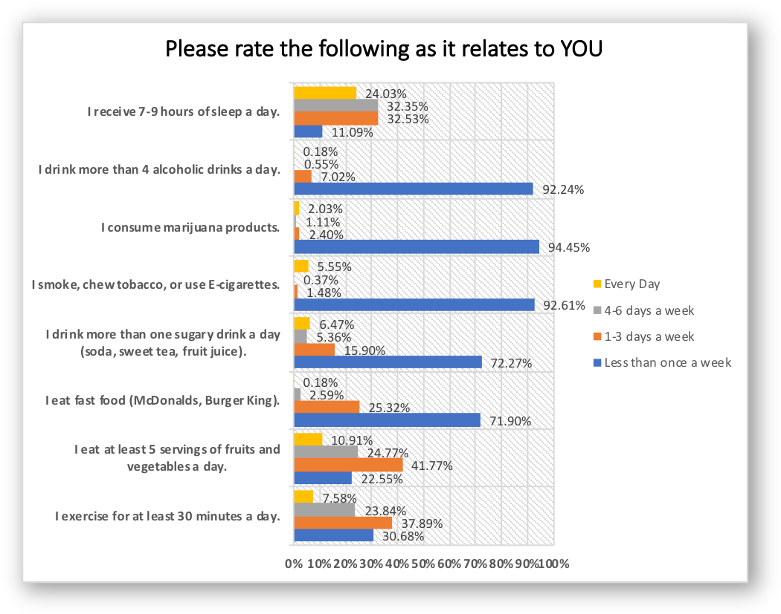
Social/Demographic Determinants Related to Health Behaviors
Multiple characteristics show significant relationships with health behaviors. The following relationships were found using correlational analyses:
Sleep tends to be higher for more educated people.
Alcohol consumption shows not significant correlations.
Marijuana usage tends to be higher for those with less education and those with lower income.
Tobacco usage/E-cigarettes tends to be higher for those with less education.
Sugary beverage consumption tends to be higher for young people, Black people and those with lower income and lower education.
Frequency of fast food tends to be higher for younger people. Frequency of fast food tends to be lower for White people, those with higher income and those with more education
Consumption of fruits and vegetables tends to be higher for those with more education and those with higher income.
Exercise tends to be higher for those with higher income and more education. Exercise tends to be lower for Latino people.

Participants could select if they have been affected by any of the behaviors listed below. For respondents, 6.47% said because of a physical, mental, or emotional condition, they have serious difficulty concentrating, remembering, or making decisions. The least selected behavior was that a participant is blind or has serious difficulty seeing even when wearing glasses. 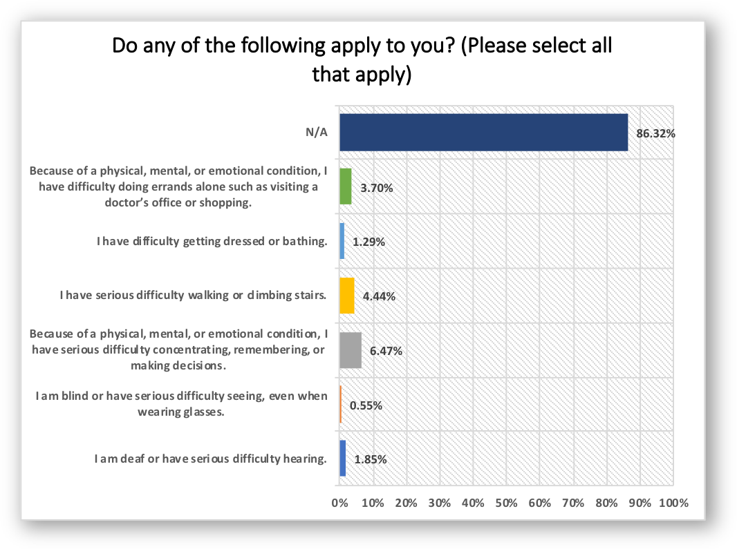

Social/Demographic Determinants Related to Physical, Mental and/or Emotional Challenges
Multiple characteristics show significant relationships with physical, mental or emotional challenges. The following relationships were found using correlational analyses:
The only significant correlations for the possible attributes listed in the graph above were found for situations where a respondent experiences difficulty with physical, mental and/or emotional challenges when trying to remember/make decisions or successfully performing typical daily tasks like running errands, going to the doctor or shopping. Specifically, people are more likely to experience challenges if they are non-White, and have low income.
Health Care and Dental Care

Participants were given options to identify where they receive health care. The most used facility is Carle Clinic with 70.24% of participants identifying this facility for their primary health care needs. The second highest selected is Christie Clinic, which was selected by 21.44% of participants.
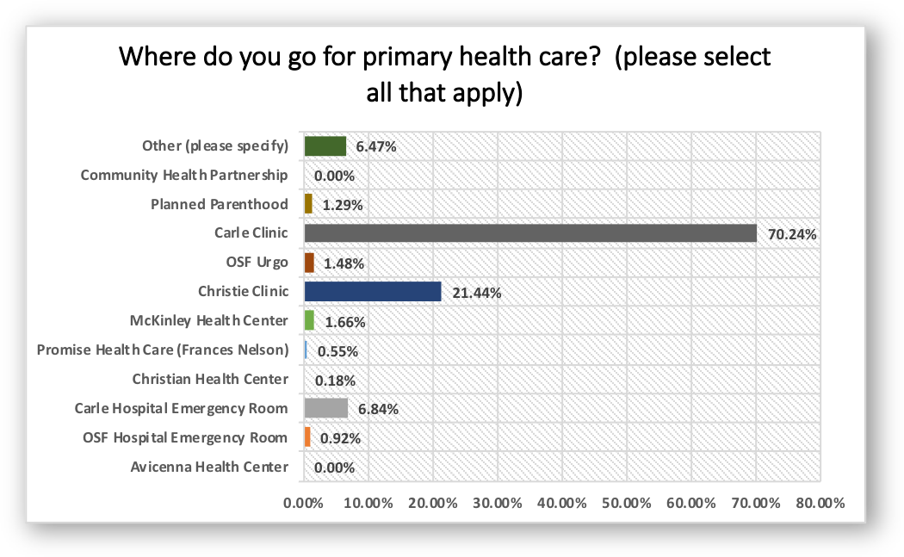

When asked if participants have a primary care physician, almost 90% responded with yes.
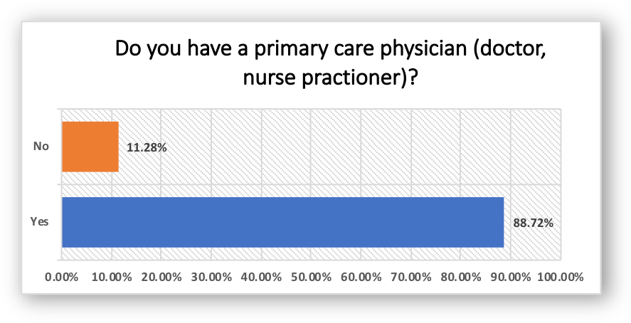

Social/Demographic Determinants Related to Having a Primary Physician
Multiple characteristics show significant relationships with having a primary physician. The following relationships were found using correlational analyses:
Having a primary physician tends to be higher for older people, women, and White people.

Participants were then asked how long it has been since their last routine checkup at a doctor’s office. Almost 70% of participants responded that they have had a checkup within the past year. Slightly less than 5% responded that it has been more than five years since their last routine checkup.
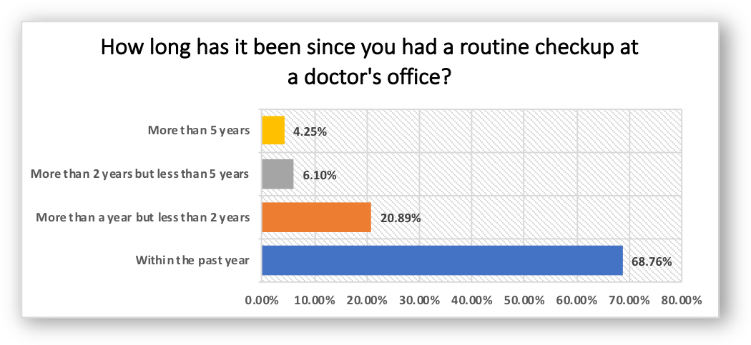
Social/Demographic Determinants Related to Routine Checkup
There were no social or demographic determinants related to frequency of a routine checkup at a doctor’s office.

The participants were asked how they pay for their health care. Almost 90% pay for their health care with private insurance. Over 5% pay with Medicare. Only .55% responded that they do not have health insurance.
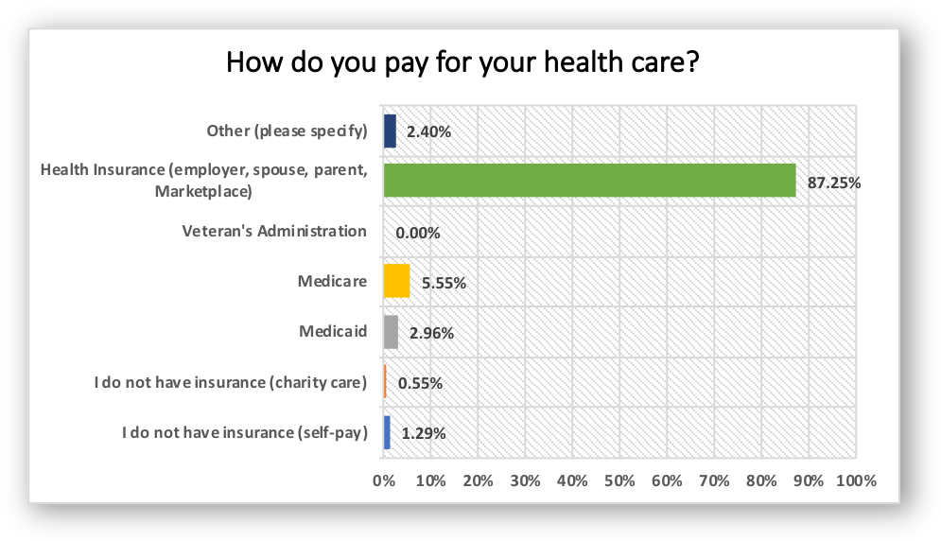
Social/Demographic Determinants Related to Type of Insurance
Multiple characteristics show significant relationships with how people pay for healthcare. The following relationships were found using correlational analyses:
Use of private insurance tends to be higher for younger people, women, White people, more educated people and those with higher income.
Use of Medicare tends to be higher for older people, and White people.
Use of Medicaid tends to be higher for Black people, less educated people and those with lower income.

Participants were given options of dental-care facilities used in Champaign County. The most commonly used facility is private dentist office, with almost 90% of participants selecting this option for dental needs.

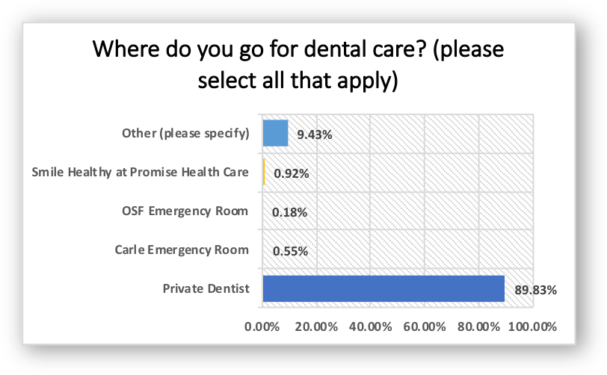
Social/Demographic Determinants Related to Private Dentist
Multiple characteristics show significant relationships with those that use a private dentist. The following relationships were found using correlational analyses:
Use of a private dentist tends to be higher for women, White people, those with higher income and more education.
Note due to response rates, none of the other sources could be assessed.

When asked if participants had a dentist, slightly over 80% responded with yes.
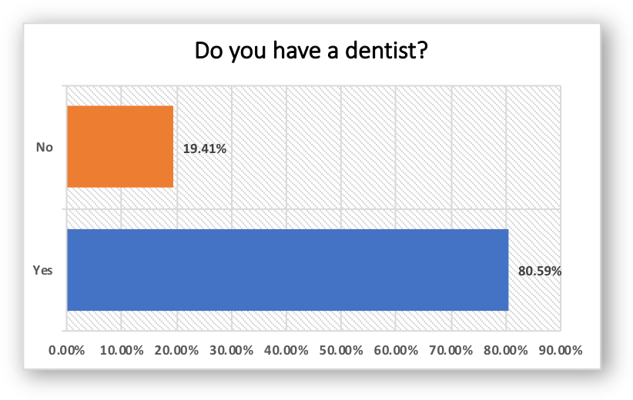
Social/Demographic Determinants Related to Having a Dentist
Multiple characteristics show significant relationships with having a dentist. The following relationships were found using correlational analyses:
Having a dentist tends to be higher for women, White people, those with higher income and more education.

Then, participants were asked how long it has been since their last routine check-up at a dental office. Slightly over 66% of participants responded that they have been within the past year. Slightly less than 10% responded that it has been more than five years since their last routine check-up.
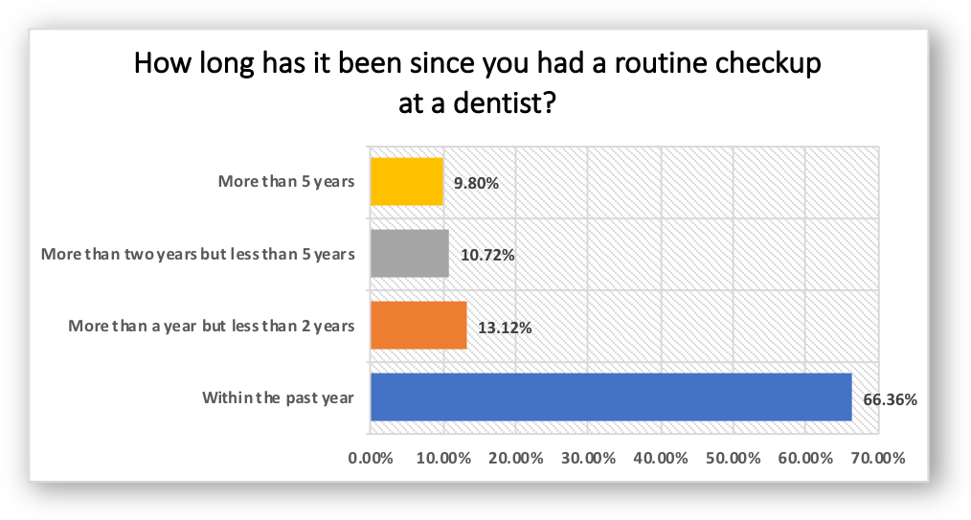

Social/Demographic Determinants Related to Frequency of Dental Checkup
Multiple characteristics show significant relationships with frequency of dental checkups. The following relationships were found using correlational analyses:
Frequency of dental checkup tends to be higher for White people, those with higher income and those with more education. Frequency of dental checkup tends to be lower for Black people.

Participants were asked to give their satisfaction with the quality and accessibility of the dental care and health care in Champaign County. For both health care and dental care, less than 15% of participants were dissatisfied on the quality of health care and dental care. However, over 25% of participants responded that they were not satisfied with the access to affordable health care and dental care.
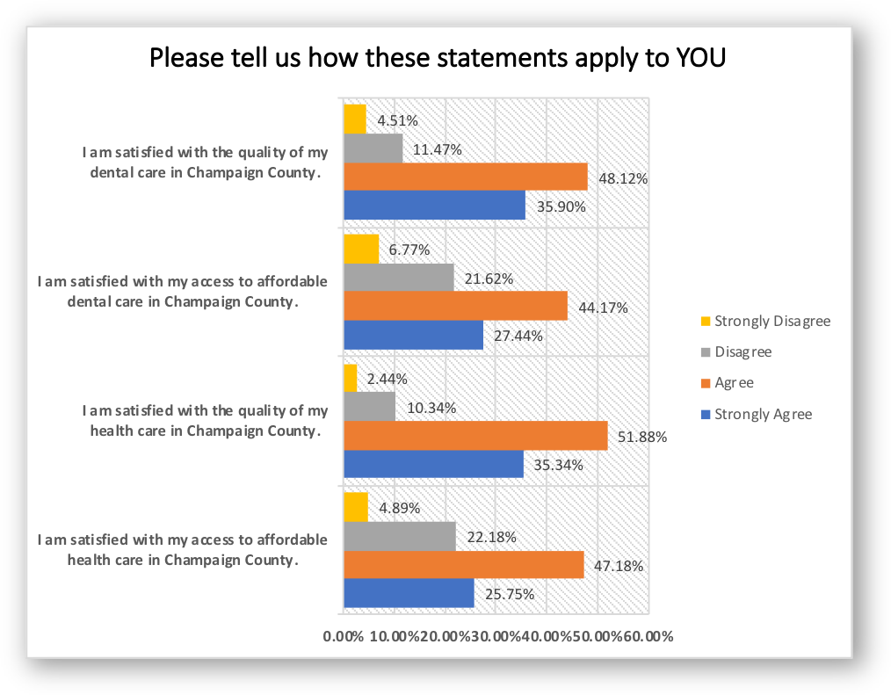

Community Health Concerns
Participants were asked to select the top five health concerns they believed were most important in Champaign County. The top five health concerns identified are mental health, child abuse and neglect, gun violence, infectious diseases, and senior/ aging challenges. The lowest concern is dental problems. Mental health was found to be significantly higher than any other factor based on t-tests.
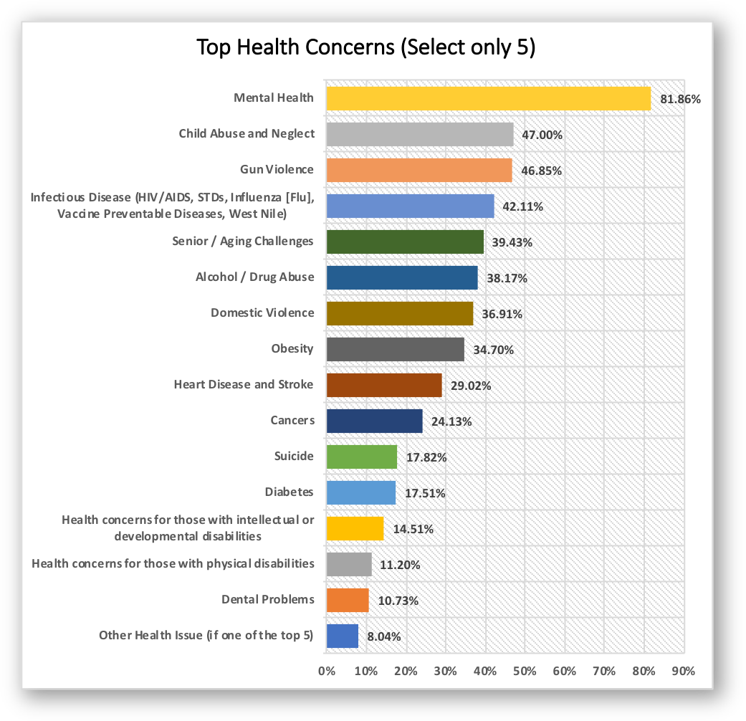

Food Accessibility
Most survey respondents get food from the grocery store. Less than half a percent of the participants get food from a soup kitchen.
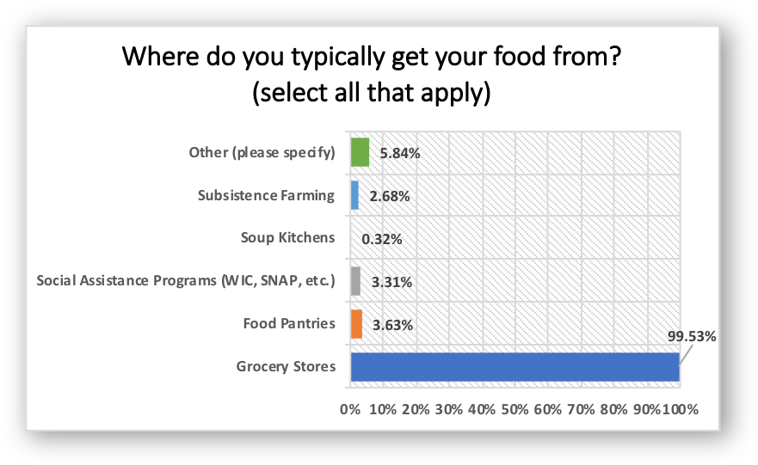
Social/Demographic Determinants Related to use of Grocery Stores
Multiple characteristics show significant relationships with use of grocery stores. The following relationships were found using correlational analyses:
Use of grocery stores tends to be lower for Latino people.

Participants were asked if they qualify for food access programs. Slightly over 94% responded that they do not. The food access program selected most was SNAP/Food Stamps at 2.88%.
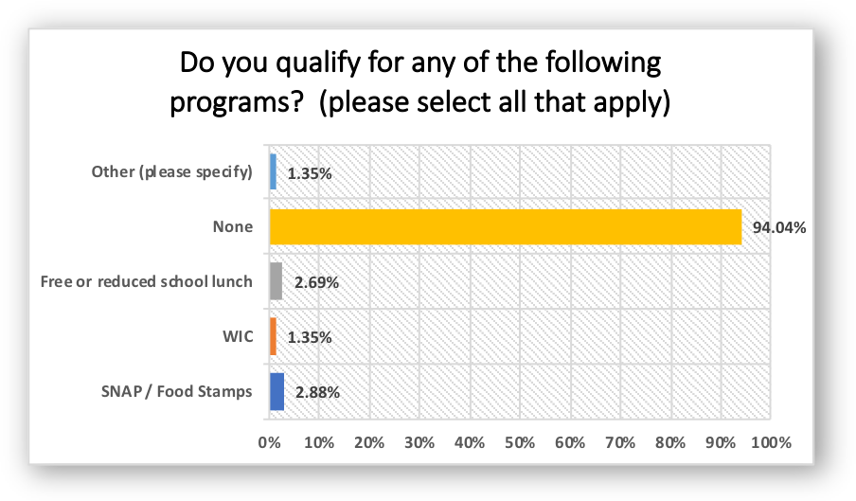
Social/Demographic Determinants Related to Qualifying for Food Access Programs
Multiple characteristics show significant relationships with qualifying for food access programs. The following relationships were found using correlational analyses:
Qualifying for food access programs (including WIC, SNAP, and free lunch) tends to be rated higher for younger people, Black people, Latino people, less educated people, and those with lower income.

Over 12% of participants responded there were times when they ran out of food before they had the means to buy more.
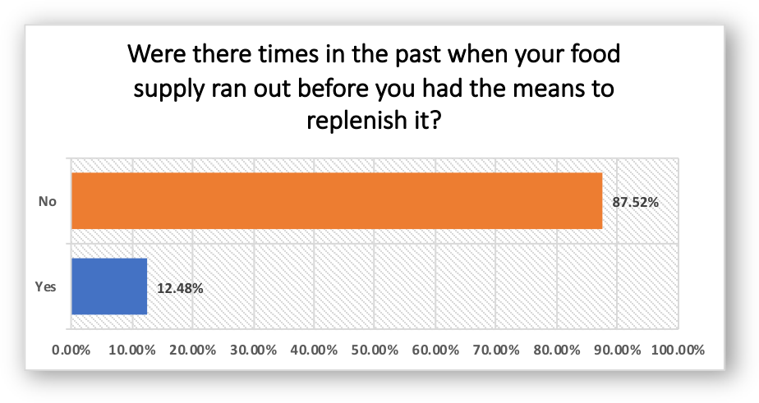

Social/Demographic Determinants Related to Running out of Food
Multiple characteristics show significant relationships with running out of food. The following relationships were found using correlational analyses:
Running out of food tends to be higher for younger people, Black people, less educated people, and those with lower income.
.

IV. Forces of Change Assessment
The Forces of Change Assessment observes what is occurring or might occur that impacts the health of the community or local public health system, and what threats or opportunities are generated by these occurrences. A total of 25 surveys were collected from community leaders who brainstormed ideas and took the assessment online via Survey Monkey or on paper at the second Community Health Plan meeting in July 2020.
KEY FINDINGS
Community Concerns
The four most important health concerns were:

- Cancer (100%)
- Gun violence (60%)
- Drug/alcohol abuse (52%)
- Obesity (44%)

Accessibility
The two highest rated areas of accessibility were:
- Low vision accessibility
- Wheelchair accessibility
The three lowest rated areas of accessibility were:
- Access to public transportation
- Access to sidewalks
- Access to streetlights

Safety
Issues related to safety were ranked highest-to-lowest as follows:
- Crime rates
- Gang activities
- Lack of crime patrol
- Traffic speeds

Priority Health Issues
Nearly 50 individuals representing various agencies within Champaign County, met and determined that there will be three areas will have priority focus over the next three years. These community leaders were presented with the findings from the MAPP assessment components, then leaders were asked to list their top health priorities, justify their reasoning and what would be the implication for not addressing these priorities in the short and long term. After an extended discussion the following three were selected as the health priorities to be addressed in the current 3-year community health plan. These are not ranked in order or preference.

Priority | Areas to Address Under Priority
Behavioral Health | Access, prevention, substance abuse, and resources
Reducing Obesity and Promoting Healthy Lifestyles | Nutrition, environment, and physical activity
Violence | Gun Violence, domestic violence, child abuse and neglect

Following is a description of each priority area, risk factors, indirect and direct contributing factors selected for each of the three health priority areas. These health plans were developed in partnership with community leaders representing multiple agencies and organizations.

Reducing Obesity and Promoting Healthy Lifestyles

Like many communities in the United States, obesity and obesity related illnesses continue to be a concern in Champaign County. Obesity is associated with poorer mental health outcomes, reduced quality of life, and the leading cause of death in the U.S. and worldwide, through contributing to heart disease, stroke, diabetes and some types of cancer. According to 2019 County Health Rankings, the obesity in Champaign County is 31% an increase from 26% in 2015. Obesity and its related health problems have a heavy economic impact throughout the United States. Obesity is linked with higher healthcare costs for adults and children through direct medical costs, along with impacting job productivity and absenteeism. Reducing obesity, increasing activity, and improving nutrition can have a strong impact on lowering health care costs through fewer prescription drugs, sick days, ER visits, doctor’s office visits, and admissions to the hospital.
Health Problem: Obesity
Risk Factors:  - Heart Disease  - Diabetes  - Chronic Disease  - Cancer  - High Blood Pressure | Contributing Factors:  - Inactivity  - Poor Diet  - Sense of defeat/embarrassment  - Sense of acceptance  - Genetics  - Family Lifestyles  - Social and Economic Factors  - Sexual Abuse | Barriers:  - Unsafe Neighborhoods  - Family Support  - Poverty  - Cost of Food/Cost of recreational facility  - Limited access to healthy foods.  - Limited knowledge of area programs/services
Goal 1: Increase opportunities for active living in Champaign County communities by 2023.
Objective 1: Hold Healthy Champaign County meetings monthly to promote healthy eating and active living in our community. The􀈱group will serve as the Obesity and Healthy Lifestyle workgroup working towards the 2020-2023 IPLAN goals.
Strategy 1.1.1: Expand outreach to grow number of active participants in HCC through contact with local organizations and marketing.
Strategy 1.1.2: Maintain HCC website and HCC social media sites to distribute local health and wellness information to the community including an wellness event calendar.
Strategy 1.1.3: Maintain HCC website and HCC social media sites to distribute local health and wellness information out to the community.
Strategy 1.1.3: Partner with member organizations to develop an outreach plan, identify and obtain funding to implement outreach plan for Healthy Champaign County.
Objective 1.2 Increase the proportion of trips made by bicycling and walking by 1% by 2022.
Strategy 1.2.1: Expand and increase public education programs to encourage use of transit, walking, and biking by: raising awareness of the local bike share program, facilitating improvements in walking and biking infrastructure, working to extend of local trail networks, raising public awareness on the benefits of walking and biking, expanding education programs, events, and classes for walking and biking.
Strategy 1.2.2: Promote certification of local businesses to apply for and become Bicycle Friendly Businesses through the League of American Bicyclists.
Strategy 1.2.3: Support and expand local bikeshare program to reach underserved populations by increasing the number of bikes available to the community and do outreach and education on bikeshare and its benefits.
Strategy 1.2.4: Expand current data collection for walking and biking trips through additional installation of bike and pedestrian counting systems similar to the ones installed for the MCORE project and Kickapoo Trail.
Strategy 1.2.5: Expand Safe Routes to Parks Project to include more Champaign Parks and finalize the Urbana Park District Report to provide safe walking and bicycling access to parks within ½ mile of every household, particularly multifamily households (apartment buildings and manufactured home parks). Utilize project data to apply for grants to fix infrastructure issues and address obstacles that were identified that prevent community members from safely and conveniently accessing parks.
Strategy 1.2.6: Encourage adoption of Vision Zero goals by cities and villages and develop and implement Vision Zero Plans to achieve the goal of zero roadways deaths and serious injury crashes to make walking and biking safe and viable trip options for community members.
Strategy 1.2.7: Hold multiple events each year that encourage physical activity such as: Illinois Marathon, Bike to Work Month, Walk ‘n Roll to School Day, Walks with the Mayors, Bike to Work and School Days, Bike to Parks Day, Bike to Worship Day, Turkey Trot, Polar Bear Ride, etc. Partner with local park districts, Champaign County Forest Preserve, health providers, bike and running clubs, and cities to sponsor events. Work to hold public events every month of the year.
Objective 1.3 Improve the health of children in K-12 by increasing the number of active transportation trips to school.
Strategy 1.3.1: Work with school districts to establish Walking School Buses and Park ‘n Walk programs to reduce congestion and improve safety for students to walk or bike to and from school.
Strategy 1.3.2: Work with school districts to hold at least two events per year focusing on walking and biking (Walk ‘n Roll to School Day in the fall and Bike to School Day in the spring.)
Strategy 1.3.2: Promote the health, environmental, educational, and social benefits of walking and bicycling to school through activities such as contests, bike rodeos, walking audits, and through providing incentives.
Strategy 1.3.3: Apply for state, federal, and private grants to support Safe Routes to School programs and projects.
Strategy 1.3.4: Expand and raise awareness of Snow Angels program, the local program designed to encourage volunteers to help clear sidewalks of snow in winter, to provide safe access to those who walk to work, school, bus stops, etc.
Objective 1.4 Expand outreach and awareness of available resources for small and medium sized businesses to adopt and implement workplace wellness programs.
Strategy 1.4.1: Publicize resources available on the C-U Public Health and Healthy Champaign County websites.
Strategy 1.4.2: Use social media platforms to provide information to businesses.
Strategy 1.4.3: Partner with the Champaign County Chamber of Commerce and the Urbana Business Association to share wellness program resources including offering webinars and lunch ‘n learn programs.
Objective 1.5 Continue developing programs that increase the number of physical activity and nutrition education opportunities for area families.
Strategy 1.5.1: Undertake outreach program to physicians and other health professionals through local organizations and institutions such as Carle, OSF, Frances Nelson, and Champaign-Urbana Public Health District.

GOAL 2: Improve access to, interest in, and affordability of healthy foods

Strategy 3.1.1: Work with organizations who manage food access programs in order to provide accurate information to the community about the locations, dates, times, and products offered for convenient access to affordable, healthy food.
Strategy 3.1.2: Identify gaps in availability of affordable, healthy foods and work to fill within existing partnerships. Map accessible healthy food market locations, times, products etc. by July 2021.
Strategy 3.1.3 Support membership for low-income families with subsidization of SNAP or insurance rebates, acceptance of EBT funds online or by farmers for weekly CSA shares.

Behavioral Health

Behavioral health issues continue to be an issue across the county. Lack of resources, funding, and stigma contribute to the issue in Champaign County. According to County Health Rankings the ratio of mental health providers per 100,000 has improved drastically over the past six years, moving from 2055:1 in 2010 to 444:1 in 2019. According to the CDC, National Vital Statistics System, the Champaign County suicide rate in 2018 was 12.9 per 100,000 which is higher than the state of Illinois rate of 10.8 but lower than the national rate of 13.4. According to the death certificate data compiled by Vital Records at Champaign-Urbana Public Health District, there were 262 drug-related deaths for the five-year period 2015-2019. Of these deaths, 198 were residents of Champaign County. Opiates were the leading cause of drug-related deaths in Champaign County.
Health Problem:
Mental Health
Risk Factor:  - Environmental Health Stressors  - Unidentified Mental Health Disorders | Contributing Factors:  - Stigma  - Lack of Education  - PTSD  - Physical / Verbal Abuse  - Genetics  - Lack of social support  - Poor Medicaid Reimbursement  - Lack of Awareness  - Language Barriers  - Trauma  - Substance Abuse  - Low self Esteem  - Sexual Abuse | Barriers:  - Lack of support system  - Lack of transportation  - Lack of funding  - Lack of Providers who take Medicaid  - Availability and access to counseling and screening programs  - Lack of screening in Primary Care Offices  - Education Levels  - Lack of interagency referral  - Participant follow-up
GOAL: Make advancements in behavioral health for Champaign County residents by expanding access to prevention, intervention, and treatment services.
Objective 1: Promote awareness of and increase usage of 211 services to connect people to behavioral health services.
- Strategy 1.1 Encourage all modalities of behavioral health available to patients (i.e. virtual, in person, groups, etc.)
- Strategy 1.2 Promote currently available programs and existing health services through public service announcements and other education campaigns.
  - Strategy 1.2.1 This will facilitate an increase in awareness of services offered in the county and eventually lead to an increased utilization of these services as well as a better understanding of which programs and services are in greatest demand.
- Strategy 1.3 Use national awareness “holidays” to increase awareness around mental health issues and services.
Objective 2: Educate primary care physicians on medicating/prescribing drugs that are potentially addictive as a means of early intervention for patients.
- Strategy 2.1 Connect with healthcare entities to develop and execute educational opportunities that include medicinal alternatives to opioids.
- Strategy 2.2 Develop a plan for early intervention and assessment of patients.
Objective 3: Continue to advocate for services for those in crisis
- Strategy 3.1 Work to improve retention and recruitment of mental health providers to increase access
- Strategy 3.2 Increase access to services by improving the number of people with health insurance and those with too high of deductibles to afford services.
- Strategy 3.2 Expansion of current treatment options.
  - 3.2.1 Continue advocating for triage center for those actively in crisis and/or has an encounter with law enforcement.

Violence

Champaign County crime rate has decreased over the last couple years, but remains higher compared to the State of Illinois and surrounding counties. As stated by the 2019 County Health Rankings the violent crime rate (the number of reported violent crime offenses per 100,000 populations) is 487 which is still remains higher than the state of Illinois rate of 403. From the Illinois State Police Crime Reports, 2015-2019, Champaign County has seen an increase in forcible rapes and robbery by 28% and 25%, respectively; while homicides, and assault/battery have decreased by about 9%. Burglary, theft (including motor vehicle), arson, saw double digit decreases. According to Champaign-Urbana Public Health District Death Certificates there were 19 gun-related deaths in Champaign County 13 suicides and 6 homicides.
As part of the Community Health Survey, respondents were asked to rate their neighborhood safety concerns. 35% reported they were concerned or very concerned about crime rates, and increase of about 4% from the last assessment. 30% reported they were concerned or very concerned with gang activity, an increase of about 7%. When respondents were asked to rank their top 5 health concerns in their community, Gun Violence, Domestic Violence, and Child Abuse and Neglect all ranked highly in the top community health concerns.
Violence was chosen as a priority health concern in the previous Community Health Plan cycle. There were two main objectives developed as part of the violence plan; 1) to foster a better relationship with community and increase outreach and community engagement and 2) Reduce recidivism by providing linkage to services for individuals begin released from state and county correctional system. Both objectives were met by the community. The Champaign County Community Coalition implemented several initiatives in the community to foster a better relationship with community and increase community engagement.
Health Problem: Violence
Risk Factors:  - Involvement with drugs or alcohol  - Poor behavioral control  - Exposure to violence  - Low parental involvement  - Poor family functioning  - Involvement in gangs  - Diminished economic opportunities  - Low levels of community participation  - Low self-esteem  - History of family violence | Contributing Factors:  - poverty  - substance abuse  - fear  - lack of education  - mental health issues  - economic stress  - family violence | Barriers:  - Weak community sanctions (e.g., unwillingness of neighbors to speak out in situations where they witness violence)  - Unhealthy family relationships  - Low neighborhood attachment  - Few organized activities in community for youths  - Access to guns or other weapons  - Lack of supportive services  - Lack of supervision or support from parents or caring adults

Priority: Violence 2021- 2023
Goals and Objectives
Goal:
Decrease gun violence, domestic violence, and child abuse and neglect in community by increasing community engagement, fostering better relationships between law enforcement and citizens, and implementing anti‐violence initiatives.
Objective 1.1 Promote, support, and encourage effective police community relations
Strategy 1.1.1 Support Champaign County Community Coalition and its ongoing initiatives to foster a better relationship between law enforcement and the community. The Champaign County Community Coalition (CCCC) is a network of community residents and local organizations that include local government; law enforcement; juvenile justice; education; behavioral health; child welfare; and community-based service providers. Law enforcement from each jurisdiction in Champaign County attend monthly Coalition meetings to provide updates to the community and respond to questions.
Strategy 1.1.2 Hold a minimum of four ‘Walk as One’ events a year to build stronger relationships between the Champaign Police and larger Champaign Community by engaging citizens with their neighborhood.
Objective 1.2 As a community, utilize resources to develop and promote strategic methods of crime reduction and prevention.
Strategy 1.2.1 Participate in and support the Champaign County Community Coalition in CU Fresh Start, a targeted approach to deter gun violence. CU Fresh Start is designed to focus on core offenders with a history of violent, gun‐related behaviors. The model has three key components, bringing together community voices, law enforcement, and supportive community services. Law enforcement from each jurisdiction will participate in the CU Fresh Start Steering Committee, Participant Review, and Custom Notification Subcommittees.
Strategy 1.2.2 Continue to support school‐based violence prevention program such as Champaign Unit 4 Goal Getters and Urbana District 116 Self-Made Kingz that work with high school-aged males.
Strategy 1.2.3 Support trauma‐based trainings through the Champaign County Community Coalition. CU Trauma & Resilience Initiative (CU TRI) is a collaborative initiative designed to educate the community about trauma, trauma-informed care, and resiliency. Additionally, CU TRI advocates for more trauma-informed policies, practices, and principles by providing free community wide trainings.
Strategy 1.2.4 Host community-wide events to foster dialogue about racial equity and its role in community violence.
Strategy 1.2.5 Support the Community Violence Response Task Force (CVRT) in establishing and maintaining a community crisis and trauma response team to support neighborhoods impacted by increased violence and gun related activity. The CVRT administers neighborhood safety needs assessments to residents at Neighborhood Safety Forums.
Objective 1.3 Implement programs to encourage community and youth Engagement.
Strategy 1.3.1 Recruit and involve local youth in the development of community messaging targeting other youth.



The Action Cycle

The action cycle is the last phase of MAPP. This phase indicates the process that will assist in achieving the goals expressed in the work plans. After having a final session with committee members on the IPLAN, the action cycle was created. The three major stages of the action cycle (planning, implementation, and evaluation) were addressed and are described in detail below.

Planning
Enhance communication between providers
a. Assemble members of different organizations with common interest
b. Form task forces to focus on different problems within the community
c. Create a schedule so that task forces will meet regularly
d. Ensure that task forces will plan and implement programs in the fields of obesity, accidents, violence, and lack of access to care to improve the conditions of health in Champaign County

Implementation
Increase awareness
a. Use a task force to locate and compile information
b. Make information accessible through a website
c. Track progress and trends of health problems on a regular basis
d. Frequently update information on website for residents’ awareness

Improve built environment
a. Utilize a task force of city and county urban planners
b. Produce a plan to improve infrastructure and built environment
c. Implement plans to have a more physically active environment with more walking and biking paths

Evaluation
- Assemble the task forces with updated results on each major priority issue
- Discuss trends and progress towards health goals
- Discuss the goals and reported results
- Determine what changes can be made to further improve the health of the community
- Implement new strategies and convene regularly to re-evaluate the progress of goals and objectives

APPENDIX

Appendix 1: Forces of Change Assessment Survey Results

Social Forces

- Social media
  - Threat: Disinformation spreading fast
  - Opportunity: Quick, effective way to spread message to broad audience - can be used to share correct public health info and promote health education
  - Threat: Misinformation or perpetuate emotion discord
  - Opportunity: An avenue to inform community of events, emergency situations, health information, etc. quickly
  - Threat: Facebook can be used for sharing incorrect information regarding health and healthcare services
  - Opportunity: Facebook can be used to promote education and health events
- Smartphone use
  - Threat: limits in person social interaction/everyone has their face in the phone
  - Opportunity: increases access to information wherever a person may be
  - Threat: texting and driving
  - Opportunity: campaign to put phones out of reach when you get in your car
- Nextdoor.com
  - Threat: incorrect, biased, or discriminatory information/comments can be propagated
  - Opportunity: sharing of information at the neighborhood level.
- Religious intolerance
  - Threat: decline in acceptance of different religious perspectives
  - Opportunity: learning opportunity for community about value diversity
- Influx of low-income housing populations from Chicago and St. Louis
  - Threat: Big-city caliber crime and violence brought to Champaign-Urbana
  - Opportunity: opportunity for health infrastructure to expand to accommodate growing populations
- Influx of temporary populations; international students
  - Threat: Populations who are culturally unaware and thus more vulnerable to crime and exploitation
  - Opportunity: Increased cultural diversity, increase of educated and affluent populations
- Violence
  - Threat: Segments of the community are experiencing increased level of trauma that can lead to negative health and safety.
  - Opportunity: Opportunity to reach out to impacted communities.
  - Threat: guns
  - Opportunity: education on guns for safety & hobby sport vs guns for revenge & harm dialogue
- Hate crimes
  - Threat: detrimental to all and our social fabric
  - Opportunity: recognition that hate crimes are a serious public health problem, and be addressed as a public health problem
- Rise of community collaboration groups
  - Threat: duplication and meeting burnout
  - Opportunity: greater collaboration between organizations and shared resources
- Increase in community events
  - Threat: congestion, public safety
  - Opportunity: ability for diverse community to gather, promoting healthy and fun outlets for community members
- Local Media
  - Threat: can spread inaccurate information and/or fan the flames of anger and resentment toward those trying to improve health
  - Opportunity: can be used to inform, build consensus and advocate for positive change
  - Threat: doesn’t cover all sides of an issue
  - Opportunity: provide information needed to wide audience
- Overpricing of essential utilities to renters
  - Threat: Inability to keep up with power, water, and phone bills
- New American Welcome Center
  - Opportunity: community involvement in welcoming new cultures and expanding our diversity
- Drug addictions
  - Threat: health threat to our community
  - Opportunity: make more treatment services available (inpatient) in our community
- Bullying
  - Threat: causes stress/trauma to the youth in our community
  - Opportunity: provide positive social/ emotional trauma information to teacher in middle schools and high schools
- Undocumented immigration and refugee community access to care
  - Threat: legitimation of paper work in order to receive treatment
  - Opportunity: work as community together and practice human rights for the well-being of everyone.
- Vulnerability of the elderly
  - Threat: abuse of their finances
  - Opportunity: more resources, more visibility of the issue
- Migration from Chicago
  - Threat: violence
  - Opportunity: diversity
- Lack of community engagement
  - Threat: lack of diversity, others opinions
  - Opportunity: new ideas, creating events/ groups that community would enjoy more and be more active in.

Economic Forces

- Abundance of minimum wage part time jobs
  - Threat: Inadequate health care coverage
  - Opportunity: known targets to support enrollment in Obamacare insurance plans
- Economic disparity
  - Threat: lack of economic opportunity and living wage depresses overall economic growth
  - Opportunity: increase minimum wage to a living wage
- Corporate Welfare
  - Threat: Low wages paid by business results in employee reliance on social services
  - Opportunity: Exposes corporations for exploiting employees and not being good corporate citizens
- Unemployment
  - Threat: People being bored and impoverished due to lack of employment
  - Opportunity: Unemployment may represent unused time that could be spent productively
- Growth of the University of Illinois
  - Threat: Massive population swings as students leave and return over vacation
  - Opportunity: University-run social programs that directly benefit Champaign-Urbana
- Federal funding shifts/cuts
  - Threat: Federal funding shifts away from evidenced-based programs and services will lead to negative health outcomes
  - Opportunity: Form community coalitions to looks for alternative funding sources
- Lack of adequate/timely state funding
  - Threat: Many community services are losing staff, services, and sometimes closing their doors
  - Opportunity: There is an opportunity to have more dialogue with state legislative partners to come up with solutions
- State budget
  - Threat: bills not being paid to providers (caring for Medicaid patients) or public health
  - Opportunity: creative new partnerships to address these issues
- State Funding for Social Services
  - Threat: reduced access to safe housing and foods
  - Opportunity: improve community and healthcare services
  - Threat: decreased care of those most in need
  - Opportunity: create non-government sponsorship for agencies
- High housing costs
  - Threat: long-term transitional homelessness among young families
  - Opportunity: agencies working together to open homeless/ transitional shelters
- Health care fees/programs
  - Threat: Uncertainty of stability of insurance, rising costs of care, facility fees
  - Opportunity: Budget issues for mental health services
  - Threat: providers less open to accepting state payment (Medicaid), long wait lists for individuals to begin services
  - Opportunity: local funding
- Loss of middle income jobs, fewer well-paying jobs in manufacturing and construction
  - Threat: Middle income families are unable to maintain healthy lifestyles without adequate income. Shrinking middle class.
  - Opportunity: Provide training and education for jobs that are in demand that provide a living wage. Potential charitable donations from higher earners.
- State pension reform
  - Threat: people are very upset about pension reform and may do something directed at the University of Illinois out of anger
- Too many costly retirees in our state
  - Threat Bankrupting the state and cities
  - Opportunity: make others understand the problem to fix the system
- economic growth
  - Threat lack of large companies entering our area with lots of good paying jobs
  - Opportunity small tech companies at Research Park
- lack of qualified and motivated workforce
  - Threat youth are not graduating with skills needed
  - Opportunity increase workforce development opportunities
- Widening Income Gap
  - Threat: misunderstanding among highest income of challenges faced by low income groups, affecting health care, employment, and overall health.
  - Opportunity: Can awaken public opinion of need for change to address these issues
- Population growth
  - Threat: Resource scarcity, infectious disease
  - Opportunity: economic justice improvement
- Discussion of a livable wage/ increase minimum wage
  - Threat: many small businesses will struggle to adopt the changes
  - Opportunity: families and individuals will be able to afford healthcare, home improvements, education.
- Predatory money lending
  - Threat: low income people often lose good credit/ obtain debt
  - Opportunity: an unbanked population has access to loans
- Lack of Vocational education
  - Threat: lack of training in schools has impacted construction and other trade workforces
  - Opportunity: Community and nonprofit partners can work together to provide programs and training opportunities.
- Rise in income inequality
  - Threat: increased levels of poverty and related issues
  - Opportunity: social divide could increase awareness of disparity and desire for change.
- Decrease in homeless shelters
  - Threat: homeless population more at risk – more difficult to remain healthy mentally and physically
  - Opportunity: programmatic changes to help individuals move out of homelessness.
- Development on campus/ downtown C-U
  - Threat: Segregating campus from community further
  - Opportunity: business opportunities for local entrepreneurs to bridge gaps
- Globalization; improved economic status of other nations
  - Threat: increasing isolationism, fear, hatred
  - Opportunity: learning from other nations

Political Forces

- increased interest in rallies and protests
  - Threat: health care just one of the issues (might get drowned out)
  - Opportunity: better organization and general interest/participation in protests
- Political extremism
  - Threat: increased intolerance to differing political views
  - Opportunity: increase awareness by moderates of the threats posed to society of the polices espoused by the far right and far left
- State budget crisis
  - Threat: further tax increases necessary to balance the budget beyond the increase just passed by the state
  - Opportunity: chance to reassess funding priorities and consideration of progressive state income tax
- Racial tensions
  - Threat: Pent-up resentment over current events leading to violent protests
  - Opportunity: Peaceful protests, acknowledgement of tensions may lead to more integrated community
- Formation of White Supremacist Groups
  - Threat: Feeds racial tensions
  - Opportunity: Opportunity for local police force to show no tolerance
- The divisive, hateful political climate (national and state)
  - Threat: Racism/xenophobia in the media and political rhetoric can cause our clients to feel unsafe or unwelcome to access important services
  - Opportunity: Opportunity to reach out and engage more with impacted communities
- Shift from science to religion/magical thinking in federal programming, funding and research
  - Threat: This will slow progress of evidence-based health and safety programs
  - Opportunity: Increased partnerships with Universities and private funders
- criminal justice and racial relations
  - Threat: distrust in police authorities, increase in crime and hostility, public unrest
  - Opportunity: transparency with police operations, funding toward increases in police force and support services & equipment
- Frustration with Government officials
  - Threat: distrust of government, anger by citizens due to disagreement of policy and funding
  - Opportunity: individuals getting more involved with government proceedings - contact with reps and senators, increase presence of local government and citizen participation and awareness of meetings, etc.
  - Threat: violence and distrust in government
  - Opportunity: gained interest in community level politics and higher voting rates
- Emergency preparedness
  - Threat Increased time and money
  - Opportunity Good ROI in the event of emergency
- Political corruption in Illinois State Government
  - Threat: Low morale and ability to provide leadership in state gov.
  - Opportunity: It has to get better since it cannot get any worse
  - Threat Decreased business coming to Illinois
  - Opportunity Term Limits
- radical discord between democrats & republicans
  - Threat sticking to party lines is not getting work done at the state level
  - Opportunity collaboration
  - Rising tension towards federal government
- Zoning meetings – 5th and Hill
  - Threat: Toxic soil will have to be relocated, responsibility
  - Opportunity: Move public input to redirect the conversations
- Political gerrymandering of congressional districts
  - Threat: more divided country
  - Opportunity: take district organization out of political process
- Sugar Tax
  - Threat: prices go up/ can’t afford
  - Opportunity: decrease purchases that are unhealthy

Technological Forces

- Ubiquitous smart phones
  - Threat: the people who don't have smart phones are more likely to be those who most need support with medical services and access (mentally ill, homeless)
  - Opportunity: can reach nearly everyone, even if they don't have a computer
  - Threat: Risk of increased injury due to texting. More social isolation and cyber bullying. Less interaction with the environment.
  - Opportunity: There is an opportunity for direct contact with clients, and an opportunity to create or promote games and apps that increase and encourage healthy behaviors.
  - Threat: driving accidents and drop in social skills
  - Opportunity: can be used as learning tools
  - Threat: lead to social isolation
  - Opportunity: creatively explore avenues for in-person group meetings where people must interact
- Driverless cars
  - Threat: reduces employment opportunities in transportation industry
  - Opportunity: ability of elderly to live independently, assuming can afford the new vehicle
  - Threat high cost of transportation and no current laws on usage
  - Opportunity fewer car accidents
- Ability to survey and solicit community feedback through online surveys
  - Threat Unequal sampling, conflicting surveys may create misleading reflection of community status
  - Opportunity Greater information about community consensus on which to base public health decisions
- Use of technology in education to increase lesson plans
  - Threat: Technology is expensive and thus may increase economic inequality
  - Opportunity: Use of technology in education allows introduction of more diverse and engaging lesson plans in primary and secondary education
- Increased reliance of news from Facebook and internet sources
  - Threat: Misinformation is starting to crowd out fact. This makes it for difficult to get factual information to a wide audience.
  - Opportunity: There is an opportunity to find creative ways to reach the community with factual information. This will require "screaming above the noise".
- Increased video game use
  - Threat: rise in obesity and lack of exercise
  - Opportunity: video games can improve critical thinking skills and be used as a learning too
  - Threat child obesity on the rise
  - Opportunity develop interactive games that allow kids to participate in video games but get exercise to power the games
- Use of mobile phones is significantly higher than land lines
  - Threat: frequent number changes, loss of client contact, screening process to even acknowledge a call, data/time/plan runs out
  - Opportunity: can reach people where they are located, quicker access to contact for services, use other means of contact, individuals must show initiative to continue contact
- reliance of online database systems for agencies/health care
  - Threat: loss of information, the ability to function if systems are down, cyber security threats, not all systems are consistent
  - Opportunity: quick access to information, efficient, ability to compare and utilize data
- MTD bus e-schedule and app
  - Threat: perhaps costly to do and maintain
  - Opportunity: huge benefit to riders in our community
- electronic medical information systems
  - Opportunity: improve detection, reporting and remediation of health threats
- Increased use of technology
  - Threat People/children do not interact as should, cannot work with others
  - Opportunity Use technology to show how to interact and limit screen time
- University of Illinois research
  - Threat Focusing on big problems, sometimes leaves the immediate problems unattended
  - Opportunity Help more individuals and solve problems
- Research Park
  - Threat small startups being bought out by larger companies and leave the area
  - Opportunity growing small businesses
- uc2b internet
  - Threat not everyone has home access to computers
  - Opportunity computer labs
- Big data analysis
  - Threat: privacy concerns, misuse of data
  - Opportunity: improved decision making
- Increased automation into the workforce
  - Threat: replacing jobs
  - Opportunity: increase in innovation
- Increasing hacking of personal data
  - Threat: identity theft
  - Opportunity: improve safe guards

Environmental Forces
- Climate change
  - Threat: increase in extreme weather events
  - Opportunity: economic development associated with dealing with potential extreme conditions
  - Threat: increase in new health problems
  - Opportunity: increase motivation to change behaviors
  - Threat: increase in heat symptoms, respiratory illnesses, infectious diseases, etc.
  - Opportunity: make healthcare facilities leaders in energy efficiency and clean energy; community education on threats from greenhouse gas emissions
  - Threat: Extreme weather will tax community resources for responses (blizzards, extreme heat, tornadoes, wind)
  - Opportunity: Encourage individuals, churches, CBOs to develop emergency plans
- Climate change-increase in insects, plants and animals that can negatively impact safety and health
  - Threat: Aedes Albopictus mosquitoes are capable of spreading diseases which we are not accustomed to here (Zika, Chikungunya, Dengue).
- Water quality
  - Threat: Poor water quality, i.e. lead contamination, poses health risk
  - Opportunity: rise awareness, develop new standards and testing practices
- Noise pollution
  - Threat: Noise from traffic, construction, industry disturbs community peace
  - Opportunity: Noise could be interpreted as sign of community growth and liveliness
- Land zoning
  - Threat land distribution for commercial/residential change, run off, lack/over development in areas
  - Opportunity growth opportunity, ability to rezone for service/agency needed based on demographics
- Urban sprawl
  - Threat: 'dead' areas in central cities
  - Opportunity: repurpose these areas to continue to work to bring people back to the city
- Natural Disaster (tornado)
  - Threat displaced residents and infrastructure
  - Opportunity partnerships to plan for response
- Draught
  - Threat decreased farm production
  - Opportunity evaluate draught-tolerant plane species
- Urban gardening
  - Threat: increased waste
  - Opportunity: partner with food local pantries

Scientific Forces

- Major grants funded to research at the University
  - Threat: Money from grants may not necessarily directly benefit Champaign-Urbana, but still attract personnel that utilize city resources
  - Opportunity: Money from grants may flow into benefits for Champaign-Urbana
- Broader impacts of research grants
  - Threat: Broader impacts/outreach programs funded by research may benefit only privileged education programs in town
  - Opportunity: Broader impacts/outreach programs expose younger generations to scientific training and education
- Alternative energy (solar, wind, electric vehicles)
  - Threat: There is not equal access for adopting alternative energy
  - Opportunity: Financial incentives for adopting alternative energy (solar, wind)
- University of IL scientific resources and expertise
  - Threat: Potential for Bioerror or other accidents (radiation, chemical)
  - Opportunity: Innovation and dissemination of knowledge through community collaborations
- Removal of US from the Paris Climate Agreement
  - Threat: harm the environment
  - Opportunity: could give people locally motivation to change personal behaviors to better the environment
- Medical research
  - Threat: staff needed, requirements necessary for the research, access to results
  - Opportunity: access to good medical facilities, medical clinic being established at U of I, partnerships developed
- Expanding WIFI/broadband services to all
  - Threat: expensive
  - Opportunity: bring huge long-term benefits to our citizens
- Childhood obesity
  - Threat: Increased prevalence puts kids at risk of chronic disease
  - Opportunity: Increased walking and biking paths, walking to school
- Prevention
  - Threat: screenings, immunization, flu shots etc. below needed levels
  - Opportunity: Large health care provider networks; public health system
- Genetic advancements
  - Threat: some may bring up moral issues
  - Identifying risks, potential cures

Legal Forces

- Continue to urge the decriminalize marijuana
  - Threat: backlash that pushes for harsher treatment of the crimes
  - Opportunity: reduce racial imbalance of victimless crimes
- Gun violence/violent crime
  - Threat: disrupts quality of life for community and victims
  - Opportunity: address trauma associated with the incidents, improve community response and relations with criminal justice system to reduce incidents
- Illegal immigration
  - Threat: creates an environment where victims of crime may not report to police for fear of investigation into own legal status
  - Opportunity: reform laws to provide a path to citizenship
- Uncertain/ Changing Immigration laws
  - Threat: increased discrimination against to both legal and illegal aliens
- Not enough peace officers in the police force
  - Threat: Not enough peace officers in the police force to serve and protect the community!
  - Opportunity: Not enough peace officers in the police force to fret about minor infractions
- Deregulation of internet neutrality
  - Threat: Greater commercialization of internet by large companies, i.e. Comcast
- Opiate addiction
  - Threat: Increase in morbidity and mortality due to opiate addiction
  - Opportunity: Opportunity for increased community building with those who are addicted to opiates (and their friends and family) to prevent overdose. This can be the initial, low-threshold entry into treatment.
- Vaping and electronic cigarette proliferation
  - Threat: Increased initiation by non-smokers can lead to nicotine addiction
  - Opportunity: Can work as a harm reduction tool for heavy smokers to reduce their reliance on combustible tobacco
- ACA legislation
  - Threat: confusion on if it will remain in place, increased stress for those with pre-existing conditions, access to mental health services
  - Opportunity: access to preventative care, access to insurance
  - Threat: decreased number of people with insurance leading to poorer health outcomes
  - Opportunity: campaign for adjustments to improve ACA
- Community police board in Champaign
  - Threat suggests distrust of police force
  - Opportunity creates more openness and dialogue among police and community
- Concealed carry in Illinois
  - Threat more people may use deadly force to protect themselves in a non-deadly force situation, more gun violence, more availability of weapons, more easily stolen
  - Opportunity people will be able to protect themselves in a deadly force situation, gun safety classes
- Mental health
  - Threat: physical violence, e.g. public {school, mall} shooters
  - Opportunity: we can do more; maybe everyone needs a mental health check-up like a physical or dental check-up
- Inadequate access to legal recourse for poor
  - Threat: Loss of entitlements and access
- Lack of mental health awareness among police officers
  - Threat: mentally impaired people will not be compliant because of mental health episodes
  - Opportunity: Support residents by making sure law enforcement has ample training on common mental health conditions in our community.

Ethical Forces

- Affordable housing
  - Threat: high housing costs limit results in overcrowding or inability to afford other basic needs; food, utilities, healthcare
  - Opportunity: community collaboration to develop new resources
  - Threat sky high rental rates driven by university student population
  - Opportunity incentives to landlords to diversify their properties
- Police brutality
  - Threat: Police overstepping authority in enforcing laws
- Mental health concerns
  - Threat: Individuals with severe mental health problems can cause massive social disruption
  - Opportunity: Improved, more accessible mental health services benefit everyone
- Incarceration of those with mental illness
  - Threat: Persons are being incarcerated due to behaviors related to mental illness
  - Opportunity: Opportunity for mental health providers and government to work together to find alternative, more humane, less expensive options.
- Incarceration of those with substance abuse disorders
  - Threat: Persons are being incarcerated due to behaviors related to substance use
  - Opportunity: Opportunity for substance abuse treatment and prevention providers and government to work together to find alternative, more humane, less expensive options.
- Differences in immigration laws and sanctuary cities in County
  - Threat: increased discrimination. Confusion over laws
  - Opportunity: awareness- conversations happening throughout the community
- High Crime rate in concentrated areas of Champaign County
  - Threat: Rising violence
  - Opportunity: addressing root cause and increased collaborations among police departments.
- Move to change rules around alcohol use
  - Threat: infringing upon business activity
  - Opportunity: decrease alcohol abuse, safer community
- Support for domestic violence survivors
  - Threat: expense
  - Opportunity: new collaborations as this is a compassionate necessity, safer community
- Continued high unemployment
  - Threat increasing disparity between rich and poor, shrinking middle class, lack of affordable (low cost) housing
- Addressing childhood obesity
  - Threat chronic diseases
  - Opportunity increased partnerships
- Food insecurity
  - Threat low educational achievement
  - Opportunity community gardens to feed and foster skills
- Opiate addiction
  - Threat underachievement
  - Opportunity Increase the number of treatment facilities
- Violence in the community
  - Threat Cause residents to be afraid
  - Opportunity Work to decrease and help those affected
- Lack of services for mental illnesses
  - Threat Violence, child abuse, homelessness, drain on economy
  - Opportunity Multiple offices could combine and work together to combat this issue
- Cost of living in Champaign County
  - Threat: Paying for housing, parking utilities limits the amounts of monies people have to save, pay off debts (student loans). Decrease in the amount of people who are purchasing property – increase in renters
  - Opportunity: with new housing structures going up every day, prices could be decreasing. Decreased housing costs would allow people to spend more money and would boost the economy.
- Increase in bio-ethical discussion
  - Threat: targets marginalized communities
  - Opportunity: place policies that further protect and inform patients
- Food insecurity – WIC, Food Pantries, etc
  - Threat: too many people relying on limited services
  - Opportunity: collaboration and education – work together to teach people how to better their situation.

Appendix 2: Local Public Health System Assessment

Performance Scores by Essential Public Health Service for Each Model Standard
Figure 1 displays the average performance score for each of the Model Standards within each Essential Service. This level of analysis enables you to identify specific activities that contributed to high or low performance within each Essential Service.

Figure 1. Performance Scores by Essential Public Health Service for Each Model Standard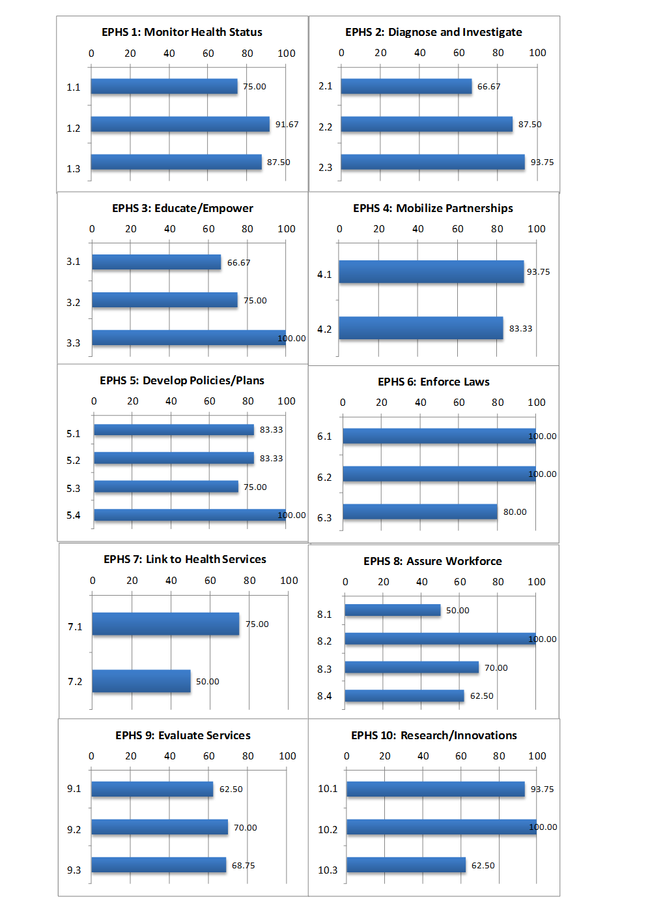
Individual Questions and Responses

ESSENTIAL SERVICE 1: Monitor Health Status to Identify Community Health Problems
1.1 | Model Standard: Population-Based Community Health Assessment (CHA)  At what level does the local public health system:
1.1.1 | Conduct regular community health assessments? |  |  |  |  |  |  |  | 100
1.1.2 | Continuously update the community health assessment with current information? |  |  |  |  |  |  |  | 75
1.1.3 | Promote the use of the community health assessment among community members and partners? |  |  |  |  |  |  |  | 50
1.2 | Model Standard: Current Technology to Manage and Communicate Population Health Data  At what level does the local public health system:
1.2.1 | Use the best available technology and methods to display data on the public’s health? |  |  |  |  |  |  |  | 100
1.2.2 | Analyze health data, including geographic information, to see where health problems exist? |  |  |  |  |  |  |  | 100
1.2.3 | Use computer software to create charts, graphs, and maps to display complex public health data (trends over time, sub-population analyses, etc.)? |  |  |  |  |  |  |  | 75
1.3 | Model Standard: Maintenance of Population Health Registries  At what level does the local public health system:
1.3.1 | Collect data on specific health concerns to provide the data to population health registries in a timely manner, consistent with current standards? |  |  |  |  |  |  |  | 100
1.3.2 | Use information from population health registries in community health assessments or other analyses? |  |  |  |  |  |  |  | 75
ESSENTIAL SERVICE 2: Diagnose and Investigate Health Problems and Health Hazards
2.1 | Model Standard: Identification and Surveillance of Health Threats  At what level does the local public health system:
2.1.1 | Participate in a comprehensive surveillance system with national, state and local partners to identify, monitor, share information, and understand emerging health problems and threats? |  |  |  |  |  |  |  | 75
2.1.2 | Provide and collect timely and complete information on reportable diseases and potential disasters, emergencies and emerging threats (natural and manmade)? |  |  |  |  |  |  |  | 75
2.1.3 | Assure that the best available resources are used to support surveillance systems and activities, including information technology, communication systems, and professional expertise? |  |  |  |  |  |  |  | 50
2.2 | Model Standard: Investigation and Response to Public Health Threats and Emergencies  At what level does the local public health system:
2.2.1 | Maintain written instructions on how to handle communicable disease outbreaks and toxic exposure incidents, including details about case finding, contact tracing, and source identification and containment? |  |  |  |  |  |  |  | 75
2.2.2 | Develop written rules to follow in the immediate investigation of public health threats and emergencies, including natural and intentional disasters? |  |  |  |  |  |  |  | 100
2.2.3 | Designate a jurisdictional Emergency Response Coordinator? |  |  |  |  |  |  |  | 100
2.2.4 | Prepare to rapidly respond to public health emergencies according to emergency operations coordination guidelines? |  |  |  |  |  |  |  | 75
2.2.5 | Identify personnel with the technical expertise to rapidly respond to possible biological, chemical, or and nuclear public health emergencies? |  |  |  |  |  |  |  | 75
2.2.6 | Evaluate incidents for effectiveness and opportunities for improvement? |  |  |  |  |  |  |  | 100
2.3 | Model Standard: Laboratory Support for Investigation of Health Threats  At what level does the local public health system:
2.3.1 | Have ready access to laboratories that can meet routine public health needs for finding out what health problems are occurring? |  |  |  |  |  |  |  | 100
2.3.2 | Maintain constant (24/7) access to laboratories that can meet public health needs during emergencies, threats, and other hazards? |  |  |  |  |  |  |  | 75
2.3.3 | Use only licensed or credentialed laboratories? |  |  |  |  |  |  |  | 100
2.3.4 | Maintain a written list of rules related to laboratories, for handling samples (collecting, labeling, storing, transporting, and delivering), for determining who is in charge of the samples at what point, and for reporting the results? |  |  |  |  |  |  |  | 100
ESSENTIAL SERVICE 3: Inform, Educate, and Empower People about Health Issues
3.1 | Model Standard: Health Education and Promotion  At what level does the local public health system:
3.1.1 | Provide policymakers, stakeholders, and the public with ongoing analyses of community health status and related recommendations for health promotion policies? |  |  |  |  |  |  |  | 75
3.1.2 | Coordinate health promotion and health education activities to reach individual, interpersonal, community, and societal levels? |  |  |  |  |  |  |  | 75
3.1.3 | Engage the community throughout the process of setting priorities, developing plans and implementing health education and health promotion activities? |  |  |  |  |  |  |  | 50
3.2 | Model Standard: Health Communication  At what level does the local public health system:
3.2.1 | Develop health communication plans for relating to media and the public and for sharing information among LPHS organizations? |  |  |  |  |  |  |  | 75
3.2.2 | Use relationships with different media providers (e.g. print, radio, television, and the internet) to share health information, matching the message with the target audience? |  |  |  |  |  |  |  | 75
3.2.3 | Identify and train spokespersons on public health issues? |  |  |  |  |  |  |  | 75
3.3 | Model Standard: Risk Communication  At what level does the local public health system:
3.3.1 | Develop an emergency communications plan for each stage of an emergency to allow for the effective dissemination of information? |  |  |  |  |  |  |  | 100
3.3.2 | Make sure resources are available for a rapid emergency communication response? |  |  |  |  |  |  |  | 100
3.3.3 | Provide risk communication training for employees and volunteers? |  |  |  |  |  |  |  | 100
ESSENTIAL SERVICE 4: Mobilize Community Partnerships to Identify and Solve Health Problems
4.1 | Model Standard: Constituency Development  At what level does the local public health system:
4.1.1 | Maintain a complete and current directory of community organizations? |  |  |  |  |  |  |  | 100
4.1.2 | Follow an established process for identifying key constituents related to overall public health interests and particular health concerns? |  |  |  |  |  |  |  | 100
4.1.3 | Encourage constituents to participate in activities to improve community health? |  |  |  |  |  |  |  | 75
4.1.4 | Create forums for communication of public health issues? |  |  |  |  |  |  |  | 100
4.2 | Model Standard: Community Partnerships  At what level does the local public health system:
4.2.1 | Establish community partnerships and strategic alliances to provide a comprehensive approach to improving health in the community? |  |  |  |  |  |  |  | 75
4.2.2 | Establish a broad-based community health improvement committee? |  |  |  |  |  |  |  | 100
4.2.3 | Assess how well community partnerships and strategic alliances are working to improve community health? |  |  |  |  |  |  |  | 75
ESSENTIAL SERVICE 5: Develop Policies and Plans that Support Individual and Community Health Efforts
5.1 | Model Standard: Governmental Presence at the Local Level  At what level does the local public health system:
5.1.1 | Support the work of a local health department dedicated to the public health to make sure the essential public health services are provided? |  |  |  |  |  |  |  | 75
5.1.2 | See that the local health department is accredited through the national voluntary accreditation program? |  |  |  |  |  |  |  | 100
5.1.3 | Assure that the local health department has enough resources to do its part in providing essential public health services? |  |  |  |  |  |  |  | 75
5.2 | Model Standard: Public Health Policy Development  At what level does the local public health system:
5.2.1 | Contribute to public health policies by engaging in activities that inform the policy development process? |  |  |  |  |  |  |  | 100
5.2.2 | Alert policymakers and the community of the possible public health impacts (both intended and unintended) from current and/or proposed policies? |  |  |  |  |  |  |  | 50
5.2.3 | Review existing policies at least every three to five years? |  |  |  |  |  |  |  | 75
5.3 | Model Standard: Community Health Improvement Process and Strategic Planning  At what level does the local public health system:
5.3.1 | Establish a community health improvement process, with broad- based diverse participation, that uses information from both the community health assessment and the perceptions of community members? |  |  |  |  |  |  |  | 100
5.3.2 | Develop strategies to achieve community health improvement objectives, including a description of organizations accountable for specific steps? |  |  |  |  |  |  |  | 50
5.3.3 | Connect organizational strategic plans with the Community Health Improvement Plan? |  |  |  |  |  |  |  | 75
5.4 | Model Standard: Plan for Public Health Emergencies  At what level does the local public health system:
5.4.1 | Support a workgroup to develop and maintain preparedness and response plans? |  |  |  |  |  |  |  | 100
5.4.2 | Develop a plan that defines when it would be used, who would do what tasks, what standard operating procedures would be put in place, and what alert and evacuation protocols would be followed? |  |  |  |  |  |  |  | 100
5.4.3 | Test the plan through regular drills and revise the plan as needed, at least every two years? |  |  |  |  |  |  |  | 100
ESSENTIAL SERVICE 6: Enforce Laws and Regulations that Protect Health and Ensure Safety
6.1 | Model Standard: Review and Evaluation of Laws, Regulations, and Ordinances  At what level does the local public health system:
6.1.1 | Identify public health issues that can be addressed through laws, regulations, or ordinances? |  |  |  |  |  |  |  | 100
6.1.2 | Stay up-to-date with current laws, regulations, and ordinances that prevent, promote, or protect public health on the federal, state, and local levels? |  |  |  |  |  |  |  | 100
6.1.3 | Review existing public health laws, regulations, and ordinances at least once every five years? |  |  |  |  |  |  |  | 100
6.1.4 | Have access to legal counsel for technical assistance when reviewing laws, regulations, or ordinances? |  |  |  |  |  |  |  | 100
6.2 | Model Standard: Involvement in the Improvement of Laws, Regulations, and Ordinances  At what level does the local public health system:
6.2.1 | Identify local public health issues that are inadequately addressed in existing laws, regulations, and ordinances? |  |  |  |  |  |  |  | 100
6.2.2 | Participate in changing existing laws, regulations, and ordinances, and/or creating new laws, regulations, and ordinances to protect and promote the public health? |  |  |  |  |  |  |  | 100
6.2.3 | Provide technical assistance in drafting the language for proposed changes or new laws, regulations, and ordinances? |  |  |  |  |  |  |  | 100
6.3 | Model Standard: Enforcement of Laws, Regulations, and Ordinances  At what level does the local public health system:
6.3.1 | Identify organizations that have the authority to enforce public health laws, regulations, and ordinances? |  |  |  |  |  |  |  | 75
6.3.2 | Assure that a local health department (or other governmental public health entity) has the authority to act in public health emergencies? |  |  |  |  |  |  |  | 100
6.3.3 | Assure that all enforcement activities related to public health codes are done within the law? |  |  |  |  |  |  |  | 100
6.3.4 | Educate individuals and organizations about relevant laws, regulations, and ordinances? |  |  |  |  |  |  |  | 50
6.3.5 | Evaluate how well local organizations comply with public health laws? |  |  |  |  |  |  |  | 75
ESSENTIAL SERVICE 7: Link People to Needed Personal Health Services and Assure the Provision of Health Care when Otherwise Unavailable
7.1 | Model Standard: Identification of Personal Health Service Needs of Populations  At what level does the local public health system:
7.1.1 | Identify groups of people in the community who have trouble accessing or connecting to personal health services? |  |  |  |  |  |  |  | 75
7.1.2 | Identify all personal health service needs and unmet needs throughout the community? |  |  |  |  |  |  |  | 75
7.1.3 | Defines partner roles and responsibilities to respond to the unmet needs of the community? |  |  |  |  |  |  |  | 75
7.1.4 | Understand the reasons that people do not get the care they need? |  |  |  |  |  |  |  | 75
7.2 | Model Standard: Assuring the Linkage of People to Personal Health Services  At what level does the local public health system:
7.2.1 | Connect (or link) people to organizations that can provide the personal health services they may need? |  |  |  |  |  |  |  | 50
7.2.2 | Help people access personal health services, in a way that takes into account the unique needs of different populations? |  |  |  |  |  |  |  | 50
7.2.3 | Help people sign up for public benefits that are available to them (e.g., Medicaid or medical and prescription assistance programs)? |  |  |  |  |  |  |  | 50
7.2.4 | Coordinate the delivery of personal health and social services so that everyone has access to the care they need? |  |  |  |  |  |  |  | 50
ESSENTIAL SERVICE 8: Assure a Competent Public and Personal Health Care Workforce
8.1 | Model Standard: Workforce Assessment, Planning, and Development  At what level does the local public health system:
8.1.1 | Set up a process and a schedule to track the numbers and types of LPHS jobs and the knowledge, skills, and abilities that they require whether those jobs are in the public or private sector? |  |  |  |  |  |  |  | 75
8.1.2 | Review the information from the workforce assessment and use it to find and address gaps in the local public health workforce? |  |  |  |  |  |  |  | 50
8.1.3 | Provide information from the workforce assessment to other community organizations and groups, including governing bodies and public and private agencies, for use in their organizational planning? |  |  |  |  |  |  |  | 25
8.2 | Model Standard: Public Health Workforce Standards  At what level does the local public health system:
8.2.1 | Make sure that all members of the public health workforce have the required certificates, licenses, and education needed to fulfill their job duties and meet the law? |  |  |  |  |  |  |  | 100
8.2.2 | Develop and maintain job standards and position descriptions based in the core knowledge, skills, and abilities needed to provide the essential public health services? |  |  |  |  |  |  |  | 100
8.2.3 | Base the hiring and performance review of members of the public health workforce in public health competencies? |  |  |  |  |  |  |  | 100
8.3 | Model Standard: Life-Long Learning through Continuing Education, Training, and Mentoring  At what level does the local public health system:
8.3.1 | Identify education and training needs and encourage the workforce to participate in available education and training? |  |  |  |  |  |  |  | 100
8.3.2 | Provide ways for workers to develop core skills related to essential public health services? |  |  |  |  |  |  |  | 75
8.3.3 | Develop incentives for workforce training, such as tuition reimbursement, time off for class, and pay increases? |  |  |  |  |  |  |  | 50
8.3.4 | Create and support collaborations between organizations within the public health system for training and education? |  |  |  |  |  |  |  | 75
8.3.5 | Continually train the public health workforce to deliver services in a cultural competent manner and understand social determinants of health? |  |  |  |  |  |  |  | 50
8.4 | Model Standard: Public Health Leadership Development  At what level does the local public health system:
8.4.1 | Provide access to formal and informal leadership development opportunities for employees at all organizational levels? |  |  |  |  |  |  |  | 75
8.4.2 | Create a shared vision of community health and the public health system, welcoming all leaders and community members to work together? |  |  |  |  |  |  |  | 75
8.4.3 | Ensure that organizations and individuals have opportunities to provide leadership in areas where they have knowledge, skills, or access to resources? |  |  |  |  |  |  |  | 75
8.4.4 | Provide opportunities for the development of leaders representative of the diversity within the community? |  |  |  |  |  |  |  | 25
ESSENTIAL SERVICE 9: Evaluate Effectiveness, Accessibility, and Quality of Personal and Population-Based Health Services
9.1 | Model Standard: Evaluation of Population-Based Health Services  At what level does the local public health system:
9.1.1 | Evaluate how well population-based health services are working, including whether the goals that were set for programs were achieved? |  |  |  |  |  |  |  | 50
9.1.2 | Assess whether community members, including those with a higher risk of having a health problem, are satisfied with the approaches to preventing disease, illness, and injury? |  |  |  |  |  |  |  | 50
9.1.3 | Identify gaps in the provision of population-based health services? |  |  |  |  |  |  |  | 75
9.1.4 | Use evaluation findings to improve plans and services? |  |  |  |  |  |  |  | 75
9.2 | Model Standard: Evaluation of Personal Health Services  At what level does the local public health system:
9.2.1 | Evaluate the accessibility, quality, and effectiveness of personal health services? |  |  |  |  |  |  |  | 75
9.2.2 | Compare the quality of personal health services to established guidelines? |  |  |  |  |  |  |  | 75
9.2.3 | Measure satisfaction with personal health services? |  |  |  |  |  |  |  | 75
9.2.4 | Use technology, like the internet or electronic health records, to improve quality of care? |  |  |  |  |  |  |  | 50
9.2.5 | Use evaluation findings to improve services and program delivery? |  |  |  |  |  |  |  | 75
9.3 | Model Standard: Evaluation of the Local Public Health System  At what level does the local public health system:
9.3.1 | Identify all public, private, and voluntary organizations that provide essential public health services? |  |  |  |  |  |  |  | 50
9.3.2 | Evaluate how well LPHS activities meet the needs of the community at least every five years, using guidelines that describe a model LPHS and involving all entities contributing to essential public health services? |  |  |  |  |  |  |  | 75
9.3.3 | Assess how well the organizations in the LPHS are communicating, connecting, and coordinating services? |  |  |  |  |  |  |  | 75
9.3.4 | Use results from the evaluation process to improve the LPHS? |  |  |  |  |  |  |  | 75
ESSENTIAL SERVICE 10: Research for New Insights and Innovative Solutions to Health Problems
10.1 | Model Standard: Fostering Innovation  At what level does the local public health system:
10.1.1 | Provide staff with the time and resources to pilot test or conduct studies to test new solutions to public health problems and see how well they actually work? |  |  |  |  |  |  |  | 100
10.1.2 | Suggest ideas about what currently needs to be studied in public health to organizations that do research? |  |  |  |  |  |  |  | 100
10.1.3 | Keep up with information from other agencies and organizations at the local, state, and national levels about current best practices in public health? |  |  |  |  |  |  |  | 100
10.1.4 | Encourage community participation in research, including deciding what will be studied, conducting research, and in sharing results? |  |  |  |  |  |  |  | 75
10.2 | Model Standard: Linkage with Institutions of Higher Learning and/or Research  At what level does the local public health system:
10.2.1 | Develop relationships with colleges, universities, or other research organizations, with a free flow of information, to create formal and informal arrangements to work together? |  |  |  |  |  |  |  | 100
10.2.2 | Partner with colleges, universities, or other research organizations to do public health research, including community-based participatory research? |  |  |  |  |  |  |  | 100
10.2.3 | Encourage colleges, universities, and other research organizations to work together with LPHS organizations to develop projects, including field training and continuing education? |  |  |  |  |  |  |  | 100
10.3 | Model Standard: Capacity to Initiate or Participate in Research  At what level does the local public health system:
10.3.1 | Collaborate with researchers who offer the knowledge and skills to design and conduct health-related studies? |  |  |  |  |  |  |  | 100
10.3.2 | Support research with the necessary infrastructure and resources, including facilities, equipment, databases, information technology, funding, and other resources? |  |  |  |  |  |  |  | 75
10.3.3 | Share findings with public health colleagues and the community broadly, through journals, websites, community meetings, etc? |  |  |  |  |  |  |  | 50
10.3.4 | Evaluate public health systems research efforts throughout all stages of work from planning to impact on local public health practice? |  |  |  |  |  |  |  | 25
Appendix 3: Community Survey

Champaign County Community Health Survey
Please take a few minutes, 5-7 minutes, to complete the survey. The purpose of the survey is to get your opinion about the health of Champaign County. Your input is important and will be used to develop plans to improve the quality of life in our community. If you would like to see how your input is used, please check the Champaign-Urbana Public Health District website (www.c-uphd.org) on the IPLAN site later this fall.
If you would like to share this survey with your friends, or would prefer to do it later, please use the link (https://www.surveymonkey.com/r/IPLAN17)
All information provided will be kept CONFIDENTIAL.
Please answer all questions.
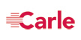

Neighborhood Issues

Traffic, Roads Please tell about YOUR neighborhood

 |  | Excellent | Good |  | Needs Improvement |  | Poor |  | N/A
Road Maintenance/Repair

Access to Public Transportation

Access to Sidewalks

Street Lights

Wheelchair Accessibility

Pedestrian Crosswalks

Bike Paths

Other (please specify)

Safety Concerns Please tell about YOUR neighborhood

 |  | Not Concerned | Somewhat Concerned |  | Concerned |  | Very Concerned |  | N/A
Traffic Speeds

Lack of Crime Patrols / Block Watches

Gang Activity

Crime rates

Other (please specify)

Health Issues (Medical, Dental, Mental Health) Please tell us what you think the TOP 5 concerns are in our community.
SELECT ONLY 5

Cancers

Heart Disease and Stroke

Mental Health

Senior / Aging Challenges

Infectious Disease (HIV/AIDS, STDs, West Nile Virus)

Infant Deaths

Obesity

Lung / Respiratory Diseases

Domestic Violence

Child Abuse and Neglect

Senior / Elder Abuse and Neglect

Gun Violence

Suicide

Dental Problems

Diabetes

Teenage Pregnancy

Alcohol / Drug Use

Other (please specify)

Community Resources: Please rate the following resources as adequate or inadequate in our community

 | Very Adequate |  |  | Adequate |  | Inadequate |  | Very Inadequate |  | Don’t Know
Affordable Housing

Employment / Ability to find jobs

Ability to pay for basic needs (food, clothing)

Drug treatment services

Mental health services

Family support services

Affordable childcare

Opportunities for youth

Funding for schools

Funding for after school programs

Senior services

Access to Health care

Services for low income persons

Other (please specify)

Personal Health: Please rate the following as it relates to YOU | Never | Less than once  a week |  |  | 1-3 days a week |  | 4-6 days a week |  | Every day
How many days do you exercise for at least 30 minutes?

I eat at least 5 servings of fruits and vegetables a day

How many days do you eat fast food (McDonalds, Burger King)?

I drink more than one sugary drink a day (soda, sweet tea, fruit juice).

I smoke, chew tobacco, or use E-cigarettes

How many days do you drink more than 4 alcoholic drinks.

Personal Satisfaction: Please tell us how these statement apply to YOU |  |  | Strongly Agree | Agree |  | Disagree |  | Strongly Disagree
I am satisfied with my access to health care in Champaign County.

I am satisfied with the cost of my health care in Champaign County.

I am satisfied with the quality of my health care in Champaign County.

I am satisfied with my access to affordable dental care in Champaign County.

Champaign County is a good place to raise children.

Champaign County is a good place to grow old.

Champaign County is a good place to live.

Champaign County is a racially, ethnically, and culturally diverse place to live.

Zip Code where you live _________________________ Gender (circle one) MALE FEMALE TRANSGENDER

Including yourself, how many people live in your household? ______ Age ______

Household Income (please select one) What is your race? (please select all that apply)

Less than $20,000 |  |  | Black / African American
$20,001 - $40,000 |  |  | Native Hawaiian / Other Pacific Islander
$40,001 - $60,000 |  |  | Asian
$60,001 - $75,000 |  |  | American Indian / Alaskan Native
$75,001 - $100,000 |  |  | White
$100,001 - $125,000 |  |  | Other (please specify)
$125,001 - $150,000 |  |  | What is your ethnicity?
$150,001 - $200,000 |  |  | Hispanic, Latino, or of Spanish Origin
Over $200,000 |  |  | Non-Hispanic
I prefer not to answer

Do you qualify for any of the following programs?  (please select all that apply) |  |  | Education (please select one)
SNAP / Food Stamps |  |  | Never attended school
WIC |  |  | Less than high school
Free/Reduced School Lunch |  |  | High school diploma / GED
None |  |  | Some college
Other (please specify) |  |  | College graduate
Other (please specify) |  |  | Graduate degree or higher
Do you have a primary care physician (doctor, NP)? YES / NO |  |  | How long has it been since you had a routine check-up with at a doctor’s office?
Where do you go for primary health care? (select all that apply) |  |  | Within the past year
Avicenna |  |  | More than a year but less than 2 years
Presence Emergency Room |  |  | More than 2 years but less than 5 years
Carle Emergency Room |  |  | More than 5 years
Christian Health Center |  |  | How do you pay for your health care?
Promise Health Care (Frances Nelson) |  |  | I don’t have insurance (self-pay)
McKinley Health Center |  |  | I don’t have insurance (charity care)
Christie Clinic |  |  | Medicaid
Carle Clinic |  |  | Medicare
Planned Parenthood |  |  | Veteran’s Administration
Other (please specify) |  |  | Health Insurance (employer, spouse, parent, Marketplace)
Other (please specify) |  |  | Other (please specify)
Do you have a dentist? YES / NO

How long has it been since you have seen a dentist? |  |  | Where do you go for dental services? (select all that apply)
Within the past year |  |  | Private Dentist
More than a year but less than 2 years |  |  | Carle Emergency Room
More than 2 years but less than 5 years |  |  | Presence Emergency Room
More than 5 years |  |  | Smile Healthy at Promise Health Care
 |  |  | Other: (please specify)

Appendix 4: Community Survey (Spanish)

Encuesta de salud de la comunidad del condado de Champaign
Por favor tome unos minutos, a menos de 5-7, para completar la encuesta de abajo. El propósito de la encuesta es obtener su opinión sobre la salud del Condado de Champaign. Tu aporte es importante y se utilizará para desarrollar planes para mejorar la calidad de vida en nuestra comunidad. Toda la información proporcionada se mantendrá confidencial. Por favor responda todas las preguntas.
Asuntos de barrio (tráfico, carreteras) Por favor Dile de su barrio
 | Excelente | Buena | Necesita mejorar | Pobre | N / A
Mantenimiento y reparación de carretera
Acceso al transporte público
Acceso a las banquetas
Luces de la calle
Accesibilidad para sillas de ruedas
Paso de Peatones
Caminos para bicicletas
Otros (especifique)
Asuntos de barrio (cuestiones de seguridad) Por favor Dile de su barrio
 | No le preocupa | Algo preocupado | preocupado | Muy preocupado | N / A
Velocidades del tráfico
Patrullas del crimen / vigilancias del bloque
Actividad de las pandillas
Porcentaje de crimen
Otros (especifique)

Problemas de salud (médico, Dental, Salud Mental)
Por favor díganos cuales son las 5 principales preocupaciones de nuestra comunidad en las que debemos enfocarnos. Seleccione solamente 5
Cancer
Enfermedad cardiaca y accidente cerebro vascular
Salud mental
Anciano/Problemas mayores de envejecimiento
Enfermedad infecciosa (VIH/SIDA, enfermedades de transmisión sexual, Virus del Nilo Occidental)
Muertes infantiles
Obesidad
Enfermedades pulmonares y respiratorias
Violencia doméstica
Negligencia y abuso infantil
Negligencia y abuso de los mayores / ancianos
La violencia armada
Suicidas
Problemas dentales
Diabetes
Embarazo en la adolescencia
Alcohol / consumo de drogas
Otros (especifique)

Recursos de la comunidad : Por favor califique los siguientes recursos como adecuada o inadecuada en nuestra comunidad
 | Muy adecuada | Adecuada | Inadecuada | Muy insuficiente | No sé
Vivienda económica y accesible
Empleo / habilidad para encontrar empleo
Capacidad de realizar los gastos básicos (comida, ropa)
Servicios de tratamiento de drogas
Servicios de salud mental
Apoyo a la familia y servicios sociales
Económica en cuidado de niños
Oportunidades para los jóvenes
Financiamiento para las escuelas
Fondos para programas extracurriculares
Servicios para personas mayores
Acceso a servicios de salud
Servicios para personas de bajos ingresos
Otros (especifique)

Satisfacción personal: Por favor díganos cómo estas afirmaciones se aplican a usted
 | Muy de acuerdo | Estoy de acuerdo | No está de acuerdo | Muy en desacuerdo
Estoy satisfecho con mi acceso a la atención médica en el condado de Champaign.
Estoy satisfecho con el costo de mi atención médica en el condado de Champaign
Estoy satisfecho con la calidad de mi atención médica en el Condado de Champaign.
Estoy satisfecho con mi acceso a la atención dental en el Condado de Champaign.
El condado de Champaign es un buen lugar para criar a los niños.
El condado de Champaign es un buen lugar para envejecer.
El condado de Champaign es un lugar seguro para vivir.
El condado de Champaign es un racialmente, étnicamente y culturalmente diverso lugar para vivir.

Personal de salud : Por favor califique los siguientes lo que se refiere a usted
 | Nunca | 1-3 días a la semana | 4-6 días a la semana | Todos los días
¿Cuantos días te ejercitas por lo menos 30 minutos al día?
Como al menos 5 porciones de frutas y verduras al día.
¿Cuántos días comes comida rápida (McDonalds, Burger King)?
Bebo más de una bebida azucarada al día (soda, té dulce, zumo de fruta).
Fumo, mastico tabaco o utilizo cigarrillos electrónicos.
¿Cuántos días bebes más de 4 bebidas alcohólicas?

Demografía:
Código postal donde vives __ _______
Género (circulo uno) mujer hombre transgénero edad ___
Eres hispano, Latino o español origen SÍ NO
¿Cuál es tu raza? (Seleccione todas las que aplican)
Negro / Afro Americano indio americano / nativo de Alaska
Nativo de Hawái /otras islas del Pacífico asiático
Blanco otros: ___
Educación (Seleccione uno)
Nunca asistió a la escuela diploma de secundaria / GED graduado de la Universidad
Menos de la secundaria alguno colegio posgrado o superior
¿Califica para cualquiera de los siguientes programas? (Seleccione todas las que aplican)
SNAP / Cupones de WIC almuerzo gratis o reducido ninguno
Otro: ____________________
Incluyéndose usted, ¿cuántas personas viven en su casa? ________________
Ingreso de los hogares (Seleccione uno)
Menos de $25,000 $50,001-$75,000 más de $100,001
$25, 001 - $50,000 $75,001-$100,000 prefiero no responder
¿Cómo paga usted su atención médica?
No tengo seguro (auto pago efectivo) Medicaid
No tengo seguro (cuidado de caridad) Medicare
Seguro médico (empleador, mercado) Administración de los veteranos
Otro: ____________________________

¿Tiene un médico de atención primaria (médico, enfermera practicante)? SÍ / NO
 | En el último año | Más de un año pero menos de 2 años | Más de 2 años pero menos de 5 años | Más de 5 años
¿Cuánto tiempo hace que no ha tenido un examen de rutina en un médico?

¿A dónde vas para atención primaria de salud? (Seleccione todas las que aplican)
Avicena Centro de la Salud Cristiana
Sala de emergencia Presence Promise Health Care
Sala de emergencia Carle McKinley Health Center
Clínica de la comunidad Planned Parenthood
Clínica de Carle Clínica de Christie
otro: __________________________

¿Tiene una dentista? SÍ / NO
 | En el último año | Más de un año pero menos de 2 años | Más de 2 años pero menos de 5 años | Más de 5 años
¿Cuánto tiempo hace que no ha tenido un examen de rutina en un dentista?

¿A dónde vas para servicios dentales? (Seleccione todas las que aplican)
Dentista privado CUPHD (servicios dentales del niño)
Sala de emergencia Carle Sonrisa saludable a Promise Health Care
Sala de emergencia Presence otro: _________________________________

Appendix 6. OSF Heart of Mary Activities 2018

Presence Covenant Medical Center became known as OSF Heart of Mary Medical Center as of February 1, 2018. Under the Presence Health System, the executive committee identified four significant health needs. OSF Heart of Mary Medical Center prioritized three of those needs in their Community Health Needs Implementation Strategy. Appendix 6 reflects a summary of activities related to these needs that occurred from February 1, 2018 through September 30, 2018. Appendix 7 reflects a summary of activities related to fiscal year 2019. Fiscal year 2020 is currently being collected.
- Behavioral Health
- Healthy Behaviors & Obesity
- Violence

- Behavioral Health
Mental Health: According to County Health Rankings, the ratio of mental health providers per 100,000 has improved drastically over the past eight years, moving from 2055:1 in 2010 to 440:1 in 2018. Residents reported they had experienced 3.7 days with poor mental health. According to the CDC, National Vital Statistics System, the Champaign County suicide rate in 2016 was 12.9 per 100,000, which is higher than the state of Illinois rate of 10.8. On the latest Community Health Survey, respondents were asked to rank the top health concerns in the community. Mental health was ranked as the number one health concern with 445 votes, while alcohol and drug abuse ranked as second with 386 votes.

Substance Abuse: Alcohol and drugs impair decision-making, often leading to adverse consequences and outcomes. Research indicates that alcohol is a gateway drug for youth, leading to increased usage of controlled substances in adult years. Opiates were the leading cause of drug-related deaths in Champaign County with nearly 47% listed as an opiate (heroin, methadone, hydrocodone, fentanyl), and an additional 10.2% had the cause of death listed as an opiate plus another drug(s). There have been 132 drug-related deaths in Champaign County from 2011-2017.
Long-term Community Health Improvement Plan Goals:
- Promote community awareness about behavioral health and encourage participation in data collection to support prevention programs.
- Implement early intervention and assessment practices to reduce the impact of mental and substance use disorders.
- Expand current available treatment and develop new treatment services.

MEASURMENT | PROGRESS for 2018 (2/1/18 – 9/30/18)
(1) Community Resource Center: Provides referral and support services to clients & helps connect them to an array of social services available in the community.  (2) Crisis Nursery: Increase parental knowledge to reduce child abuse in Champaign County and provide a safe haven for children in crisis.  (3) Faith In Action: Assist Champaign County seniors 55+ years old with maintaining their independent lifestyle to reduce the need of nursing home placement and provide support from the community, which would allow them to remain safely in their home. Serves to address the physical, social, mental, and spiritual dimensions of healthy living.  (4) Central Illinois Community Health Network Database  (5) Silver Cloud  (6) Behavioral Health Marketing  (7) Drug Take Back Program | (1) Community Resource Center:  - Navigator patient/Participant contacts: 2,411  - Unique Clients: 843  (2) Crisis Nursery:  - Total Admissions: 3,814  - Unduplicated (within the fiscal year) children served: 453  (3) Faith in Action:  - Number of Transportation to medical appointments, shopping, & other important errands: 784  - Friendly Visits, Cards/Notes: 277  - Holiday/Seasonal Gift Delivery (Special Projects): 20  - Office Volunteer Services & Volunteer Coordinator Hours: 352.25 Hours  - Intake Assessments for New Care Receivers: 20  - SHIP Counseling Sessions: 59  - SHIP Counseling Hours: 94  - Senior Events: 8  (4) Community Health Network:  - Number of participating organizations: 60  (5) Silver Cloud Activated Users: 41  (6) BH Chamber eBlast from (March  2018)  Silver Cloud marketing campaign  (July-September 2018)  (7) Exchange of bin completed 4 times for 4th quarter. Pharmacy manager and buy/pharmacist completed. 15 Minutes/person per event (2 hours total).
RELATED PROGRESS REPORT ACCOMPLISHMENTS
Partnerships include: Champaign County Mental Health Board sponsor (Disability Resource Expo, Reaching Out for Answers), Daily Bread Soup Kitchen Sponsor, Promise Healthcare Sponsor, Stroke Survivor Support Group – Meet 1x per month, Regional Executive Committee – Meet 1x per month.

- Healthy Behaviors and Obesity
Active Living. A healthy lifestyle, comprised of regular physical activity and a balanced diet, has been shown to increase physical, mental, and emotional well-being. Note that 19% of respondents in Champaign County indicated that they do not exercise at all, while the largest percentage (49%) of residents exercise less than once a week.
Healthy Eating. Only 34.10% of Champaign County residents reported eating five or more servings of fruits or vegetables a day 4 days a week or more. More than 22% of the entire population living in Champaign County has low food access. This percentage is higher than the percentage in Illinois (19.36%), but mirrors the average in the United States (22.43%). 16% of Champaign County residents are considered Food Insecure. The number of grocery stores per 100,000 is 18.4 in Champaign County, compared to state and national rates of 21.8 and 21.2.
Obesity. In Champaign County, 73% of adults and 41% of kids have been diagnosed with obesity and being overweight. Obesity data will be updated annually and used to measure progress with local Community Health Plan Obesity initiatives.
Long-term Community Health Improvement Plan Goals:
- By 2020, reduce by 1% the proportion of adults in Champaign County who report fitting the criteria for obesity.
- By 2020, increase by 1% the proportion of adolescents who report being at a healthy weight.
- By 2020, increase the Food Environment Index by 1.

Goals:
- Bring together community organizations providing education, increasing awareness, and engaging in health nutrition including exercise decisions in order to benefit community members in their everyday life and overall health.
- Increase knowledge, awareness, and engagement in healthy behaviors in order to improve Champaign County residents’ overall health.

MEASURMENT | PROGRESS for 2018 (2/1/18 – 9/30/18)
(1) Community Resource Center: Provides referral and support services to clients & helps connect them to an array of social services available in the community.  (2) OSF4Life: Participation/HRA/Challenge  (3) Cardiopulmonary Rehabilitation (Community Fitness, Parkinson’s Support Group Cardiac Rehab Exercise)  (4) Drug Take Back Program  (5) Central Illinois Community Health Network Database: Case mgmt. platform that extends health system & health plan networks to include community based organizations to address health related social needs.  (6) SmileHealthy Mobile Dental Clinics  (7) Pediatric Restorative Outpatient Surgery (PROPS): In partnership with Promise Healthcare. Dentist provides comprehensive treatment under general anesthesia in a hospital setting. | (1) Community Resource Center:  - Navigator patient/Participant contacts: 2,411  - Unique Clients: 843  (2) OSF4Life:  - Total Participants: 17  - Completed HRAs: 12  - Get-Fit Challenge Participants: 4  (3) 2018: Community Fitness:  - Persons Served: 102 Individuals  - Total Visits: 4,189  (4) Exchange of bin completed 4 times for 4th quarter. Pharmacy manager and buy/pharmacist completed. 15 Minutes/person per event (2 hours total). No invoice available for this time period.  (5) Community Health Network:  - Number of participating organizations: 60  (6) SmileHealthy Mobile Dental Clinics:  - Total Patients Seen: 76  - Number of Treatments Rendered: 203  (7) Pediatric Restorative Outpatient Surgery (PROPS):  - Total Cases: 19
RELATED PROGRESS REPORT ACCOMPLISHMENTS
List of partnerships: Promise Healthcare, SmileHealthy, Champaign County Mental Health Board Sponsorship (Disability Resource Expo, Reaching Out for Answers), Cunningham Children’s Home, Daily Bread Soup Kitchen, Crisis Nursery, Make a Wish – Walk for Wishes, Living Alternatives Annual Life Banquet, UIUC C-HeARTS Research Team, CC Down Syndrome Network – 2018 Buddy Walk, Stroke Support – meet 1x per month; Blood Drive – quarterly; Breastfeeding (Feeding Your Baby), Childbirth Education, Sibling’s Class, Dad’s Class offered at various times throughout the FY; BLS – offered; Heart saver CPR/AED – offered; First Aid – offered; Regional Executive Committee – Meet 1x per month.

- Violence
Crime. According to 2018 County Health Rankings, the violent crime rate (the number of reported violent crime offenses per 100,000 populations, is 526, which is substantially higher than the state of Illinois rate of 388. From the Illinois State Police crime reports, 2012-2015, we see that Champaign County has seen a 75% increase in homicide from 2012-2015 with four homicides in 2012 and seven in 2015. There was a spike in 2014, with 11 murders in Champaign County. In the Community Health Survey, 330 respondents marked Gun Violence, making it the 3rd highest ranked concern. 285 reported domestic violence and 278 reported child abuse and neglect, making them the 5th & 7th highest ranked health concerns.
Long-term Community Health Improvement Plan Goals:
- Decrease child abuse and neglect, gun violence, and domestic violence in the community by increasing community engagement, fostering better relationships between law enforcement and citizens, and implementing anti-violence initiatives.

MEASURMENT | PROGRESS for 2018 (2/1/18 – 9/30/18)
(1) Community Resource Center: Provides referral and support services to clients & helps connect them to an array of social services available in the community.  (2) Crisis Nursery: Increase parental knowledge to reduce child abuse in Champaign County and provide a safe haven for children in crisis.  (3) Drug Take Back Program  (4) Central Illinois Community Health Network Database: Case mgmt. platform that extends health system & health plan networks to include community based organizations to address health related social needs. | (1) Community Resource Center:  - Navigator patient/Participant contacts: 2,411  - Unique Clients: 843  (2) Crisis Nursery:  - Total Admissions: 3,814  - Unduplicated (within the fiscal year) children served: 453  (3) Exchange of bin completed 4 times for 4th quarter. Pharmacy manager and buy/pharmacist completed. 15 Minutes/person per event (2 hours total). No invoice available for this time period.  (4) Community Health Network:  - Number of participating organizations: 60
RELATED PROGRESS REPORT ACCOMPLISHMENTS
Partnerships include: Champaign County Mental Health Board Sponsorship (Disability Resource Expo, Reaching Out for Answers), Cunningham Children’s Home, Daily Bread Soup Kitchen, Crisis Nursery, Make a Wish – Walk for Wishes, Living Alternatives Annual Life Banquet, UIUC C-HeARTS Research Team, CC Down Syndrome Network – 2018 Buddy Walk; Regional Executive Committee – Meet 1x per month.

Appendix 7. OSF Heart of Mary Activities 2019
- Behavioral Health
Mental Health: According to County Health Rankings, the ratio of mental health providers per 100,000 has improved drastically over the past eight years, moving from 2055:1 in 2010 to 420:1 in 2019. Residents reported they had experienced 3.7 days with poor mental health. According to the CDC, National Vital Statistics System, the Champaign County suicide rate in 2016 was 12.9 per 100,000, which is higher than the state of Illinois rate of 10.8. On the latest Community Health Survey, respondents were asked to rank the top health concerns in the community. Mental health was ranked as the number one health concern with 445 votes, while alcohol and drug abuse ranked as second with 386 votes.

Substance Abuse: Alcohol and drugs impair decision-making, often leading to adverse consequences and outcomes. Research indicates that alcohol is a gateway drug for youth, leading to increased usage of controlled substances in adult years. Opiates were the leading cause of drug-related deaths in Champaign County with nearly 47% listed as an opiate (heroin, methadone, hydrocodone, fentanyl), and an additional 10.2% had the cause of death listed as an opiate plus another drug(s). There have been 132 drug-related deaths in Champaign County from 2011-2017. In 2018 there were 29 drug overdose deaths.
Long-term Community Health Improvement Plan Goals:
- Promote community awareness about behavioral health and encourage participation in data collection to support prevention programs.
- Implement early intervention and assessment practices to reduce the impact of mental and substance use disorders.
- Expand current available treatment and develop new treatment services.

MEASURMENT | PROGRESS for 2019
(1) Community Resource Center: Provides referral and support services to clients & helps connect them to an array of social services available in the community.  (2) Crisis Nursery: Increase parental knowledge to reduce child abuse in Champaign County and provide a safe haven for children in crisis.  (3) Faith In Action: Assist Champaign County seniors 55+ years old with maintaining their independent lifestyle to reduce the need of nursing home placement and provide support from the community, which would allow them to remain safely in their home. Serves to address the physical, social, mental, and spiritual dimensions of healthy living.  (4) Central Illinois Community Health Network Database  (5) Silver Cloud  (6) Drug Take Back Program | (1) Community Resource Center:  - Navigator patient/Participant contacts: 3,254  - Unique Clients: 1,007  (2) Crisis Nursery:  - Total Admissions: 4,706  - Unduplicated (within the fiscal year) children served: 487  (3) Faith in Action:  - Number of Transportation to medical appointments, shopping, & other important errands: 1,257  - Friendly Visits, Cards/Notes: 611  - Holiday/Seasonal Gift Delivery (Special Projects): 69  - Office Volunteer Services & Volunteer Coordinator Hours: 335.75 Hours  - Intake Assessments for New Care Receivers: 49  - SHIP Counseling Sessions: 42  - SHIP Counseling Hours: 61  - Senior Events: 17  (4) Community Health Network:  - Number of participating organizations: 92  (5) Silver Cloud Users to Complete the Online Program (Champaign & Vermilion Counties combined): 144  (6) Exchange of bin completed 12 times.
RELATED PROGRESS REPORT ACCOMPLISHMENTS
Partnerships include: Sponsorships of Champaign County Mental Health Board (Disability Resource Expo, Reaching Out for Answers), Daily Bread Soup Kitchen, Promise Healthcare, United Way of Champaign County, Cunningham Children’s Home, and Crisis Nursery. Stroke Survivor Support Group – Meet 1x per month, Regional Executive Committee – Meet 1x per month. Behavioral & Mental Health services, psychiatry, and pediatric psychiatry available by OSF Medical Group.

- Healthy Behaviors and Obesity
Active Living. A healthy lifestyle, comprised of regular physical activity and a balanced diet, has been shown to increase physical, mental, and emotional well-being. Note that 19% of respondents in Champaign County indicated that they do not exercise at all, while the largest percentage (49%) of residents exercise less than once a week.
Healthy Eating. Only 34.10% of Champaign County residents reported eating five or more servings of fruits or vegetables a day 4 days a week or more. More than 22% of the entire population living in Champaign County has low food access. This percentage is higher than the percentage in Illinois (19.36%), but mirrors the average in the United States (22.43%). 15% of Champaign County residents are considered Food Insecure. The number of grocery stores per 100,000 is 18.4 in Champaign County, compared to state and national rates of 21.8 and 21.2. In 2017, the food insecurity rate in Champaign County for children was 15.4% with 6,100 food insecure children.
Obesity. In Champaign County, 73% of adults and 41% of kids have been diagnosed with obesity and being overweight. Obesity data will be updated annually and used to measure progress with local Community Health Plan Obesity initiatives.
Long-term Community Health Improvement Plan Goals:
- By 2020, reduce by 1% the proportion of adults in Champaign County who report fitting the criteria for obesity.
- By 2020, increase by 1% the proportion of adolescents who report being at a healthy weight.
- By 2020, increase the Food Environment Index by 1.

Goals:
- Bring together community organizations providing education, increasing awareness, and engaging in health nutrition including exercise decisions in order to benefit community members in their everyday life and overall health.
- Increase knowledge, awareness, and engagement in healthy behaviors in order to improve Champaign County residents’ overall health.

MEASURMENT | PROGRESS for 2019
(1) Community Resource Center: Provides referral and support services to clients & helps connect them to an array of social services available in the community.  (2) Cardiopulmonary Rehabilitation (Community Fitness, Parkinson’s Support Group Cardiac Rehab Exercise)  (3) Drug Take Back Program  (4) Central Illinois Community Health Network Database: Case mgmt. platform that extends health system & health plan networks to include community based organizations to address health related social needs.  (5) SmileHealthy Mobile Dental Clinics  (6) Pediatric Restorative Outpatient Surgery (PROPS): In partnership with Promise Healthcare. Dentist provides comprehensive treatment under general anesthesia in a hospital setting.  (7) Kids Events to Promote Healthy Behaviors:  - Health Lives 4 Kids (HL4K) Day in conjunction with Children’s Hospital of Illinois  - EMS Children’s Day  (8) Chest Pain Accreditation Outreach Education Initiatives  (9) Blood Drive  (10) SmartMeals: Sharing Christ’s Love through Food (Food insecurity program) | (1) Community Resource Center:  - Navigator patient/Participant contacts: 3,254  - Unique Clients: 1,007  (2) Cardiopulmonary Rehabilitation  Community Fitness:  - Persons Served: 103 Individuals  - Total Visits: 7,788  Parkinson’s Support Group:  - Total Staff Hours: 31.5  - Total Persons Served (Duplicated): 973  (3) Exchange of bin completed 12 times. Pharmacy manager and buy/pharmacist completed.  (4) Community Health Network:  - Number of participating organizations: 92  - Individuals Attending Further Training Events: 22  - Number of Logins: 2,857  - Number of Bulletins/Comments Posted: 108  (5) SmileHealthy Mobile Dental Clinics:  - Total Patients Seen: 59  - Number of Treatments Rendered: 170  (6) Pediatric Restorative Outpatient Surgery (PROPS):  - Total Cases: 25  (7) Kids Events to Promote Healthy Behaviors:  - HL4K: Event at Urbana Middle School on 9/14/19 that served 58 adults and 63 kids with representation by 11 community organizations that provide services for children.  - EMS Children’s Day: Education event at PRO Ambulance with 85 Persons served  (8) Chest Pain Accreditation: Participated in 7 outreach events to serve 270 people. Health screenings were offered at each event. Health screenings include blood pressures, spirometry, fingerstick cholesterol tests, etc.  (9) Units of Blood Donated: 82  (10) SmartMeals:  - Surveys Received: 541  - Percentage of meals that were provided to a recipient with a preexisting medical condition:  - Heart Disease: 37.5%  - High Blood Pressure: 27%  - High Cholesterol: 18.3%  - Stroke: 4.8%; Diabetes: 15.9%; Pulmonary Disease: 8%
RELATED PROGRESS REPORT ACCOMPLISHMENTS
Partnerships include: Promise Healthcare, SmileHealthy, YMCA of the University of Illinois, Champaign County Mental Health Board Sponsorship (Disability Resource Expo, Reaching Out for Answers), Cunningham Children’s Home, Daily Bread Soup Kitchen, Crisis Nursery, Make a Wish – Walk for Wishes, Living Alternatives Annual Life Banquet, UIUC C-HeARTS Research Team, CC Down Syndrome Network – 2018 Buddy Walk, Fellowship of Christian Athletes Sponsor for FCA Day Camps, Stroke Support – meet 1x per month; Blood Drive – quarterly; Breastfeeding (Feeding Your Baby), Childbirth Education, Sibling’s Class, Dad’s Class offered at various times throughout the FY; BLS – offered; Heart saver CPR/AED – offered; First Aid – offered; Regional Executive Committee – Meet 1x per month.

- Violence
Crime. According to 2019 County Health Rankings, the violent crime rate (the number of reported violent crime offenses per 100,000 populations, is 487, which is substantially higher than the state of Illinois rate of 403. From the Illinois State Police crime reports, 2012-2015, we see that Champaign County has seen a 75% increase in homicide from 2012-2015 with four homicides in 2012 and seven in 2015. There was a spike in 2014, with 11 murders in Champaign County. In the Community Health Survey, 330 respondents marked Gun Violence, making it the 3rd highest ranked concern. 285 reported domestic violence and 278 reported child abuse and neglect, making them the 5th & 7th highest ranked health concerns.
Long-term Community Health Improvement Plan Goals:
- Decrease child abuse and neglect, gun violence, and domestic violence in the community by increasing community engagement, fostering better relationships between law enforcement and citizens, and implementing anti-violence initiatives.

MEASURMENT | PROGRESS for 2019
(1) Community Resource Center: Provides referral and support services to clients & helps connect them to an array of social services available in the community.  (2) Crisis Nursery: Increase parental knowledge to reduce child abuse in Champaign County and provide a safe haven for children in crisis.  (3) Drug Take Back Program  (4) Central Illinois Community Health Network Database: Case mgmt. platform that extends health system & health plan networks to include community based organizations to address health related social needs. | (1) Community Resource Center:  - Navigator patient/Participant contacts: 3,254  - Unique Clients: 1,007  (2) Crisis Nursery:  - Total Admissions: 4,706  - Unduplicated (within the fiscal year) children served: 487  (3) Exchange of bin completed 12 times.  (4) Community Health Network:  - Number of participating organizations: 92  - Individuals Attending Further Training Events: 22  - Number of Logins: 2,857  - Number of Bulletins/Comments Posted: 108
RELATED PROGRESS REPORT ACCOMPLISHMENTS
Partnerships include: Champaign County Mental Health Board Sponsorship (Disability Resource Expo, Reaching Out for Answers), Cunningham Children’s Home, Daily Bread Soup Kitchen, Crisis Nursery, Make a Wish – Walk for Wishes, Living Alternatives Annual Life Banquet, UIUC C-HeARTS Research Team, CC Down Syndrome Network – 2018 Buddy Walk; Regional Executive Committee – Meet 1x per month.

